DRAFT
Slough Borough Council
Air Quality Action Plan (2024 – 2028)

In fulfilment of Part IV of the Environment Act 1995
Local Air Quality Management
February 2024

Information | Slough Borough Council Details
Local Authority Officer | Sophia Norfolk
Department | Carbon and Sustainability
Address | Observatory House, 25 Windsor Road, Slough, SL1 2EL
Telephone | 01753 475111
E-mail | environmentalquality@slough.gov.uk
Report Reference Number | AQAP 2024-2028
Date | February 2024

Executive Summary
This Air Quality Action Plan (AQAP) has been produced as part of our statutory duties required by the Local Air Quality Management framework. It outlines the actions we will take to improve air quality in Slough between 2024 and 2028.
This action plan replaces the previous action plans which were produced in 2005 and 2012, and supports Slough Borough Council’s Low Emission Strategy (2018-2025). Key projects delivered through the past action plans include:
- Development of the Slough Electric Vehicle Charging Infrastructure Strategy in preparation of a boroughwide rollout of electric vehicle charging facilities.
- Securing mitigation and S106 contributions via the Low Emission Strategy to reduce emissions from new developments and building funding towards the Low Emission Strategy Programme.
- Securing funding from Defra and the Office for Zero Emission Vehicles (OZEV) to support the taxi trade to transition to electric vehicles.
- Implementation of the A4 bus lane scheme and securing funding for expanding the scheme to incorporate segregated cycle lanes and address safety issues on the A4.
- Successful trial of e-scooters and Cabinet approval to restart the scheme for a further four years, extended to include e-bikes.
- Road widening schemes to improve traffic flows, including Langley High Street widening from Langley College to Elmhurst Road and Brands Hill widening and junction upgrade / redesign from the A4 to Colnbrook By-pass.
- Improving the public realm at train stations, including the Slough Station Forecourt (north side), including the provision of new access arrangements.
- Junction upgrades to ease congestion, including William Street North junction upgrade and the A4/Wellington Street junction upgrade for right turning vehicles, in conjunction with traffic signal junction improvements across the borough.

Current Air Quality in Slough
Slough Borough Council monitor air quality to assess compliance against the following air quality objectives shown in Table A below:
Pollutant | Air Quality Objective | Averaging Period
Nitrogen Dioxide (NO₂) | 200 µg/m³ not to be exceeded more than 18 times a year | hourly mean
Nitrogen Dioxide (NO₂) | 40 µg/m³ | annual mean
Particulate matter (PM₁₀) | 50 µg/m³ not to be exceeded more than 35 times a year | 24 hour mean
Particulate matter (PM₁₀) | 40 µg/m³ | annual mean
Particulate matter (PM_{2.5}) | 20 µg/m³ | annual mean
Particulate matter (PM_{2.5}) | Target of 20% reduction in concentrations at urban background | annual mean
Table A: Air Quality Objectives for Pollutants in Slough

Slough Borough Council operate both a network of continuous (automatic) and passive (non-automatic) monitors.
During 2022, the Council continuously monitored air quality at six locations. Six monitoring stations monitor NO₂ concentrations, and four monitoring stations monitor particulate (PM₁₀) concentrations using established reference methods. The Council also undertook passive monitoring using diffusion tubes at 72 sites (102 diffusion tubes in total) during 2022.
This data has been used to assess how air quality has changed over the last five years. Overall, both NO₂ and PM have improved over this time period. The pandemic accelerated this improvement, which has been sustained across a number of monitoring sites. A summary by AQMA is provided below (please refer to the AQMA map provided in Appendix F). Reductions and increases in pollutant concentrations are denoted with ‘-‘ and ‘+’, respectively.

AQMA 1:
Over the last five years, average NO₂ concentrations within AQMA 1 have dropped by -10.2µg/m³ (31%). The biggest improvement is observed at Paxton Avenue (SLO 25) which has reduced by -13.6µg/m³ (41%) to 19.6µg/m³ since 2018, whereas the site with the smallest improvement is Grampian Way (SLO 8) by -7.0µg/m³ (20%), measuring 27.8µg/m³ in 2022. As expected, the year on year trend shows a large drop in 2020 as a result of the pandemic, with a slight recovery of NO₂ concentrations by 2022, most apparent at Grampian Way which increased from 23.0µg/m³ in 2021 to 27.8µg/m³ in 2022.

AQMA 2:
AQMA 2 has experienced the greatest drop in average NO₂ concentrations since 2018 out of all the AQMAs, at -13.0µg/m³ (31%). The biggest improvement is seen at Brands Hill (A) (SLO 18) by -21.6µg/m³ (41%), measuring 31.6µg/m³ in 2022, whereas the smallest improvement is seen at Brands Hill triplicate site (SLO 63, SLO 64 and SLO 65) at -6.5µg/m³ (15%) and falls within 10% of the AQO at 36.8µg/m³ in 2022. SLO 18 also sees the highest year on year rate of improvement at 12% on average. Continuous monitoring data (SLH 11) reflects this trend, with concentrations dropping by -2.4µg/m³ on average year on year.

AQMA 3 + Extension:
A smaller reduction in average NO₂ is observed at AQMA 3 (-8.6µg/m³) relative to 2018 concentrations, with Tuns Lane (B) (SLO 50) showing the greatest improvement in concentrations at -12.9µg/m³ (28%), representing the third year of falling below 10% of the AQO at 32.9µg/m³ in 2022, and the highest average year on year improvement at 7%. The smallest improvement is observed at Farnham Road (SLO 30) by -5.6µg/m³, however this site is far below the AQO in 2022 at 23.4µg/m³.
The AQMA 3 Extension shows a similar improvement in NO₂ concentrations since 2018, with the greatest reduction observed at the Windmill triplicate (SLO 57, SLO 58 and SLO 59) by -12.8µg/m³, measuring at 28.8µg/m³ in 2022. Although NO₂ concentrations have increased since 2020, the rate has been slow (average 2%).

AQMA 4:
Since 2018, concentrations have improved across all sites within AQMA 4 (average
-8.1µg/m³, 22%), the greatest being at Blair Road (SLO 37) with a -12.8µg/m³ decrease in NO₂ (32%). The Wellington Street triplicate (SLO 60, SLO 61 and SLO 62) has improved the least by -4.4µg/m³ (12.8%), however NO₂ concentrations measured over the last five years have remained below 10% of the AQO. This site has also seen the slowest year on year rate of improvement by -1.1µg/m³ (2%) on average, alongside Wellington Street Stratfield (SLO 33). Continuous monitoring data (SLH 10) shows a 7.7µg/m³ reduction in NO₂ since 2018, with concentrations at 28.3µg/m³ in 2022.
The pandemic brought widespread compliance with the AQO within AQMA 4, with Yew Tree Road (SLO 29) dropping by 14.7µg/m³ from 2019 to 2020, resulting in all sites falling below 10% of the AQO. Compliance was sustained for the majority of sites into 2021, however Yew Tree Road increased by 5.1µg/m³ (15%) to just under the AQO at 39.0µg/m³. A further increase to 44.2µg/m³ occurred in 2022, however once distance corrected from the roadside to the residential façade, this falls to 36.6µg/m³.

PM₁₀ & PM_{2.5}
In regards to PM monitoring, in 2022 Slough monitored PM₁₀ within AQMA 1 (Spackmans Way SLH 13), AQMA 2 (Brands Hill SLH 11), AQMA 3 Extension (Windmill SLH 12), and outside of the AQMAs at Pippins Colnbrook SLH 3 (only until March 2022) and obtained data from the Grundons Energy from waste (EfW) site in Colnbrook (SLH 8 and SLH 9). Due to the health effects associated with particulate matter, Slough Borough Council strives to reduce concentrations as far as possible, however in some locations, progress is slow. The greatest year on year improvement from 2018 to 2022 on average is -1.4µg/m³ (5%) observed at Brands Hill (SLH 11) whilst Lakeside 2 (SLH 9) has seen a greater fluctation with an overall worsening of PM₁₀ by +0.9µg/m³ (9%) on average across the time series.
Prior to 2022, the five year trend had shown a gradual decline over the monitoring period, however 2022 saw an increase in PM₁₀ at five of the six monitoring sites by +1.9µg/m³ on average, the greatest being an increase of +5.7µg/m³ observed at Lakeside 2 (SLH 9). This site however is monitored using an Osiris which is indicative only, therefore this data may be more unreliable relative to MCERTS accredited monitors. Comparing to the co-located BAM (SLH 8), the data shows an increase but at a lower value of +2.1µg/m³.

AQMA Status
A review of AQMA status has been completed as part of the action plan. Defra have clarified that due to the effects of COVID-19 on traffic levels and therefore local pollutant concentrations, monitoring data from 2020 and 2021 should be excluded when a local authority is considering compliant years for AQMA revocation. However, it is advised that 2020 and 2021 datasets can be considered as compliant years with respect to AQMA revocation if compliance was achieved in 2019 or earlier. Each AQMA and the collected data has been reviewed in light of this. In summary:

AQMA1: LONG TERM COMPLIANCE - REVOKE
No diffusion tube sites have shown an exceedance of 40µg/m³ since 2017 and concentrations have been below 36µg/m³ from 2018 onwards. Continuous monitoring data from sites in Chalvey (originally located within the waste depot and now based on Spackmans Way) last showed exceedance of the AQO in 2016. As there have been no exceedances of the AQO within AQMA 1 since 2017, the Council will prepare to revoke this AQMA in 2024.

AQMA 2: APPROACHING COMPLIANCE - RETAIN.
The first year that all sites in AQMA 2 complied with the AQO for NO₂ was 2020. Prior to this, concentrations were high, particularly on London Road (49.4µg/m³ at SLO 18) in 2019. Excluding COVID-19 years of 2020 and 2021, the first year of compliance was therefore 2022. As such, revocation of AQMA 2 can only be considered in 2025, if the three following years of data show concentrations below 36µg/m³.

AQMA 3 + Extension: APPROACHING COMPLIANCE - RETAIN.
Some monitoring sites, such as Tuns Lane (SLO 23), have fallen below 10% of the AQO for over 5 years, whereas others such as Tuns Lane (B) (SLO 50) have only reached compliance as a result of the pandemic. The first year of compliance is therefore 2022, with the highest concentration within AQMA 3 being Tuns Lane (SLO 50) at 32.9µg/m³, and the highest concentration within the AQMA 3 Extension being the Windmill triplicate (SLO 57, SLO 58 and SLO 59) at 28.8µg/m³. As such, the earliest year that revocation can be considered is 2025.

AQMA 4: NON-COMPLIANT - RETAIN.
The pandemic brought widespread compliance with the AQO within AQMA 4, with Yew Tree Road (SLO 29) dropping by 14.7µg/m³ from 2019 to 2020, resulting in all sites falling below 10% of the AQO. Yew Tree Road however recovered after the pandemic by 5.1µg/m³ (15%) to just under the AQO at 39µg/m³ in 2021. 2022 saw a further increase to 44.2µg/m³, however once distance corrected, this falls to 36.6µg/m³. As this is within 10% of the AQO, 2022 cannot be considered a year of compliance for AQMA 4.

Despite the improvement in air quality over the last five years, more needs to be done to meet compliance across the AQMAs in their entirety and address particular hotspot areas. In addition, there are areas outside of Slough’s AQMAs, which, pre-pandemic, were approaching non-compliance, therefore intervention is required to ensure that poor air quality in these areas remains suppressed. As such, this AQAP has been designed to address boroughwide air pollution. The focus remains on NO₂ reduction measures, however some measures will also assist in addressing particulate matter and indoor air quality.

Sources of Poor Air Quality
Across the borough, on average 46% of local NOx emissions are apportioned to road emissions. It is observed that for sites within AQMAs, on average, there is a higher contribution from road emissions than non-road emissions. The results of the study show that diesel cars were the greatest source of NO_{X} emissions (24.4%) on average across the borough; followed by rural (18.0%), domestic (8.0%) and LGVs (7.5%) in 2022.

For PM₁₀, the source apportionment study found that non-road emissions sources, such as secondary PM (37.7%), residual (33.3%), and domestic heating (9.6%), are the key contributors to total emissions. Road emissions sources only contributed to 10.6% of total PM₁₀ emissions in 2022.
Similarly, for PM_{2.5}, the key emissions sources are secondary PM (47.9%), residual (22.7%), domestic heating (13.9%), and road sources (9.3%). Secondary PM is formed in the atmosphere through complex chemical reactions from precursor pollutants such as nitrogen oxides (NOx), volatile organic compounds (VOCs), sulphur dioxides (SO₂), and ammonia. Residual PM is sea salt, calcium and iron rich dusts and regional primary PM and residual non characterised sources (residual is 1.0μg/m³)
As such, the Slough AQAP appropriately includes measures focusing on non-road emissions to reduce PM₁₀ and PM_{2.5} concentrations.
A breakdown of sources for NOx is provided below. The average contribution across monitoring sites has been calculated for each AQMA and non-AQMA site categories of industrial, kerbside and roadside, as defined within Technical Guidance LAQM.TG(22). The colour coding scale shows low percentage contributions (0%-3%) in green, medium percentage contributions (3%-14%) in yellow, and high percentage contributions (14% up to 35%) in red / orange.
Table B: NOx source contributions by percentage for each AQMA and non-AQMA areas (industrial, kerbside and roadside)
NOx Sources | AQMA 1 | AQMA 2 | AQMA 3 | AQMA 4 | Industrial | Kerbside | Roadside
Petrol cars | 5.4% | 3.8% | 4.7% | 4.2% | 2.5% | 4.5% | 3.4%
Diesel cars | 34.4% | 19.8% | 24.3% | 23.4% | 12.5% | 24.3% | 18.4%
Hybrid Petrol Cars | 0.3% | 0.2% | 0.2% | 0.2% | 0.1% | 0.2% | 0.1%
Hybrid Diesel Cars | 0.4% | 0.2% | 0.3% | 0.3% | 0.2% | 0.3% | 0.2%
LGVs | 11.8% | 8.3% | 8.7% | 5.9% | 0.4% | 0.8% | 2.2%
Rigid HGVs | 3.5% | 6.4% | 3.3% | 2.8% | 4.0% | 4.9% | 4.7%
Artic HGVs | 2.8% | 2.2% | 1.2% | 1.0% | 1.9% | 0.8% | 1.3%
Buses | 0.2% | 3.2% | 2.3% | 3.3% | 0.7% | 0.4% | 0.5%
Taxis | 2.5% | 2.4% | 3.0% | 4.9% | 1.6% | 4.2% | 2.9%
Minor Rd + Cold Start | 4.9% | 5.1% | 6.3% | 7.0% | 5.9% | 9.1% | 7.8%
Industry | 2.5% | 2.8% | 2.8% | 4.8% | 5.2% | 4.4% | 8.4%
Domestic | 6.0% | 6.3% | 8.3% | 9.0% | 6.2% | 10.8% | 9.3%
Aircraft | 1.8% | 6.0% | 1.4% | 1.9% | 17.1% | 1.9% | 3.3%
Rail | 2.8% | 2.4% | 9.5% | 6.5% | 1.5% | 4.4% | 7.8%
Other | 4.0% | 4.2% | 5.2% | 4.9% | 10.3% | 5.8% | 6.3%
Point Sources | 1.9% | 7.7% | 1.9% | 2.4% | 7.9% | 2.2% | 2.9%
Rural | 14.8% | 18.9% | 16.5% | 17.3% | 22.1% | 21.0% | 20.4%

From 2022 monitoring data, it was identified that one location in Slough (SLO 29, AQMA 4) exceeded the national NO₂ objective of 40 µg/m³ (44.2 µg/m³). The site is located at Yew Tree Road, where a large contribution to air pollution is attributed to congestion leading up to the junction on the A4 and A412. As such, the largest contributor to NOx emissions at SLO 29 was diesel cars, responsible for 28.6% of total emissions.
In order to achieve compliance with the national annual mean NO₂ objective (40 µg/m³) at Yew Tree Road, the required NOx reduction from road traffic is 4.2µg/m³ (9.5%) in accordance with the LAQM Technical Guidance (TG22).
In regards to PM₁₀ and PM_{2.5}, dispersion modelling from the baseline study (Appendix D) shows that both PM₁₀ and PM_{2.5} concentrations across the borough were well below the national air quality objectives in 2022.
The highest modelled PM₁₀ concentration in 2022, using a global adjustment factor, was 19.58 µg/m³ (SLO 93, SLO 94, SLO 95), and for PM_{2.5} the highest concentration was 12.21 µg/m³ (SLO 52). As such, there are no required reductions in particulate matter emissions in order to comply with air quality objectives. However, due to the severity of health impacts associated with particulate matter exposure, Slough Borough Council aims to reduce emissions of these pollutants for the benefit of improving the health of Slough’s residents, in line with our Corporate Plan. The three strategic priorities of the Corporate Plan are:
- A borough for children and young people to thrive.
- A town where residents can live healthier, safer and more independent lives.
- A cleaner, healthier and more prosperous Slough.

The AQAP will directly contribute towards the delivery of these priorities.

Air Quality Challenges
Air pollution is associated with a number of adverse health impacts. It is recognised as a contributing factor in the onset of heart disease and cancer. Additionally, air pollution particularly affects the most vulnerable in society: children and older people, and those with heart and lung conditions. There is also often a strong correlation with equalities issues, because areas with poor air quality are also often the less affluent areas,. The annual health cost to society of the impacts of particulate matter alone in the UK is estimated to be around £16 billion.
Slough has a number of specific challenges which exacerbate and sustain air quality issues in the borough:
- Slough is the third most densely populated local authority in the South East (following Portsmouth and Southampton) with 4,871 usual residents per square kilometre (48.7 per hectare compared to 45.8 in 2011, South East: 4.87, England: 4.34), therefore ten-fold higher than the South East average.
- Slough has a high proportion of households with one or more vehicles relative to its population density (79.7%) when compared with other high density areas including Reading (71.6%), Portsmouth (69.7%) and Southampton (72.6%). Likewise Slough has a lower proportion of households without access to a car or van (20.3%), compared to Reading (28.4%), Portsmouth (30.3%) and Southampton (27.4%) (ONS, 2021).
- Residents support having a high quantity of private vehicles in Slough and public transport schemes have received little public support (Slough 2040 Vision engagement survey, 2020). The A4 cycle lane scheme consultation results indicate that 87% of respondents use private vehicles to travel on the A4 compared to 14.7% by bus (A4 Cycle Scheme Consultation, 2023).
- Of residents who travel to work, the majority (71%) travel in a car or van, and often travel using this mode for short journeys under 10km (68%) (ONS, 2021).
- For school travel from 2018/19 to 2022/23, car sharing was the second most popular usual mode choice until 2021/22, when this was overtaken by the single child car mode. Single child car mode remains the second most popular usual mode choice, peaking at 38% in 2022/23 (Hands Up Surveys, 2018-2023).
- Slough falls within the top 25% of most deprived local authorities in England and a number of these areas of deprivation are located in poor air quality areas.
- The percentage of physically active adults in Slough is 51.6%, which is the lowest out of all England authorities (the next lowest after Slough is Blackburn with Darwen at 53.7%) and the average for the South (70.5%).
- High inactivity results in further health issues in Slough, including high mortality rates attributed to cardiovascular diseases, with 108.9 deaths per 100,000 under 75 years old, a high prevalence of obesity in Year 6 children (over 28.4%), and adulthood, with 62% of adults in Slough overweight or obese in 2020/21 (approx. 71,112 people).
- The healthy life expectancy for a male and female are 58.1 and 60.3 years old, much lower than neighbouring boroughs and lower than the South East average (7.4yrs and 5.6yrs higher for males and females, respectively).
- Slough’s location in proximity to London and Heathrow, in addition to direct links to the Strategic Road Network, results in high commuter traffic and favours travel via private vehicles.
However, despite these challenges, engagement with Slough’s residents has indicated that:
- Improving children’s health is an important value for schools in Slough (school engagement survey, 2024) and children are motivated to travel sustainably (hands up surveys, 2018-2022).
- When asked about contributors to poor air quality, the majority of respondents (52%) voted that vehicle traffic contributes towards poor air quality, which suggests that Slough residents have a good understanding of the dominant pollutant sources in the borough (Thinks report, 2023).
- Slough residents have concerns about their weight (67.3%) and activity levels (65.8%), with a willingness to get active (77.8%), suggesting that there is appetite for active travel related schemes and projects (Healthy behaviours survey, 2022).
- Residents voted that cheaper sustainable travel (e.g discounted public transport), wider public transport links and better public transport infrastructure (70% in total) would encourage them to travel more sustainably (Thinks report, 2023).
- The community would like to be more involved in community engagement activities, with 72% agreeing, alongside useful engagement suggestions including community meetings, newsletters and surveys, showing an interest in involvement (Thinks report, 2023).

Air Quality Measures
Slough Borough Council is committed to reducing the exposure of people in Slough to poor air quality in order to improve health.
We have developed actions with the intention to achieve the following two aims:
- Achieve a boroughwide NO₂ target concentration of <35µg/m³ by 2028
- Revoke all of Slough Borough Council’s AQMAs by 2030

The actions can be considered under three broad topics:
- Environment: focusing on emission management and reduction of emissions at the source
- Transport: focusing on traffic management and infrastructure to support modal shift
- Health Education & Awareness: focusing on improving the air quality knowledge base across the borough.
These aims will be achieved by focusing on the priority areas and objectives shown in Table C below.
Table C: Air Quality Action Plan (AQAP) Objectives
Environment Objective 1 (EO-1) | Undertake statutory duties to monitor, review and manage air quality
Environment Objective 2 (EO-2) | Ensure that air quality is a key consideration in all planning applications and support the Council's clean air ambitions at new developments
Environment Objective 3  (EO-3) | Reduce vehicle and building emissions associated with Council operations.
Environment Objective 4 (EO-4) | Reduce emissions from staff e.g. vehicles associated with Council staff 'grey' fleet to improve air quality and meet CO₂ targets
Environment Objective 5 (EO-5) | Reduce emissions from public transport by implementing emission standards via partnerships and promoting ULEV use with operators
Environment Objective 6 (EO-6) | Work in partnership with stakeholder groups to reduce emissions from vehicles and buildings
Environment Objective 7 (EO-7) | Work in collaboration with council officers to deliver the Air Quality Action Plan & LES Programme and promote the air quality agenda
Transport Objective 1  (TO-1) | Implement major infrastructural change, focusing on active travel, public transport and traffic management.
Transport Objective 2  (TO-2) | Increase uptake on public transport
Transport Objective 3  (TO-3) | Manage vehicle parking in Slough to achieve balance between accommodating growth and managing congestion
Transport Objective 4  (TO-4) | Implement traffic management measures to improve traffic flow and manage congestion
Transport Objective 5  (TO-5) | Improve the uptake of walking and cycling by making active travel an attractive travel option
Health Education & Awareness Objective 1  (HEAO-1) | Work in partnership with communities, businesses, schools and healthcare establishments to improve air quality
Health Education & Awareness Objective 2  (HEAO-2) | Improve information dissemination to the public regarding air quality
Health Education & Awareness Objective 3  (HEAO-3) | Improve education and awareness of air quality to promote healthy choices in relation to physical activity, transport, energy efficiency, smoke control and indoor air quality.

In development of this AQAP, an air quality steering group was established.
The steering group undertook a rigorous process to identify the key actions to form the core AQAP. A large number of measures which align with the objectives above were considered, which were scoped based on potential for air pollutant reduction, technical feasibility, implementation timeframe, cost, and funding source, which informed a viability score. This process resulted in a final shortlist of 26 measures, which fall into the following categories in accordance with the National Air Quality Plans:
- Alternatives to private vehicle use
- Policy guidance and development control
- Promoting low emission transport
- Promoting travel alternatives
- Promoting low emission plant
- Transport planning and infrastructure
- Traffic management

Scenario Impact Assessment
Following this exercise, the impact of five measure bundles were modelled to predict their impact on NOx concentrations. The top two measure bundles that had the biggest impact on NOx reduction were chosen to model PM₁₀, PM_{2.5} and CO₂ impact, to ensure that measure delivery would support reductions for all pollutants.
The measure bundles and the modelled concentration reductions are outlined below. Please refer to Table 5.3 for details on specific measures.
Scenario 1a-1c: Modal shift to active travel and EV transition
#1a 9.5% modal shift; #1b 9.5% modal shift + 5% BEV cars; #1c 9.5% modal shift + 10% BEV cars
- Measures HEA1, TM1, TM2, TM3, TM4, TM5, TM6, TM7, EM7, EM8, EM9, EM10
- Pollutant reduction on average across borough: NO₂: -1.6µg/m³; PM₁₀: -0.2µg/m³; PM_{2.5}: -0.1µg/m³; CO₂: -102 kt (12.6%)
Scenario 2a-2c: Yew Tree Road (AQMA 4) junction improvement
- Measure TM16
- Pollutant reduction on average across Yew Tree Road area: NO₂: -0.6µg/m³
Scenario 3: Minimum Euro VI HGVs and LGVs
- Measures EM3, EM4, EM5, EM6
- NO₂ reduction on average across borough: -0.5µg/m³
Scenario 4: 100% zero emission vehicle (ZEV) buses
- Measure TM13
- NO₂ reduction on average across borough: -0.4µg/m³
Scenario 5: Combination of quantified AQAP borough-wide measures and 100% ZEV taxis
Combination of measure #1c, #3, #4, + transition of taxi fleet to 100% ZEV
- All measures above (except TM16), plus EM11, EM12 and EM19
- Pollutant reduction on average across borough: NO₂: -2.6µg/m³; PM₁₀: -0.2µg/m³; PM_{2.5}: -0.2µg/m³; CO₂: -143kt (18.7%).

A summary of the NO₂ reductions by AQMA (excluding scenario 2 which only affects AQMA 4) is presented in Figure A below. Scenario #1c (9.5% modal shift and 10% BEVs) has the largest impact when compared to other scenarios and is most effective on average at AQMA 2 (-2.7µg/m³ NO₂ reduction). Overall, the biggest improvement in emissions can be achieved through the implementation of all measures in combination (scenario #5).
Figure A: Scenario impacts on NO₂ at AQMAs and non-AQMA areas (industrial, kerbside/roadside, and suburban/urban background)

It should be noted however that although not all measures have been modelled or feature within the shortlisted core action plan, many of the actions shown in the long list of measures list (Appendix C) in combination contribute to air quality improvements, therefore the Council will endeavour to deliver all viable measures from 2024 to 2028 where funding and officer resource is available. In addition, should funding or resource become available that improves the viability of a measure, it shall be promoted to the core AQAP measures shortlist table. This shortlist shall be reviewed annually by the recently formed (February 2024) air quality, public health and active travel collaborative steering group ‘Sustainability and Health’ and presented within the Annual Status Report (ASR).
In this AQAP we outline how we plan to effectively tackle air quality issues within our control. However, we recognise that there are a large number of air quality policy areas that are outside of our influence (such as vehicle emissions standards agreed in Europe), but for which we may have useful evidence, and so we will continue to work with regional and central government on policies and issues beyond Slough Borough Council’s direct influence.

Responsibilities and Commitment
This AQAP was prepared by the Carbon and Sustainability Team of Slough Borough Council with the support and agreement of the following officers and departments:
- Development Control
- Planning Policy
- Transport Planning
- Highways Development
- Sustainable Transport
- Parking
- Carbon and Sustainability
- Public Health
- Policy and Strategy
This AQAP has been approved by: [to be signed off following consultation]
- Lead Member for the Environment, Environmental Services and Open Spaces
- Executive Director of Housing and Property
- Director of Public Health
This AQAP will be subject to an annual review and appraisal of progress. Progress each year will be reported in the Annual Status Reports (ASRs) produced by Slough Borough Council, as part of our statutory Local Air Quality Management duties.
If you have any comments on this AQAP please send them to Sophia Norfolk, Principal Environment Officer at:
Observatory House, 25 Windsor Road, Slough, SL1 2EL
01753 475111
environmentalquality@slough.gov.uk
Table of Contents
Executive Summary i
Current Air Quality in Slough ii
AQMA Status v
Sources of Poor Air Quality vi
Air Quality Challenges viii
Air Quality Measures xi
Scenario Impact Assessment xiii
Responsibilities and Commitment xvi
1 Introduction 1
2 Summary of Current Air Quality in Slough 2
2.1 Monitoring Network 2
2.1.1 Automatic (continuous) monitoring 3
2.1.2 Non-automatic (passive) monitoring 3
2.2 Air Quality Management Areas (AQMAs) 5
2.3 Air Quality Trends 6
2.3.1 National Trends from 2018 to 2022 6
2.3.2 Local trends from 2018 to 2022 8
2.4 Summary of air quality trends in Slough 14
3 Slough Borough Council’s Air Quality Priorities 16
3.1 Slough Context 16
3.1.1 Population, Age and Ethnicity 16
3.1.2 Deprivation 17
3.2 Public Health Context 19
3.2.1 Health in All Policies 19
3.2.2 Additional air quality challenges 23
3.3 Planning and Policy Context 26
3.3.1 National Air Quality Management and Legislation 26
3.3.2 Local Policy and Strategy 31
3.4 Source Apportionment 32
3.4.1 NOx source apportionment 33
3.4.2 PM₁₀ and PM_{2.5} source apportionment 35
3.5 Required Reduction in Emissions 37
3.5.1 NOx and NO₂ 37
3.5.2 PM₁₀ and PM_{2.5} 37
3.6 Key Priorities 38
4 Development and Implementation of Slough Borough Council’s AQAP 40
4.1 Consultation and Stakeholder Engagement 40
4.2 Steering Group 41
5 AQAP Measures 42
5.1 Measures selection process 42
5.2 Summary of Measures 45
5.2.1 Environment 45
5.2.2 Transport 47
5.2.3 Health Education and Awareness 50
Appendix A: Response to Consultation 56
Appendix B: Reasons for Not Pursuing Action Plan Measures 57
Appendix C: Full Measures and Matrix Scoring 60
Appendix D: 2022 Baseline Model, Source Apportionment and Scenario Modelling Study 74
Appendix E: Evidence Base 109
E.1 Local Policy Review 109
E.2 Behaviours and Attitudes Towards Healthy Choices: Prior Consultation Review 134
E.3: Behaviours and Attitudes Towards Healthy Choices: Census Data 173
Appendix F: Maps 185
Appendix G: Air Quality Objectives 188
Glossary of Terms 190
References 191

List of Tables
Table A: Air Quality Objectives for Pollutants in Slough ii
Table B: Source contributions by percentage for each AQMA and non-AQMA areas (industrial, kerbside and roadside) vii
Table C: Air Quality Action Plan (AQAP) Objectives xii
Table 3.1: Air Quality Objectives (AQOs) applicable to Slough 27
Table 3.2 – Average split of source apportionment for NOx, PM₁₀ and PM_{2.5} emissions across Slough 34
Table 3.3: NOx source apportionment by AQMA and non-AQMA areas 35
Table 3.4: PM₁₀ source apportionment by AQMA and non-AQMA areas 35
Table 3.5: PM_{2.5} source apportionment by AQMA and non-AQMA areas 36
Table 5.1: Scoring matrix for measures assessment 43
Table 5.2: Car ownership per dwelling in town centres 49
Table C.1: Full Short List of Measures 60
Table C.2: Full Long List of Measures - Environment 63
Table C.3: Full Long List of Measures – Transport 68
Table C.4: Full Long List of Measures – Heath Education & Awareness 72
Figure 2-A – Model domain used for 2022 baseline model and source apportionment assessment; including measured NO₂ concentrations in 2022 76
Table 2-1 - Statistics of meteorological parameters for Heathrow meteorological station 78
Table 2-2– Measured & modelled annual mean NO2 concentrations for the 2022 base year scenario. 86
Table 2-3– Modelled annual mean PM10 concentrations for the 2022 base year scenario 89
Table 2-4 – Modelled annual mean PM_{2.5} concentrations for the 2022 base year scenario. Above the 2040 PM_{2.5} objective ( ≥10 µg/m³ and <15 µg/m³) but below the current PM_{2.5} objective = yellow. 90
Table 4-1 – measures included in scenario modelling 97
Table 4-2– measures included in scenario modelling 99
Table 4-3 - Scenario #2 average speed at Yew Tree Road junction 99
Table 4-4 – scenario modelling NO₂ concentrations across Slough (using global adjustment factor). 103
Table 4-5 - scenario modelling NO₂ concentrations across Slough (using individual adjustment factors) 103
Table 4-6 - scenario modelling NO₂ concentrations for sites SLO29, SLO40, SLO26, SLO5 and SLH10 (east AQMA 4) (using AQMA 4 adjustment factor). 103
Table 4-7 – scenario modelling PM₁₀ concentrations across Slough (using global adjustment factor) 106
Table 4-8 - scenario modelling PM₁₀ concentrations across Slough (using individual adjustment factors) 106
Table 4-9 - scenario modelling PM₁₀ concentrations for sites SLO29, SLO40, SLO26, SLO5 and SLH10 (east AQMA 4) (using AQMA 4 adjustment factor) 106
Table 4-10 – scenario modelling PM_{2.5} concentrations across Slough (using global adjustment factor) 106
Table 4-11 - scenario modelling PM_{2.5} concentrations across Slough (using individual adjustment factors) 106
Table 4-12 - scenario modelling PM_{2.5} concentrations for sites SLO29, SLO40, SLO26, SLO5 and SLH10 (east AQMA 4) (using AQMA 4 adjustment factor) 107
Table 4-13 - scenario modelling CO₂ emissions for all vehicles 107
Table 4-14 - scenario modelling CO₂ emissions for light vehicles (cars, taxis and HGVs) 107
Table 4-15 - scenario modelling CO₂ emissions for heavy vehicles (HGVs and buses) 108

List of Figures
Figure A: Scenario impacts on NO₂ at AQMAs and non-AQMA areas (industrial, kerbside/roadside, and suburban/urban background) xv
Figure 3.1: Age distribution of Slough’s population 17
Figure 3.2: Distribution of areas of deprivation in Slough 18
Figure 3.3: The wider determinants of Health 19
Figure 3.4: Health statistics in Slough compared with the Royal Borough of Windsor and Maidenhead and the average for the South East 21
Figure 2-B - 2022 wind rose for Heathrow meteorological station 77
Figure 2-C - Modelled road links 79
Figure 2-D - Modelled street canyons 80
Figure 2-E – Modelled NO₂ annual mean concentrations (2022 baseline) 85
Figure 2-F – Modelled PM₁₀ annual mean concentrations (2022 baseline) 87
Figure 2-G – Modelled PM_{2.5} annual mean concentrations (2022 baseline) 88
Figure 3-A - workflow and data used to calculate source apportionment 92
Figure 3-B - NOx source apportionment for the 2022 Baseline scenario at monitoring locations, broken down by road and background sources 94
Figure 3-C – PM₁₀ source apportionment for the 2022 Baseline scenario at monitoring locations, broken down by road and background sources 95
Figure 3-D – PM_{2.5} source apportionment for the 2022 Baseline scenario at monitoring locations, broken down by road and background sources 96
Figure 4-A – scenario modelling NO₂ concentrations across AQMA 4 monitoring sites using individual adjustment factors. 104
Figure E.1: Distribution of unhealthy behaviour concerns 140
Figure E.2: Distribution of healthy changes 141
Figure E.3: Distribution of transport modes via the A4 144
Figure E.4: Distribution of journey destinations via the A4 144
Figure E.5: Mode change as a result of the A4 scheme 145
Figure E.6: Distribution and theme of positive and negative comments 147
Figure E.7: Distribution of journey destinations for car users only 148
Figure E.8: Mode change as a result of the A4 scheme for car users only 148
Figure E.9: Mode change as a result of the scheme (excluding car only users) 149
Figure E:10: School attitudes towards health, active travel and air quality 152
Figure E.11: Annual school travel mode proportions from 2018/19 to 2022/23 157
Figure E.12: Comparison of usual travel modes between School A - C 159
Figure E.13: Comparison of preferred travel modes between School A - C 159
Figure E.14: Distribution of school travel modes by age group for School A 164
Figure E.15: Distribution of school travel modes by age group for School B 165
Figure E.16: Geographic distribution of respondents by zone 167
Figure E.17: Distribution of responses regarding sustainable transport modes 168
Figure E.18: Distribution of voted pollutant sources 169
Figure E.19: Respondent awareness of Heathrow Airwatch website 170
Figure E.20: Likelihood of visiting Heathrow Airwatch website 170
Figure E.21: Vehicle ownership per household in Slough compared to other local authorities and the England and South East average 174
Figure E.22: Correlation between percentage of households with three or more cars or vans and population density 175
Figure E.23: Breakdown of economic activity by group in Slough 176
Figure E.24: Mode choice distribution for Slough residents who are employed and travel to work 177
Figure E.25: Detailed mode choice distribution for Slough residents who are employed and travel to work 177
Figure E:26: Distance travelled for Slough residents who are employed and travel to work 178
Figure E.27: Distances travelled by mode category 179
Figure E.28: Mode choices for Slough residents who travel <10km to get to work 180
Figure E.29: percentage of Slough residents who travel less than 10km to work by location 181
Figure E.30: Bus routes in Slough 181
Figure E.31: Mode of travel to work in 2011 and 2021 182
Figure E.32: Mode of travel to work in 2011 and 2021 (excluding home working and driving a car or van) 183
Figure F.1: Air Quality Management Areas in Slough 185
Figure F.2: Passive diffusion tube monitoring sites in Slough 186
Figure F.3: Automatic (continuous) monitoring sites in Slough 187

1 Introduction
This report outlines the actions that Slough Borough Council (SBC) will deliver between 2024-2028 in order to reduce concentrations of air pollutants and exposure to air pollution; thereby positively impacting on the health and quality of life of residents and visitors to the borough.
It has been developed in recognition of the legal requirement on the local authority to work towards Air Quality Strategy (AQS) objectives under Part IV of the Environment Act 1995 and relevant regulations made under that part and to meet the requirements of the Local Air Quality Management (LAQM) statutory process.
This Plan will be reviewed every five years at the latest and progress on measures set out within this Plan will be reported on annually within Slough Borough Council’s air quality Annual Status Report (ASR).

2 Summary of Current Air Quality in Slough
As outlined in LAQM TG.22, all local authorities are required to annually report their air quality data to Defra, within an Annual Status Report (ASR). Local authorities outside of London are required to submit their ASRs by 30th June of each year. The ASR presents air quality trends, updates on measures and changes to the monitoring network, associated with the previous calendar year. Full details on air quality data and trends can be found within Slough Borough Council’s ASRs, available on the Council webpages.
The following sections provide a summary of Slough Borough Council’s air quality monitoring network and air quality trends both nationally and at Slough, within and outside of the Council’s Air Quality Management Areas (AQMAs) (further explanation as to how and why AQMAs are declared is provided in Section 3.3.1). This forms part of the evidence base to support the need for air quality improvement.
A summary of the Air Quality Objectives (AQOS) is provided in Section 3.3 and Appendix G of which compliance is measured and assessed.
It should be noted that the World Health Organisation have different threshold defined compared to the legal limits, known as Air Quality Guidelines (AQGs), presented also in Appendix G. These have been developed based on scientific evidence on air pollution related health impacts, from literature reviews, evaluation and consultation with experts and end-users of the guidelines. The AQGs serve as a target to be met globally by national, regional and city governments, however they are not legally binding.

Monitoring Network
Slough Borough Council operate a network of both automatic (continuous) and non-automatic (passive) air quality monitoring sites across the borough, which has been in place for over 25 years. The monitoring locations primarily focus on areas representative of receptor exposure to poor air quality, such as residential dwellings close to major roads, which tend to be within AQMAs. There are however a number of monitoring locations that are outside of these areas, for the purpose of monitoring background levels and areas of concern or specific sources, to determine whether these areas should be designated as AQMAs.

Automatic (continuous) monitoring
Slough Borough Council currently operate six automatic (continuous) air quality monitoring stations in locations representative of each AQMA and hotspot areas, which includes:
- AQMA 1: Slough Spackmans Way, Chalvey SLH 13 - NOx, NO₂ and PM₁₀
- AQMA 2: Slough Brands Hill (London Road), SLH 11 - NOx, NO₂ and PM₁₀
- AQMA 3: Slough Windmill (Bath Road), SLH 12 - NOx, NO₂ and PM₁₀
- AQMA 4: Slough Town Centre (Wellington Street) SLH 10 - NOx and NO₂
- Non-AQMA: Slough Station Road Langley, SLH 14 - NOx and NO₂
Additionally, Grundons have operated an Energy from Waste plant in Colnbrook since 2010 and monitor ambient air quality as part of their planning consent, which includes NOx, PM₁₀ and PM_{2.5}, and is released to the Council annually.
- Non AQMA: Slough-Lakeside-2 (Lakeside Road) SLH 8 & SLH 9

Non-automatic (passive) monitoring
Diffusion tubes are used in Slough Borough Council’s passive monitoring network to monitor NO₂. The details of diffusion tubes provided in this section are as of January 2024. A summary of their locations is outlined below, with supporting maps presented in Appendix F. In total, this network consists of 102 diffusion tubes.

AQMA 1 (37 diffusion tubes in total)
The diffusion tubes located within AQMA 1 are representative of the nearest residential exposure to the M4, which is the most significant pollutant source in the area. This includes residential areas on Grampian Way, Winvale, Spackmans Way and Paxton Avenue. In 2019, 10 new receptors were identified to represent exposure resulting from the Smart Motorway scheme, affecting Junctions 3 to 12. Each of these receptor locations have three diffusion tubes, therefore increasing the diffusion tube network by 30 tubes in total. In 2021, the new continuous monitoring station located on Spackmans Way was commissioned and three additional diffusion tubes were co-located within the analyser cage.
AQMA 2 (8 diffusion tubes in total)
The monitoring sites within AQMA 2 are representative of the nearest residential exposure to the A4 London Road, which has high traffic flows from vehicles accessing the A4 and Heathrow, plus HGV movements associated with industrial activities such as nearby sand and gravel extraction, Energy from Waste plant operation and Poyle Industrial Estate operations. All but one of the eight diffusion tubes are located on London Road, with the remainder located on Colnbrook By-pass to represent exposure at a large residential development situated on the junction between Bath Road and London Road. Three of the eight diffusion tubes are co-located with the continuous monitor on London Road.
AQMA 3 & AQMA 3 Extension (6 diffusion tubes in total)
There are two diffusion tube sites on Tuns Lane that represent a dwelling that is approximately 9 metres from the roadside and is the nearest residential exposure to the A355, and a residential block on the junction between the A355 and the A4. The remaining diffusion tubes are located on Bath Road, with one on the façade of Windmill Care Centre and the other three co-located with the continuous monitoring station situated on Bath Road.
AQMA 4 (12 diffusion tubes in total)
The monitoring sites within AQMA 4 are representative of the nearest residential exposure to the A4 (Bath Road and Wellington Street) and the A412 (Yew Tree Road / Uxbridge Road). Three diffusion tube sites are located to the north side of Bath Road, and a further five sites are located on Wellington Street, three of which are co-located the Wellington Street continuous monitoring station. Two sites are located to the north of Wellington Street, on Wexham Road and Princes Street, and two sites are located to the south, on Yew Tree Road / Uxbridge Road (roadside and façade exposure sites).
Outside AQMAs (39 diffusion tubes in total)
Slough Borough Council monitor air quality at a number of locations outside of the declared AQMAs, in locations categorised as industrial, roadside, kerbside, suburban, urban background and other. The purpose of this monitoring is typically to investigate a specific air quality concern, to monitor a specific source, or represent background sources. The monitoring locations outside of AQMAs are as follows:
- 9 diffusion tubes are located at roadside sites within Langley, 6 of which were initiated in 2016 due to concerns that development in the area would result in higher levels of NO₂. A further 3 diffusion tube sites were co-located with a new roadside continuous monitor on Station Road in February 2023 for the purpose of monitoring the impact of increasing development in the area and the potential development of the Western Rail Link to Heathrow.
- 12 diffusion tube sites are located on roads in proximity to the A4 to monitor traffic displacement and congestion effects resulting from the A4 Bus Lane scheme, which were installed in 2021. The selected roads include Oatlands Drive, Elliman Avenue, Shaggy Calf Lane, Chalvey Road East, Ledgers Road and Cippenham Lane.
- 4 diffusion tube sites are representative of roadside locations and 1 is representative of a kerbside location. The majority of these sites are positioned nearby AQMA boundaries to monitor the spatial extent of exceedances within AQMAs. A diffusion tube on Albert Street (SLO 97) was deployed specifically for monitoring congestion in 2020.
- 4 diffusion tube sites are located in the Colnbrook and Poyle area, to monitor the impact of high HGV traffic flows on air quality at nearby receptors.
- 4 diffusion tubes are located in urban background and suburban areas, including one site on the outskirts of Colnbrook and Poyle, and three background sites within Salt Hill Park.
- 5 diffusion tube sites have recently (September 2023) been deployed in the residential areas of Colnbrook, to determine whether the ultra-low emission zone has resulted in NO₂ exceedances in this area.

Air Quality Management Areas (AQMAs)
Slough Borough Council have five AQMAs, declared due to exceedances of the NO₂ AQO (40µg/m³). A description of each is provided below.

AQMA 1: including land adjacent to the M4 along the north bound carriageway (junctions 5-7) and southbound carriageway (junction 5 – Brands Hill) up to a distance of approximately 100m from the central carriageway, declared in June 2005. In 2022, there were 542 residential properties within AQMA 1.

AQMA 2: incorporates A4 London Road east of junction 5 M4, 300m past Sutton Lane along the Colnbrook by-pass and covers the entire A4 London Road to Bath Road junction, declared in June 2005. A new residential development (Rogans) opposite the junction is now occupied and approximately doubles the number of residential properties exposed in this location. In 2022, there were 85 residential properties within AQMA 2.

AQMA 3: incorporates the A355 Tuns Lane from junction 6 of the M4 motorway in a northerly direction to just past its junction with the A4 Bath Road approximately 200m north along A355 Farnham Road (the area is known as the “Three Tuns”) declared in January 2011. In 2022, there were 362 residential properties within AQMA 3.

AQMA 3 Extension: The Council declared the new extended AQMA 3 on 10th May 2018 and formally submitted this to Defra. In 2022, there were 229 residential properties within AQMA 3 Extension, plus a residential care home accommodating up to 53 residents.

AQMA 4: incorporates the A4 Bath Road from the junction with Ledgers Road/Stoke Poges Lane, in an easterly direction, along Wellington Street, up to the Sussex Place junction, declared January 2011. In 2022, there were 743 residential properties within AQMA 4.

Air Quality Trends

National Trends from 2018 to 2022
Nitrogen dioxide (NO₂)
National air quality data for 2023 will be available from Defra in April 2024, therefore the following review is for 2022.
    - Across the UK, urban background NO₂ pollution reduced both in the long-term and in recent years. Between 2006 and 2019 inclusive, the annual mean NO₂ concentration at urban background sites reduced by an average of
-0.9µg/m³ each year and fell by -4.5µg/m³ (23%) in 2020 due to a reduction in traffic as a result of the COVID-19 pandemic. Concentrations recovered slightly in 2021 by 5% and decreased by 1% from 2021 to 2022.
    - Similarly, UK roadside sites saw an average reduction of NO₂ concentrations by
-1.8µg/m³ each year between 2006 and 2019. The pandemic brought a 26% reduction (-8.21µg/m³) in 2020, which recovered by 8% in 2021 (+1.8µg/m³). On average, the annual mean concentration of roadside NO₂ decreased by 5%
(-1.2µg/m³) from 2021 to 2022, whilst remaining 24% lower than concentrations in 2019. In 2022, there were also the fewest hours of ‘moderate’ air pollution in line with the DAQI index due to NO₂ per site since the beginning of the time series (1997).
    - In regards to weekday variations, the Monday-to-Friday mean concentration at UK roadside sites was 25.2µg/m³, 28% greater than the mean concentration at the weekend of 19.7µg/m³. This is primarily due to the influence of commuter traffic during the week and is a greater difference when compared to 2021 (26%).
PM_{2.5} and PM₁₀
- Urban background PM₁₀ pollution in the UK has reduced in the long-term despite a period of relative stability between 2015 to 2019, until a notable decrease in 2020 by -1.8µg/m³ (12%) to 13.2µg/m³. There was further decrease (2%) to 13.0µg/m³ in 2021, the lowest value in the time series. From there, concentrations have risen by 8% to 13.9µg/m³ in 2022.
- Similarly to PM₁₀, urban background PM_{2.5} pollution in the UK has shown stability between 2015 and 2019, with a notable decrease from 2019 to 2020 from 9.9µg/m³ to 7.9µg/m³ (20%). This recovered slightly in 2022 to 8.3µg/m³ (5%).
- Both UK roadside PM₁₀ and PM_{2.5} pollution has reduced in the long-term. Similarly to urban background sites, roadside PM₁₀ concentrations have remained relatively stable over the last 8 years, with an 8% reduction in 2020 to 16.3µg/m³, dropping by a further 2.7% in 2021 to 15.9µg/m³. Concentrations in 2022 however increased by 6% to 16.9µg/m³. PM_{2.5} has seen a similar trend with the lowest concentrations observed in 2020 at 8.1µg/m³, increasing slightly to 8.7µg/m³ by 2022.
- Comparing PM₁₀ by site location, concentrations are greater at roadside sites than urban background sites in the UK. This is likely to be due to proximity to road transport sources such as brake, tyre and road wear, in addition to resuspension caused by vehicle movements.
- Across the UK, PM_{2.5} concentrations tend to be highest in urban environments, particularly in the southern and eastern areas of the UK. This is likely due to population density, weather conditions and a greater exposure to pollution sources from mainland Europe. In 2022, the top five sites in urban environments (4 roadside and 1 background) with the greatest annual mean concentration of PM_{2.5} were located in the South or East (including London).
- Overall, roadside and urban background monitoring sites have recorded a decreasing trend in hours of ‘Moderate’ or higher PM_{2.5} air pollution since 2011.

Local trends from 2018 to 2022
Nitrogen dioxide (NO₂) within in AQMAs
This section provides a summary of NO₂ trends by AQMA. Please note that to date, 2023 diffusion tube data has not yet been processed and will be presented in ASR 2024. As such, the data provided below is for the last full monitored year which was 2022. Slough Borough Council undertook non-automatic monitoring of NO₂ at 74 sites (102 diffusion tubes) during 2022.
Overall, improvement of NO₂ concentrations have been experienced across all of Slough’s AQMAs over the last five years, with the highest rate observed in 2020, as expected due to the pandemic. Relative to 2018 data, there has been an improvement of -10.0µg/m³ (27%) across all AQMAs on average, with an average rate of improvement year on year by -2.5µg/m³ (7%).

A summary of the rate of improvement and overall improvements in 2022 relative to 2018 concentrations by AQMA is provided below, alongside a review of the AQMA’s status.

AQMA 1
Over the last five years, average NO₂ concentrations within AQMA 1 have dropped by -10.2µg/m³ (31%). The biggest improvement is observed at Paxton Avenue (SLO 25) which has reduced by -13.6µg/m³ (41%) to 19.6µg/m³ since 2018, whereas the site with the smallest improvement is Grampian Way (SLO 8) by -7.0µg/m³ (20%), measuring 27.8µg/m³ in 2022. As expected, the year on year trend shows a large drop in 2020 as a result of the pandemic, with a slight recovery of NO₂ concentrations by 2022, most apparent at Grampian Way which increased from 23.0 µg/m³ in 2021 to 27.8µg/m³ in 2022.

No diffusion tube sites have shown an exceedance of the 40µg/m³ AQO since 2017 and concentrations have been below 36µg/m³ (10% of the AQO) from 2018 onwards. Continuous monitoring data from sites in Chalvey (originally located within the waste depot and now based on Spackmans Way) last showed exceedance of the AQO in 2016. It is expected that the pandemic has contributed towards suppressing NO₂ concentrations and early data from 2023 suggests that this trend has continued.
The continuous analyser on Spackmans Way (SLH 13) has shown low concentrations since its implementation in 2021, at 23.2µg/m³ in 2021 and 22.7µg/m³ in 2022. The previous monitoring location within the depot (SLH 7) also recorded low concentrations, averaging at 26.5µg/m³ from 2018 to 2020.

Defra have clarified that due to the effects of COVID-19 on traffic levels and therefore local pollutant concentrations, monitoring data from 2020 and 2021 should be excluded when a local authority is considering compliant years for AQMA revocation. However, it is advised that 2020 and 2021 datasets can be considered as compliant years with respect to AQMA revocation if compliance was achieved in 2019 or earlier. As there have been no exceedances of the AQO within AQMA 1 since 2017, the Council will look to revoke this AQMA in 2024.

AQMA 2
AQMA 2 has experienced the greatest drop in average NO₂ concentrations since 2018 out of all the AQMAs, at -13.0µg/m³ (31%). The biggest improvement is seen at Brands Hill (A) (SLO 18) by -21.6µg/m³ (41%), measuring 31.6µg/m³ in 2022, whereas the smallest improvement is seen at Brands Hill triplicate site (SLO 63, SLO 64 and SLO 65) at -6.5µg/m³ (15%) and falls within 10% of the AQO at 36.8µg/m³ in 2022. London Road (SLO 18) also sees the highest year on year rate of improvement at 12% on average. Continuous monitoring data (SLH 11) reflects this trend, with concentrations dropping by 2.4µg/m³ on average year on year.
2020 was the first year that all sites in AQMA 2 complied with the AQO for NO₂. Prior to this, concentrations were high, particularly on London Road (49.4µg/m³ at SLO 18) in 2019. The pandemic is likely to have been the cause of compliance in 2020 and 2021, which had been sustained in 2022. Defra have advised that revocation of an AQMA should only be considered following three consecutive years of annual mean NO₂ concentrations being lower than 36µg/m³. In 2022, one monitoring site was above this value, at the triplicate co-located site (SLO 63, SLO 64, SLO 65), at 36.8µg/m³, however once corrected to relevant exposure, the concentration was 32.2µg/m³.
Excluding COVID-19 years of 2020 and 2021, the first year of compliance was therefore 2022. As such, revocation of AQMA 2 can only be considered in 2025, if the two following years of data show concentrations below 36µg/m³. AQMA 2 will therefore remain in place until sufficient evidence suggests it can be revoked.

AQMA 3 and AQMA 3 Extension
A smaller reduction in average NO₂ is observed at AQMA 3 (-8.6µg/m³) relative to 2018 concentrations, with Tuns Lane (B) (SLO 50) showing the greatest improvement in concentrations at -12.9µg/m³ (28%), representing the third year of falling below 10% of the AQO at 32.9µg/m³ in 2022, and the highest average year on year improvement at 7%. The smallest improvement is observed at Farnham Road (SLO 30) by -5.6µg/m³, however this site is far below the AQO in 2022 at 23.4µg/m³.

The AQMA 3 Extension shows a similar improvement in NO₂ concentrations since 2018, with the greatest reduction observed at the Windmill triplicate (SLO 57, SLO 58 and SLO 59) by -12.8µg/m³, measuring at 28.8µg/m³ in 2022. Although NO₂ concentrations have increased since 2020, the rate has been slow (average 2%).

The continous monitor at Windmill (SLH 12) has shown a similar trend, reducing from 41.5µg/m³ in 2018 to 28.7µg/m³ by 2022 (32% reduction) and has seen the greatest year on year improvement on average (-3.3µg/m³) when comparing against other continuous monitors. The NO₂ 1-hour mean objective (200µg/m³ not to be exceeded more than 18 times/year) has historically not been exceeded across Slough’s automatic monitoring sites, with the exception of Windmill Bath Road which had shown one exceedance of 200µg/m³ in 2021. 2022 continues this historic trend by having no exceedances of the 1-hour mean objective and is therefore not of concern.

Similarly to AQMA 2, the pandemic brought about compliance with the AQO within AQMA 3 and AQMA 3 Extension. Some monitoring sites, such as Tuns Lane (SLO 23), have fallen below 10% of the AQO for over 5 years, whereas others such as Tuns Lane (B) (SLO 50) have only reached compliance as a result of the pandemic. The first year of compliance is therefore 2022, with the highest concentration within AQMA 3 being Tuns Lane (SLO 50) at 32.9µg/m³, and the highest concentration within the AQMA 3 Extension being the Windmill triplicate (SLO 57, SLO 58 and SLO 59) at 28.8µg/m³. As such, the earliest year that revocation can be considered is 2025.

AQMA 4
Since 2018, concentrations have improved across all sites within AQMA 4 (average
-8.1µg/m³, 22%), the greatest being at Blair Road (SLO 37) with a -12.8µg/m³ decrease in NO₂ (32%). The Wellington Street triplicate (SLO 60, SLO 61 and SLO 62) has improved the least by -4.4µg/m³ (12.8%), however NO₂ concentrations measured over the last five years have remained below 10% of the AQO. This site has also seen the slowest year on year rate of improvement by -1.1µg/m³ (2%) on average, alongside Wellington Street Stratfield (SLO 33). Continuous monitoring data (SLH 10) shows a 7.7µg/m³ reduction in NO₂ since 2018, with concentrations at 28.3µg/m³ in 2022.
The pandemic brought widespread compliance with the AQO within AQMA 4, with Yew Tree Road (SLO 29) dropping by 14.7µg/m³ from 2019 to 2020, resulting in all sites within AQMA 4 falling below 10% of the AQO. Compliance was sustained for the majority of sites into 2021, however Yew Tree Road increased by 5.1µg/m³ (15%) to just under the AQO at 39.0µg/m³. 2022 saw a further increase to 44.2µg/m³, however once distance corrected, this falls to 36.6µg/m³. As this is within 10% of the AQO, 2022 cannot be considered a year of compliance for AQMA 4. The earliest that revocation can be considered would therefore be 2026, but only if concentrations below 10% of the AQO are achieved from 2023 onwards.
Nitrogen dioxide (NO₂) outside of AQMAs
- At industrial sites, relative to 2018, the average improvement in NO₂ was -13.1µg/m³ (33%), with an average year on year improvement of -3.3µg/m³ (8%). The biggest improvement is observed at Lakeside Road (SLO 12) by -16.3µg/m³ (40%). The highest concentration in 2022 is observed at Horton Road (SLO 17), however concentrations are still far below the AQO at 28.3µg/m³.
- Roadside and kerbside sites have shown compliance with the AQO since 2018, however concentrations were very close to the AQO at Windsor Road (B) (SLO 49) in 2019, at 39.5µg/m³. Since 2018, concentrations have reduced by -9.0µg/m³ on average. The highest concentration in 2022 was Windsor Road (B) (SLO 49) at 28.2µg/m³, far below the AQO.
- The two suburban sites at Elbow Meadows (SLO 13) and the Pippins Colnbrook triplicate (SLO 14, SLO 15 and SLO 16) have both remained below 10% of the AQO in the last 5 years. Concentrations were at their lowest in 2021 at 17.5µg/m³ for the triplicate location and 19.6µg/m³ at Elbow Meadows. Although concentrations increased in 2022, they remain far below the AQO at a maximum of 21.9µg/m³.
- The six sites in Langley are described separately as they were originally deployed to determine whether the Langley area should be declared as an AQMA. The data presented in the previous ASR indicated that this would be unlikely. Concentrations were particularly high at High Street Langley (SLO 53), which peaked at 39.9µg/m³ in 2019. Concentrations at this location have since dropped due to the pandemic with a -12µg/m³ reduction (30%) in NO₂. Since 2020, all monitoring sites have recorded concentrations below 30µg/m³, with an overall year on year reduction of -2.3µg/m³ (7%) on average since 2018.
- One continuous analyser outside of the AQMAs, Pippins Colnbrook (SLH 3), was operational in 2022 (but has since been discontinued). This site had the lowest year on year improvement on average at -0.2µg/m³ since 2018, however concentrations have been very low since monitoring began, averaging at 20.6µg/m³ from 2018 to 2022. This is expected given the monitor’s background location.
PM₁₀ in Slough
In 2022, Slough monitored PM₁₀ within AQMA 1 (Spackmans Way, SLH 13), AQMA 2 (Brands Hill, SLH 11), AQMA 3 Extension (Windmill, SLH 12), and outside of the AQMAs at the EfW site and at Pippins Colnbrook (SLH 3) (only until March 2022). Due to the health effects associated with particulate matter, Slough Borough Council strives to reduce concentrations as much as possible, however in some locations, progress is slow. The greatest year on year improvement from 2018 to 2022 on average is -1.4µg/m³ (5%) observed at Brands Hill (SLH 11) whilst Lakeside 2 (SLH 9) has seen a greater fluctation with an overall worsening of PM₁₀ by +0.9µg/m³ (9%) on average across the time series.
Prior to 2022, the five year trend had shown a gradual decline over the monitoring period, however 2022 saw an increase in PM₁₀ at five of the six monitoring sites by +1.9µg/m³ on average, the greatest being an increase of +5.7µg/m³ observed at Lakeside 2 (SLH 9). This site however is monitored using an Osiris which is indicative only, therefore this data may be more unreliable relative to MCERTS accredited monitors. Comparing to the co-located PM₁₀ monitor (BAM) (SLH 8), the data shows an increase but at a lower value of +2.1µg/m³.
Brands Hill (SLH 11) was the only site that saw an improvement in PM₁₀ from 2021 to 2022 by -1.3µg/m³, however all sites have remained far below the AQO over the five year period. In reference to the WHO 2021 air quality guidelines, all but one site (Lakeside 2, SLH 8) exceeded the air quality guideline level of 15µg/m³, therefore it is evident that further initiatives are required to reduce concentrations in the interest of public health.
In regards to the 24 hour mean, the trend from 2018 to 2022 shows a gradual decrease in the number of exceedances per year at Pippins Colnbrook (SLH 3), and Brands Hill (SLH 11), whereas Windmill (SLH 12), Lakeside 2 (SLH 9) and Spackmans Way (SLH 13) have seen an increase from 2021 to 2022.
PM_{2.5} in Slough
PM_{2.5} is the pollutant which has the biggest impact on public health and on which the Public Health Outcomes Framework (PHOF) indicator is based. PM_{2.5} is monitored at one location in Slough (Osiris at Lakeside 2 EfW – SLO 9) (a number of Slough operated Osiris units were discontinued after 2019). Concentrations of PM_{2.5} have worsened from 2021 to 2022 by +2.1µg/m³, with 2022 showing the highest concentration recorded over the last five years at 7.6µg/m³.
As Slough only has one location monitoring PM_{2.5}, an exercise was completed within ASR 2023 to estimate PM_{2.5} from PM₁₀ monitoring data, to provide further insight into likely PM_{2.5} concentrations across Slough. The results indicate that all calculated PM_{2.5} results are below the annual objective, however two of the four sites active in 2022 show an exceedance of the interim 2028 target level of 12µg/m³ at Brands Hill (SLH 11) and Windmill (SLH 12) at 16.7µg/m³ and 13.4µg/m³, respectively. Although the trend at Brands Hill shows improvement from 2018 to 2022, falling by -3.4µg/m³ over the time series, it is clear that further intervention is required to bring this concentration down to 12µg/m³ by the target date of 2028. All sites are above the WHO 2021 AQG level and only Spackmans Way (SLH 13) falls below the WHO 2005 AQG level.

Summary of air quality trends in Slough
Overall, both NO₂ and PM have improved over the last 5 years. The pandemic accelerated this improvement, which has been sustained across a number of monitoring sites. Despite this improvement, more needs to be done to meet compliance across the AQMAs in their entirety and address particular hotspot areas. In addition, there are areas outside of Slough’s AQMAs, which, pre-pandemic, were approaching non-compliance, therefore intervention is required to ensure that poor air quality in these areas remains suppressed. As such, this AQAP has been designed to address boroughwide air pollution. The focus remains on NO₂ reduction measures, however some measures will also assist in addressing particulate matter and indoor air quality.

3 Slough Borough Council’s Air Quality Priorities

Slough Context

Population, Age and Ethnicity
Slough’s population in the 2021 Census was 158,500. This is an increase of 13.0% from 2011, compared to increases of 7.5% in the South East and 6.6% in England (Census 2021 and 2011) and is the largest population growth relative to other neighbouring authorities. Slough is the third most densely populated local authority in the South East (following Portsmouth and Southampton), and the fifth most densely populated local authority outside of London, with 4,871 usual residents per square kilometre (48.7 per hectare compared to 45.8 in 2011, South East: 4.87, England: 4.34) (Census 2021 and 2011). Slough has high levels of overcrowding and the largest average household size in England of three people per household (2.4 in England and Wales).
In terms of age distribution, Slough’s average age is 34, compared to 41 for the South East and 40 for England (see Figure 3.1 below). This is primarily driven by a high proportion of Slough’s residents being aged 0-15 years old (25%), making Slough have the second largest proportion of children aged 15 or under in England and Wales, second to Barking and Dagenham (26.1%).
Figure 3.1: Age distribution of Slough’s population
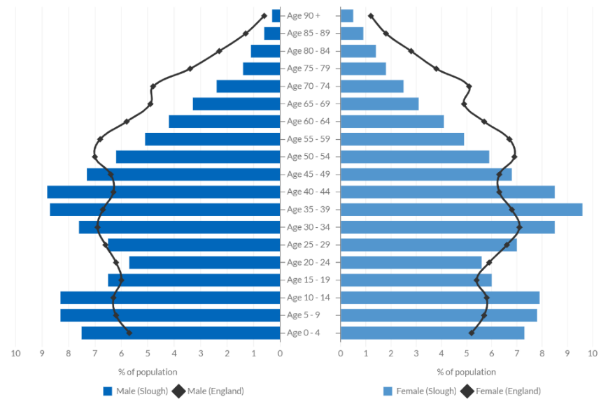
Slough has a diverse ethnic background. 56% of Slough’s population were born in the UK, whilst 24.3% were born in the Middle East and Asia, and 12.0% were born in the EU. 46.7% of Slough’s population are from Asian ethnic groups and 36.0% are from White ethnic groups. As such, there are a number of different languages spoken in Slough (only 72.7% speak English as their main language compared to 90.8% in England) and multiple different religions, with the top three being 32.0% Christian, 29.4% Muslim and 11.3% Sikh.

Deprivation
Deprivation is described in dimensions based on four key indicators, including education, employment, health and housing. A household is classified as deprived in the education dimension if no occupant has at least a level 2 qualification and no occupant aged 16 to 18 years old is a full-time student. A household is classified as deprived in an employment dimension if any member is unemployed or economically inactive due to long term sickness or disability (unless a full-time student). In terms of health, a household is classified as deprived if any person is in bad or very bad health, or is considered disabled in line with the Equality Act (2010). In a housing context, a household is considered deprived if the accommodation is overcrowded, in a shared dwelling or has no central heating.
The borough falls within the top 25% most deprived local authorities in England and is the 5th most deprived decile of local authorities in England, scoring highly in crime including violent crime. There has been a larger increase in economically inactive people than active people in Slough since 2011. There is a gap in income of £84 per week between Slough residents and those who commute into Slough for work.
Slough is more deprived than the England average of the 2019 Index of Multiple Deprivation (IMD), with 57.7% deprived in one or more dimensions. 71% of Slough’s Lower-tier Super Output Areas (LSOAs) fall below the national average of the IMD in 2021. Slough has a number of wards with high deprivation, with Chalvey considered one of the most deprived areas in the borough (see Figure 3.2 below). There are particularly severe areas of deprivation in Britwell, Chalvey, Herschel Park, Elliman, Wexham Court and Colnbrook with Poyle wards.
Figure 3.2: Distribution of areas of deprivation in Slough
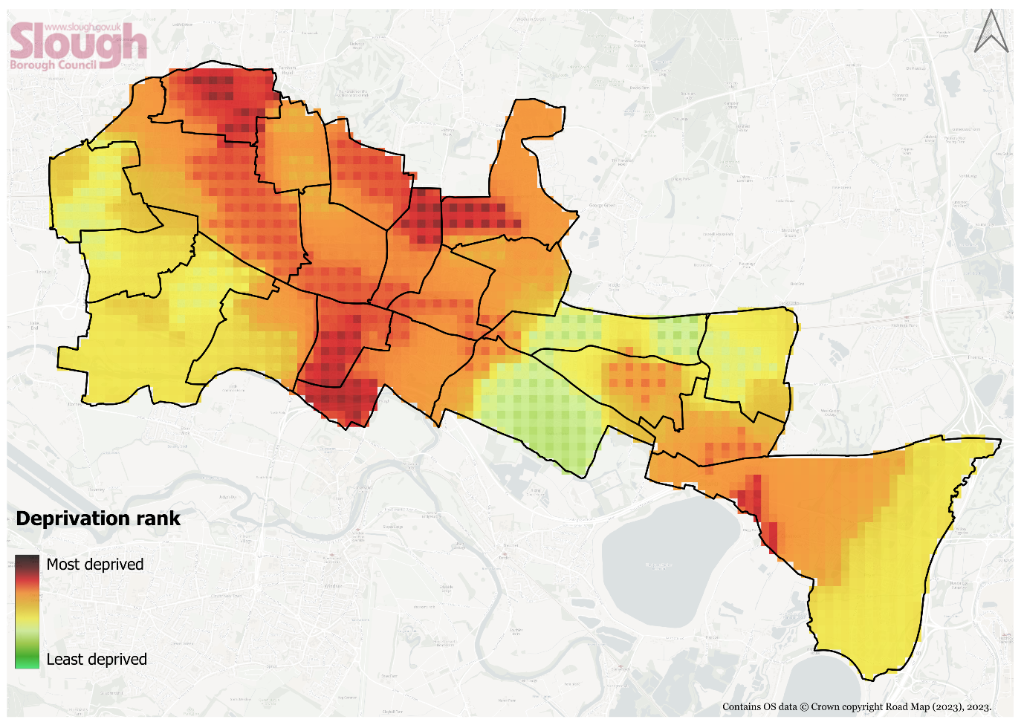

Public Health Context

Health in All Policies
Health and wellbeing is influenced by a range of different factors. The wider determinants of health are a diverse range of social, economic and environmental factors which influence a person’s mental and physical health (see Figure 3.3 below).
Figure 3.3: The wider determinants of Health
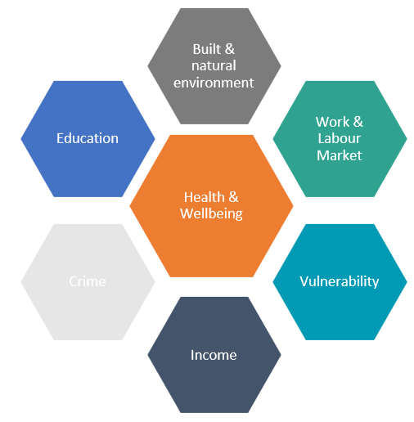
Source: Public Health Outcomes Framework
Relative contribution of determinants of health:
- 30% - Health Behaviours
- 40% - Socio-economic Factors
- 20% - Clinical Care
- 10% - Built Environment
Some areas of Slough have pockets of severe deprivation and poor environmental quality, with the built environment, open spaces, and air quality all suffering as a result. These factors all contribute to the health inequalities seen across the borough.

Slough is a relatively young town, with a high proportion of people aged 0-17 (28% of the population). When we compare the health and wellbeing of children in Slough to that of the rest of the country, a number of high priority areas emerge.

Mental health disorders in young people in Slough have risen, with 9.6% of young people aged 5 to 16 years in Slough having a mental health condition in 2015.
Slough also has high rates of physical inactivity. Being ‘Physically active’ is defined as undertaking a minimum of 150 moderate intensity equivalent minutes (2.5 hours) of physical activity per week, or 75 minutes of vigorous physical activity per week or an equivalent combination of the two, in bouts of 10 minutes or more in the previous 28 days. Data on this metric is obtained from the Active Lives Adult survey, conducted annually by Sport England.
The percentage of physically active adults in Slough is 51.6%, which is the lowest out of all England authorities (the next lowest after Slough is Blackburn with Darwen at 53.7%) and the average for the South (70.5%).
Physical inactivity is the 4th leading risk factor for global mortality accounting for 6% of deaths globally. People who have a physically active lifestyle have a 20% to 35% lower risk of cardiovascular disease, coronary heart disease and stroke compared to those who have a sedentary lifestyle. As such, Slough has high mortality rates attributed to cardiovascular diseases, with 108.9 deaths per 100,000 under 75 years old, and a high prevalence of obesity in Year 6 children over 28.4%, higher than the South East and England averages (Figure 3.4). Furthermore, 62% of adults in Slough were overweight or obese in 2020/21, which is approximately 71,112 people. Mortality rates of people under 75 years are significantly higher in areas such as Britwell & Northborough, Chalvey and Foxborough. Only 50% of Slough adults met the recommended 5-a-day fruit and vegetable portions per day in 2019/20.
Life expectancy in Slough is lower than the average for the rest of the South East and cardiovascular disease, obesity and diabetes are high. Slough also has high-rates of preventable ill health amongst children including obesity, tooth decay and higher levels of hospital admissions for long-term conditions such as asthma.
As a result, life expectancy for both men and women in Slough is below the England average. Looking at trends across the borough, life expectancy is 6 years lower for men and 4.4 years lower for women in the most deprived areas of the borough when compared to the least deprived areas.
Healthy life expectancy is a measure of the number of years a person can typically expect to live in full health without disabling illness or injury. In Slough, the healthy life expectancy for a male and female are 58.1 and 60.3 years old, respectively. This is significantly lower than neighbouring boroughs (Windsor and Maidenhead’s healthy life expectancy is 69.7 for males and 70.3 for females), and lower than the South East average (7.4yrs and 5.6yrs higher for males and females, respectively)
To put into context, boys born in Slough today can expect to live to 78 and will spend approximately 26% of their life in poor health (20 years). Girls born in Slough today can expect to live to 82 and will spend approximately 27% of their life in poor health (22 years).
Figure 3.4: Health statistics in Slough compared with the Royal Borough of Windsor and Maidenhead and the average for the South East
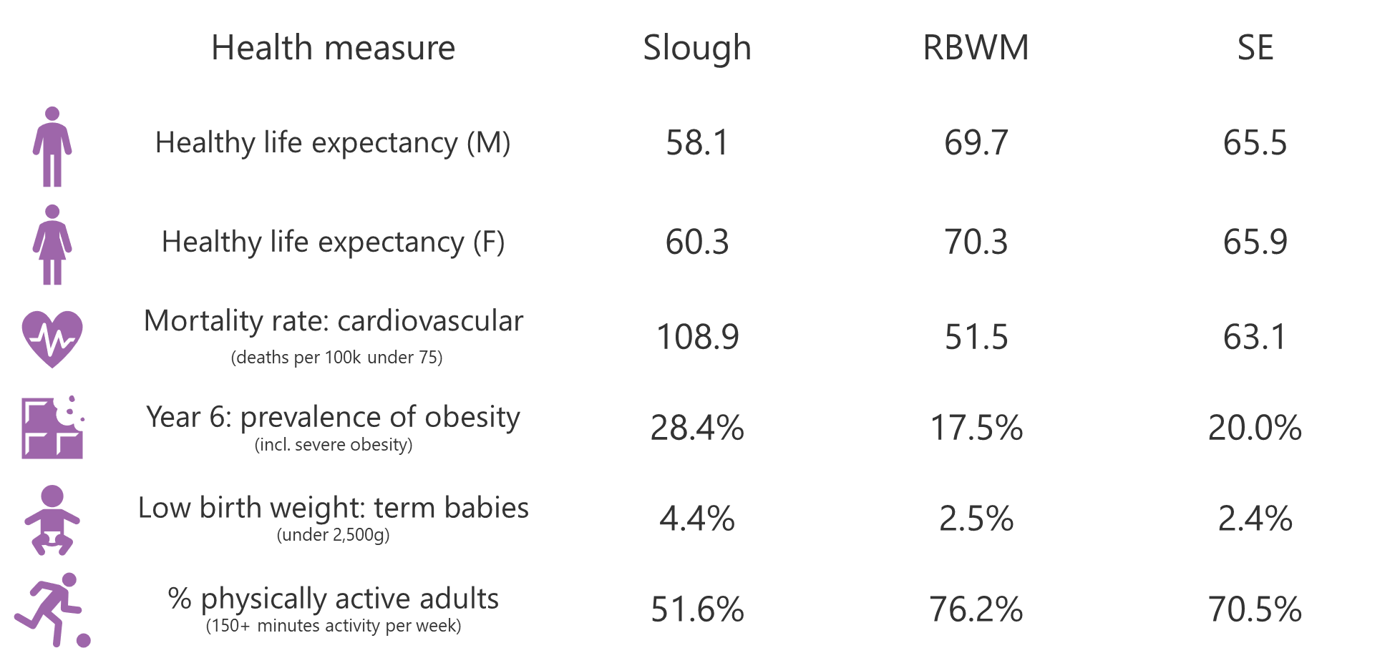
In 2021, 459 people in Slough died prematurely (aged under 75). This was 45% of all deaths in Slough, compared to 33% of deaths in England. The main causes of premature mortality in Slough were cancer and circulatory disease which accounted for 24% and 22% of premature deaths respectively (ONS, 2023).
There are inequalities in health, primarily between different areas of the borough and between different groups. In the context of air quality specifically, different groups can be disproportionately affected by exposure to pollutants:
- Children are particularly susceptible to poor air quality, as their lungs are underdeveloped, and they inhale more air per body weight than adults.
- Elderly people are also susceptible, as poor air quality can contribute towards an accelerated decline in lung function and increase risk of developing heart diseases.
- During a woman’s pregnancy, exposure to poor air quality increases the risk of term low birth weight and there is a growing evidence base between prenatal, early-life and childhood exposure to particulate matter and lung function during childhood.
- People in lower socio-economic groups are more likely to have existing health conditions that can be exacerbated by poor air quality, and are more likely to live in an area with high deprivation, and high traffic and industrial activity due to affordability.
Air pollution can have a significant impact on an individual’s health throughout their life, starting from before birth, into adulthood and in later stages of life. There is clear evidence that exposure to poor air quality can initiate and contribute towards the development of cardiovascular and respiratory diseases, including lung cancer. In children, exposure to poor air quality can result in slower development of lung functions, asthma and initiate atherosclerosis. In adulthood, these conditions can worsen, leading to coronary heart disease, chronic obstructive pulmonary disease and diabetes. Health impacts to elderly people can include issues with heart function including heart failure, heart attacks and strokes. PM_{2.5} specifically can directly cross the olfactory nerve and cause damage to the blood-brain barrier, affecting cognitive performance and increasing the risk of developing dementia.
In 2020, the first person in the world had air pollution listed as a cause of death on their death certificate and was a high profile case in air quality management. Matters of concern raised in the coroners report include existing concentrations of particulate matter being much higher than recommended WHO standards, which if reduced, would reduce the number of deaths from air pollution in the UK; low awareness of sources of information to allow individuals to reduce their personal exposure to poor air quality; and insufficient communication of the adverse effects of air pollution on health by medical and nursing professionals. These aspects have been considered in the development of this AQAP.

Additional air quality challenges
Slough’s strategic location in proximity to London and Heathrow, and the number of headquarters located in Slough makes it an attractive employment location, however due to low skilled workers being based on Slough, this results in a high proportion of workers who commute to Slough from elsewhere. This contributes towards high levels of congestion and worsens air quality for Slough’s residents.
Slough is also well connected via the Strategic Road Network (SRN), therefore the mode of choice for those travelling to and from Slough is more likely to be by private vehicle. High costs, accessibility issues and poor reliability associated with public transport discourages its use in favour of private vehicle use, which is typically seen as a more affordable and convenient travel option.
In addition to the challenges outlined in this section, there are certain behaviours and attitudes that are prominent in Slough that contribute towards a worsening of air quality and subsequently poor health. Appendix E.2 contains a review of prior consultations undertaken with Slough’s residents, from which the following can be drawn:
Vehicle use and ownership
- Residents support having a high quantity of private vehicles in Slough and public transport schemes have received little public support (Slough 2040 Vision engagement survey, 2020)
- Slough has a high proportion of households with one or more vehicles relative to its population density (79.7%) when compared with other high density areas including Reading (71.6%), Portsmouth (69.7%) and Southampton (72.6%). Likewise Slough has a lower proportion of households without access to a car or van (20.3%), compared to Reading (28.4%), Portsmouth (30.3%) and Southampton (27.4%) (ONS, 2021).
- Of respondents who engaged in the A4 cycle lane scheme consultation, 87% use private car to travel on the A4 compared to 14.7% by bus, for trips to shops (79.3%), social / leisure activities (58.7%) and work (54.3%). 71% of respondents said that the scheme would not encourage them to change to a different mode of travel (A4 Cycle Scheme Consultation, 2023).
- For school travel from 2018/19 to 2022/23, car sharing was the second most popular usual mode choice until 2021/22, when this was overtaken by the single child car mode. Single child car mode remains the second most popular usual mode choice, peaking at 38% in 2022/23 (Hands Up surveys, 2018-2023)
- Of residents who travel to work, the majority (71%) travel in a car or van, and often travel using this mode for short journeys under 10km (68%) (ONS, 2021).
Understanding and awareness
- There is a lack of understanding and awareness of the resources available to residents on healthy choices and how to access them, and the subsequent impact of behaviours on health, due to a lack of information promotion and engagement (healthy behaviours survey, 2022).
- In regards to awareness of air quality information, 62% of Slough respondents in the Thinks report (2023) were not aware of Heathrow’s Airwatch website and of that 62%, 44% voted that they would not be likely to visit it.
- Within schools, a strong link between sustainable travel and health is not apparent, with some schools not actively promoting active travel and others only participating in initiatives for one week of the year. The link between active travel and air quality was only apparent to one participating school in the School Engagement Survey (2024).
- In schools, 3 out of 9 who engaged in the school engagement survey said that they would not like to be kept informed of air quality trends and data, whilst 2 said that they would not like to be kept informed of active travel projects. Barriers to a lack of involvement in active travel initiatives include lack of resources and capacity, poor communication, and negative perceptions of active travel.
- Out of possible air pollutant sources, fireplaces (i.e. solid fuel burning) was not seen as a significant contributor towards poor air quality (selected by 2% of participants), which suggests much more engagement is needed to raise awareness of the dangers of wood burning (Thinks Report, 2023).
However, the review in Appendix E.2 has also highlighted the following positive outcomes:
- Improving children’s health is an important value for schools in Slough (school engagement survey, 2024) and children are motivated to travel sustainably (hands up surveys, 2018-2022).
- When asked about contributors to poor air quality, the majority of respondents (52%) voted that vehicle traffic contributes towards poor air quality, which suggests that Slough residents have a good understanding that road traffic is the dominant pollutant source in the borough.
- Slough residents have concerns about their weight (67.3%) and activity levels (65.8%), with a willingness to get active (77.8%), suggesting that there is appetite for active travel related schemes and projects (Healthy Behaviours Survey, 2022).
- Residents voted that cheaper sustainable travel (e.g discounted public transport), wider public transport links and better public transport infrastructure (70% in total) would encourage them to travel more sustainably (Thinks report, 2023).
- The community would like to be more involved in community engagement activities, with 72% agreeing, alongside useful engagement suggestions including community meetings, newsletters and surveys, showing an interest in involvement (Thinks Report, 2023).
Slough Borough Council’s most significant challenge is financial.
In July 2021, the Council’s S151 officer issued a Notice under Section 114 of the Local Government Finance Act (1988), that available resources are unlikely to meet planned budgetary demands in the financial year 2021/22. This has continued into 2022/23 and 2023/24, and it is expected that it will take a few more years to achieve a balanced budget alongside required annual savings targets. As a consequence, officer resource and capacity has significantly reduced, with two environment officers seconded to different roles in 2021, causing a delay to projects during 2022 and 2023.
This therefore impacts the delivery of actions outlined in Table 5.3. The Council however acknowledges that the seriousness of air quality impacts to the health of Sloughs residents cannot not be underestimated and will endeavour to deliver the actions outlined within the plan. Partnership working and exploring funding opportunities will be key in enabling the Council to deliver the action plan.

Planning and Policy Context
The following sections provide a summary of the national legislation and guidance, and local policy and strategy that has been considered in the development of the AQAP.

National Air Quality Management and Legislation
Legislation
In England, concentrations of key pollutants are regulated by the Air Quality Standards Regulations 2010, to control human exposure to pollutants by requiring concentrations to be within specified limit values. These limits are legally binding for concentrations in outdoor air for a number of major air pollutants that impact health, which includes nitrogen dioxide (NO₂) and particulate matter (PM₁₀ and PM_{2.5}). These Regulations consolidated the National Air Quality Objectives defined in the Air Quality (England) Regulations 2000 (amended 2002) and transpose the limits specified in the Ambient Air Quality Directive 2008 (2008/50/EC).
The Secretary of State for Environment, Food and Rural Affairs is responsible for meeting the limit values in England, whilst the national administrations in Scotland, Wales and Northern Ireland are responsible for their domains. Assessment of air quality and the production of air quality plans for the UK is coordinated by the Department for Environment, Food and Rural Affairs (Defra).
A summary of the air quality objectives relevant to Slough are provided in Table 3.1 below. Full details of all the UK air quality limits and the legislation they relate to are provided in Appendix G.

Table 3.1: Air Quality Objectives (AQOs) applicable to Slough
Pollutant | Air Quality Objective: Concentration | Air Quality Objective: Measured as
Nitrogen Dioxide (NO₂) | 200µg/m³ not to be exceeded more than 18 times a year | 1-hour mean
Nitrogen Dioxide (NO₂) | 40µg/m³ | Annual mean
Particulate Matter (PM₁₀) | 50µg/m³, not to be exceeded more than 35 times a year | 24-hour mean
Particulate Matter (PM₁₀) | 40µg/m³ | Annual mean
Particulate Matter  (PM_{2.5}) | 20µg/m³ | Annual mean
Particulate Matter  (PM_{2.5}) | 10µg/m³ not to be exceeded at any relevant monitoring station by 31st December 2040  Interim target: 12µg/m³ not to be exceeded at any relevant monitoring station by 31st December 2028 | Annual mean

The Environment Act 1995 (amended 2021) requires the Government to produce an Air Quality Strategy. The 2007 Air Quality Strategy was superseded by the Air Quality Strategy: Framework for Local Authority Delivery which was published by the UK Government in April 2023. The priorities defined within the Strategy include:
- Planning reforms helping to deliver on air quality.
- Building capacity in local councils through training, guidance and knowledge sharing.
- Reducing emissions from industrial sources through improved enforcement of environmental permits.
- Reducing pollution from domestic burning through smoke control areas and cleaner fuels.
- Raising awareness within local communities of air quality impacts and how to reduce them.
- Boosting active travel and public transport to improve air quality.
Part IV of the Environment Act 1995 (amended 2021) outlines Local Air Quality Management duties that local authorities must undertake. Local authorities are responsible for undertaking a review and assessment of air quality in their areas, to identify areas where national air quality objectives will not be achieved. Areas that are above legal limits or are likely to breach these limits, must be declared as an Air Quality Management Area (AQMA). Once an AQMA has been declared, the local authority is required to develop an Air Quality Action Plan (AQAP), setting out measures to improve air quality within the specified area in order to revoke the AQMA, and dates by which they will be carried out.
All local authorities are expected to take proactive action to improve air quality, whether or not they have an AQMA. Local authorities which have no active AQMAs are required to produce an Air Quality Strategy which details how compliance with air quality objectives will be maintained, therefore long term air quality management is a statutory duty and this requirement ensures that air quality management remains a high priority for local authorities.
National Planning Policy Framework (NPPF)
The National Planning Policy Framework outlines Government planning policy for land use in England. At the heart of the Framework is a ‘presumption in favour of sustainable development’, which in a plan-making context, requires plans to promote a sustainable pattern of development that seeks to improve the environment.
Air quality is a material consideration in the planning process, in line with the following paragraphs of the NPPF:
180. Planning policies and decisions should contribute to and enhance the natural and local environment by […]:
e) preventing new and existing development from contributing to, being put at unacceptable risk from, or being adversely affected by, unacceptable levels of soil, air, water or noise pollution or land instability. Development should, wherever possible, help to improve local environmental conditions such as air and water quality, taking into account relevant information such as river basin management plans;
192. Planning policies and decisions should sustain and contribute towards compliance with relevant limit values or national objectives for pollutants, taking into account the presence of Air Quality Management Areas and Clean Air Zones, and the cumulative impacts from individual sites in local areas. Opportunities to improve air quality or mitigate impacts should be identified, such as through traffic and travel management, and green infrastructure provision and enhancement. So far as possible these opportunities should be considered at the plan-making stage, to ensure a strategic approach and limit the need for issues to be reconsidered when determining individual applications. Planning decisions should ensure that any new development in Air Quality Management Areas and Clean Air Zones is consistent with the local air quality action plan.
The following paragraphs recognise the impact of traffic on air quality and health and the benefits of sustainable transport modes:
108. Transport issues should be considered from the earliest stages of plan-making and development proposals, so that: […]
c) opportunities to promote walking, cycling and public transport use are identified and pursued;
d) the environmental impacts of traffic and transport infrastructure can be identified, assessed and taken into account – including appropriate opportunities for avoiding and mitigating any adverse effects, and for net environmental gains; […]
109. Significant development should be focused on locations which
are or can be made sustainable, through limiting the need to travel and offering a genuine choice of transport modes. This can help to reduce congestion and emissions, and improve air quality and public health.
111. If setting local parking standards for residential and non-residential development, policies should take into account: […]
e) the need to ensure an adequate provision of spaces for charging plug-in and other ultra-low emission vehicles.
National Planning Practice Guidance (NPPG)
National Planning Practice Guidance (NPPG) provides advice to planning authorities on implementing the NPPF. The NPPG provides guidance on how planning can take account of the impact of new development on air quality and sets out the specific issues which may need to be considered when assessing air quality impacts. This include changes in vehicle emissions; the introduction of new point sources of air pollution; exposure of people to harmful concentrations of air pollutants, for example, by introducing further development in places with poor air quality; potentially unacceptable impacts during construction, and potential adverse effects on biodiversity. It also sets out guidance on the approach to assessment.
The PPG advises that mitigation options will:
- Need to be specific to the location
- Depend on the proposed development
- Need to be proportionate to the likely impact.
Planning conditions and obligations can be used to secure mitigation where the relevant tests are met. Examples of mitigation include: maintaining adequate separation between sources of air pollution and receptors; using green infrastructure; appropriate means of filtration and ventilation; electric vehicle charging points; controlling dust emissions from construction, operation and demolition, and contributing funding to measures designed to offset the impact of air quality arising from new development.

Local Policy and Strategy
A full review of the current and emerging plans, strategies and policies which have been considered in the development of the AQAP is provided in Appendix E.1. A summary of the key policy and strategy considered is summarised below.
The Local Development Plan (LDP) sets out the vision for how Slough should develop and the strategy to enable this vision. The LDP consists of a core strategy development plan, site allocations, policies and proposals. The core strategy development plan (adopted December 2008) outlines core policies, two of which are relate to air quality:
Core Policy 7 (Transport)
“Development proposals will…have to make provisions for:
Improving air quality and reducing the impact of travel upon the environment, in particular, climate change”.
A specific target within Core Policy 7 is for the annual mean NO₂ air quality levels to be 35µg/m³ by 2021. This target has unfortunately not been achieved however it will be re-established within the new AQAP, with a target date of 2028.
Core Policy 8 (Sustainability and The Environment)
‘All development in the borough shall be sustainable, of a high quality design, improve the quality of the environment and address the impact of climate change. Development shall not:
Give rise to unacceptable levels of pollution including air pollution, dust, odour, artificial lighting or noise”
Carbon Management
In 2021, the Council developed a Climate Change Strategy, following on from a Climate Change Motion declared in 2019. The Strategy sets a target of borough-wide carbon neutrality by 2040, with an ambitious stretch target of 2030. This target complies with the UK’s national target of net zero emissions by 2050 and a reduction of 78% of emissions by 2035 relative to 1990. Actions focus on carbon reduction in six key areas, including buildings, transport, waste, industry, energy supply and natural environment. The AQAP has been designed to support the Climate Change Strategy in regards to emission reduction.
Slough Low Emission Strategy (2018-2025)
The Slough Low Emission Strategy (2018-2025) forms part of the Slough AQAP and focuses on emission reduction and improvement. The LES lays out an integrated, year on year plan to improve air quality over the period until 2025, through a reduction in vehicle emissions by accelerating the uptake of cleaner fuels and technologies.
The key projects that were implemented or are planned to achieve the LES aims and objectives are represented in the LES Programme. Full details of such are provided in Appendix E.1.

Source Apportionment
The AQAP measures presented in this report are intended to be targeted towards the predominant sources of emissions within Slough Borough Council’s area.
A source apportionment exercise was carried out by Ricardo-AEA Ltd for the benefit of Slough Borough Council in late 2023.
Source apportionment was calculated for the year 2022 using the results of the 2022 baseline model (Appendix D) for road emissions, and Defra background maps for non-road emissions. The background maps were averaged across 1 x 1 km grid squares covering the entire Slough Borough area. Defra background maps provide estimates of background concentrations for specific pollutants based on the UK national compliance air quality model, which uses emissions data from the NAEI.
Further detail on the source apportionment study is included in Appendix C of this report. The results of the source apportionment study at each NO₂ diffusion tube location are shown in Appendix D.

NOx source apportionment
Source apportionment has been carried out for NO_{X} instead of NO₂ in order to assess the contributions from both road and background sources. The percentage contributions in emissions as NO_{X} are analogous to the contributions in emissions as NO₂.
Table 3.2 presents the average split of source apportionment for NOx, PM₁₀, and PM_{2.5} emissions across Slough, showing that an average of 46% of local NOx emissions are apportioned to road emissions. It is observed that for sites within AQMAs, on average, there is a higher contribution from road emissions than non-road emissions. The results of the study show that diesel cars were the greatest source of NO_{X} emissions (24.4%); followed by rural (18.0%), domestic (8.0%) and LGVs (7.5%) in 2022. Appendix D Section 3 presents the NO_{X} source apportionment splits for air quality monitoring sites with the highest NO₂ measurements in 2022.
Within each AQMA, the average percentage of source contributions from NOx have been calculated and are shown in Table 3.3. Non-AQMA sites have been split into industrial, kerbside and roadside sites.

Table 3.2 – Average split of source apportionment for NOx, PM₁₀ and PM_{2.5} emissions across Slough

Modelled road NOx emissions (Primary, Trunk and A roads) |  |  |  |  |  |  |  |  | Background NOx (from 2022 Defra background map)
Petrol cars | Diesel cars | Hybrid Petrol Cars | Hybrid Diesel Cars | Buses | LGVs | Rigid HGVs | Artic HGVs | Taxis | Minor Rd + Cold Start | Industry | Domestic | Aircraft | Rail | Other | Point Sources | Rural
4.3% | 24.4% | 0.2% | 0.3% | 1.8% | 7.5% | 2.8% | 1.4% | 3.2% | 6.5% | 4.8% | 8.0% | 3.1% | 5.4% | 5.2% | 3.0% | 18.0%
Modelled road PM₁₀ emissions (Primary, Trunk and A roads) |  |  |  |  |  |  |  |  | Background PM₁₀ (from 2022 Defra background map)
Petrol cars | Diesel cars | Hybrid Petrol Cars | Hybrid Diesel Cars | Buses | LGVs | Rigid HGVs | Artic HGVs | Taxis | Minor Rd + Cold Start | Industry | Domestic | Rail | Other | PM Secondary | Residual | Point Source
3.9% | 3.2% | 0.4% | 0.1% | 0.3% | 1.0% | 0.8% | 0.7% | 0.4% | 0.1% | 6.3% | 9.6% | 0.8% | 1.0% | 37.7% | 33.3% | 0.6%
Modelled road PM_{2.5} emissions (Primary, Trunk and A roads) |  |  |  |  |  |  |  |  | Background PM_{2.5} (from 2022 Defra background map)
Petrol cars | Diesel cars | Hybrid Petrol Cars | Hybrid Diesel Cars | Buses | LGVs | Rigid HGVs | Artic HGVs | Taxis | Minor Rd + Cold Start | Industry | Domestic | Rail | Other | PM Secondary | Residual | Point Source
3.3% | 2.9% | 0.3% | 0.1% | 0.2% | 0.9% | 0.6% | 0.6% | 0.3% | 0.2% | 3.7% | 13.9% | 0.1% | 1.5% | 47.9% | 22.7% | 0.8%

Table 3.3: NOx source apportionment by AQMA and non-AQMA areas
NOx Sources | AQMA 1 | AQMA 2 | AQMA 3 | AQMA 4 | Industrial | Kerbside | Roadside
Petrol cars | 5.4% | 3.8% | 4.7% | 4.2% | 2.5% | 4.5% | 3.4%
Diesel cars | 34.4% | 19.8% | 24.3% | 23.4% | 12.5% | 24.3% | 18.4%
Hybrid Petrol Cars | 0.3% | 0.2% | 0.2% | 0.2% | 0.1% | 0.2% | 0.1%
Hybrid Diesel Cars | 0.4% | 0.2% | 0.3% | 0.3% | 0.2% | 0.3% | 0.2%
LGVs | 11.8% | 8.3% | 8.7% | 5.9% | 0.4% | 0.8% | 2.2%
Rigid HGVs | 3.5% | 6.4% | 3.3% | 2.8% | 4.0% | 4.9% | 4.7%
Artic HGVs | 2.8% | 2.2% | 1.2% | 1.0% | 1.9% | 0.8% | 1.3%
Buses | 0.2% | 3.2% | 2.3% | 3.3% | 0.7% | 0.4% | 0.5%
Taxis | 2.5% | 2.4% | 3.0% | 4.9% | 1.6% | 4.2% | 2.9%
Minor Rd + Cold Start | 4.9% | 5.1% | 6.3% | 7.0% | 5.9% | 9.1% | 7.8%
Industry | 2.5% | 2.8% | 2.8% | 4.8% | 5.2% | 4.4% | 8.4%
Domestic | 6.0% | 6.3% | 8.3% | 9.0% | 6.2% | 10.8% | 9.3%
Aircraft | 1.8% | 6.0% | 1.4% | 1.9% | 17.1% | 1.9% | 3.3%
Rail | 2.8% | 2.4% | 9.5% | 6.5% | 1.5% | 4.4% | 7.8%
Other | 4.0% | 4.2% | 5.2% | 4.9% | 10.3% | 5.8% | 6.3%
Point Sources | 1.9% | 7.7% | 1.9% | 2.4% | 7.9% | 2.2% | 2.9%
Rural | 14.8% | 18.9% | 16.5% | 17.3% | 22.1% | 21.0% | 20.4%

PM₁₀ and PM_{2.5} source apportionment
For PM₁₀, the source apportionment study found that non-road emission sources, such as secondary PM (37.7%), residual (33.3%), and domestic heating (9.6%), are the key contributors to total emissions. Road emission sources only contributed to 10.6% of total PM₁₀ emissions in 2022.
Similarly, for PM_{2.5}, the key emissions sources are secondary PM (47.9%), residual (22.7%), and domestic heating (13.9%). Road emissions only contributed 9.3% of total PM_{2.5} emissions.
Within each AQMA, the average percentage of source contributions from PM₁₀ and PM_{2.5} are shown in Table 3.4 and Table 3.5 below, respectively.
Table 3.4: PM₁₀ source apportionment by AQMA and non-AQMA areas
PM₁₀ Sources | AQMA 1 | AQMA 2 | AQMA 3 | AQMA 4 | Industrial | Kerbside | Roadside
Petrol cars | 4.9% | 3.1% | 3.5% | 4.4% | 1.9% | 3.8% | 3.1%
Diesel cars | 4.7% | 2.3% | 2.7% | 3.4% | 1.4% | 2.9% | 2.4%
Hybrid Petrol Cars | 0.5% | 0.3% | 0.3% | 0.4% | 0.2% | 0.4% | 0.3%
Hybrid Diesel Cars | 0.1% | 0.0% | 0.1% | 0.1% | 0.0% | 0.1% | 0.0%
Buses | 0.0% | 0.5% | 0.3% | 0.6% | 0.1% | 0.1% | 0.3%
LGVs | 1.5% | 1.0% | 1.1% | 1.0% | 0.5% | 0.7% | 0.7%
Rigid HGVs | 1.1% | 1.7% | 0.8% | 0.6% | 0.5% | 0.2% | 0.3%
Artic HGVs | 1.5% | 1.0% | 0.5% | 0.4% | 0.3% | 0.1% | 0.2%
Taxis | 0.3% | 0.2% | 0.3% | 0.6% | 0.1% | 0.4% | 0.3%
Minor Rd + Cold Start | 0.1% | 0.1% | 0.2% | 0.2% | 0.1% | 0.2% | 0.1%
Industry | 4.9% | 5.2% | 4.9% | 6.4% | 3.5% | 5.7% | 8.8%
Domestic | 8.7% | 7.9% | 10.7% | 10.4% | 6.8% | 9.7% | 10.6%
Rail | 0.5% | 0.3% | 1.4% | 1.0% | 0.1% | 0.5% | 1.1%
Other | 0.9% | 0.8% | 1.2% | 1.0% | 1.8% | 1.0% | 1.1%
PM Secondary | 35.2% | 37.8% | 41.0% | 38.0% | 47.0% | 37.1% | 38.0%
Residual | 34.7% | 37.0% | 30.5% | 30.8% | 33.9% | 36.6% | 32.0%
Point sources | 0.5% | 0.6% | 0.7% | 0.5% | 1.7% | 0.5% | 0.6%

Table 3.5: PM_{2.5} source apportionment by AQMA and non-AQMA areas
PM_{2.5} Sources | AQMA 1 | AQMA 2 | AQMA 3 | AQMA 4 | Industrial | Kerbside | Roadside
Petrol cars | 4.3% | 2.6% | 3.0% | 3.7% | 1.6% | 3.2% | 2.6%
Diesel cars | 4.4% | 2.1% | 2.4% | 3.1% | 1.3% | 2.6% | 2.1%
Hybrid Petrol Cars | 0.4% | 0.3% | 0.3% | 0.4% | 0.2% | 0.3% | 0.2%
Hybrid Diesel Cars | 0.1% | 0.0% | 0.0% | 0.1% | 0.0% | 0.0% | 0.0%
Buses | 0.0% | 0.5% | 0.3% | 0.5% | 0.0% | 0.1% | 0.3%
LGVs | 1.4% | 0.9% | 0.9% | 0.9% | 0.4% | 0.6% | 0.6%
Rigid HGVs | 0.9% | 1.5% | 0.7% | 0.5% | 0.4% | 0.2% | 0.2%
Artic HGVs | 1.3% | 0.9% | 0.4% | 0.3% | 0.2% | 0.1% | 0.1%
Taxis | 0.3% | 0.2% | 0.3% | 0.6% | 0.1% | 0.4% | 0.3%
Minor Rd + Cold Start | 0.2% | 0.2% | 0.2% | 0.2% | 0.2% | 0.2% | 0.2%
Industry | 2.6% | 2.8% | 2.8% | 3.3% | 2.4% | 2.9% | 5.9%
Domestic | 12.8% | 11.7% | 14.4% | 15.1% | 8.4% | 14.3% | 15.3%
Rail | 0.1% | 0.1% | 0.3% | 0.2% | 0.0% | 0.1% | 0.2%
Other | 1.3% | 1.1% | 1.6% | 1.5% | 2.3% | 1.4% | 1.7%
PM Secondary | 45.5% | 48.9% | 50.1% | 48.5% | 52.9% | 47.9% | 48.2%
Residual | 23.7% | 25.5% | 21.5% | 20.4% | 27.6% | 24.9% | 21.2%
Point sources | 0.7% | 0.8% | 0.8% | 0.6% | 1.9% | 0.7% | 0.8%

As such, the Slough AQAP appropriately includes measures focusing on non-road emissions to reduce PM₁₀ and PM_{2.5} concentrations.

Required Reduction in Emissions

NOx and NO₂
From 2022 monitoring data, it was identified that one location in Slough (SLO 29, AQMA 4) exceeded the national NO₂ objective of 40 µg/m³ (44.2 µg/m³). The site is located at Yew Tree Road, where a large contribution to air pollution is attributed to congestion leading up to the A4 / A412 junction.
As shown in Appendix D, the largest contributor to NOx emissions at SLO 29 was diesel cars, responsible for 28.6% of total emissions.
Table 3.6 shows the required NOx reduction from road traffic in order to achieve compliance with the national annual mean NO₂ objective (40 µg/m³) at SLO 29. This has been calculated in accordance with Section 7.115 – 7.117 (and Box 7.6) of the LAQM Technical Guidance (TG22).
Table 3.6: Required reduction in NOx emissions from road traffic to achieve compliance at monitoring sites in exceedance (based on 2022 measured data)
Site ID | Measured NO₂  (µg/m³) | Required NO₂ reduction  (µg/m³) | Required NO₂ reduction  (%) | Background NOx  (µg/m³) | Road NO_{X}  (µg/m³) | Required road NO_{X}  (µg/m³) | Required Road NO_{X} reduction  (µg/m³) | Required Road NO_{X} reduction  (%)
SLO29 | 44.2 | 4.2 | 9.5 | 22.72 | 57.55 | 47.66 | 9.89 | 17.2

PM₁₀ and PM_{2.5}
Slough collects data from nine automatic monitoring sites measuring PM₁₀ and three monitoring PM_{2.5}. In 2022, roadside monitoring sites measured PM₁₀ between 19.8µg/m³ (SLH 12) and 23.1µg/m³ (SLH 11). There are no roadside sites in Slough measuring PM_{2.5}; however, the industrial site SLH 9 measured an annual mean concentration of 7.6 µg/m³ in 2022.
Dispersion modelling from the baseline study (Appendix D) shows that PM₁₀ and PM_{2.5} concentrations across the borough were well below the national air quality objectives.
The highest modelled PM₁₀ concentration in 2022, using a global adjustment factor, was 19.58 µg/m³ (SLO 93, SLO 94, SLO 95), and for PM_{2.5} the highest concentration was 12.21 µg/m³ (SLO 52). As such, there are no required reductions in particulate matter emissions in order to comply with air quality objectives. However, due to the severity of health impacts associated with particulate matter exposure, Slough Borough Council aims to reduce emissions of these pollutants for the benefit of improving the health of Slough’s residents.

Key Priorities
Through the implementation of the AQAP, Slough Borough Council seek to achieve two key aims:
- Achieve a boroughwide NO₂ target concentration of <35µg/m³ by 2028
- Revoke all of Slough Borough Council’s declared AQMAs by 2030
These aims will be achieved by focusing on the following priority areas and objectives:
Priority 1 - Environment: emission management and emission source reduction:
EO-1: Undertake statutory duties to monitor, review and manage air quality.
EO-2: Ensure that air quality is a key consideration in all planning applications and support the Council's clean air ambitions at new developments.
EO-3: Reduce vehicle and building emissions associated with Council operations.
EO-4: Reduce emissions from staff e.g. vehicles associated with Council staff 'grey' fleet to improve air quality and meet CO₂ targets.
EO-5: Reduce emissions from public transport by implementing emission standards via partnerships and promoting ULEV use.
EO-6: Work in partnership with stakeholder groups to reduce emissions from vehicles and buildings.
EO-7: Work in collaboration with council officers to deliver the Air Quality Action Plan & LES Programme and promote the air quality agenda.

Priority 2 – Transport: traffic management and infrastructure to support modal shift
TO-1: Implement major infrastructural change, focusing on active travel, public transport and traffic management.
TO-2: Increase uptake on public transport.
TO-3: Manage vehicle parking in Slough to achieve balance between accommodating growth and managing congestion.
TO-4: Implement traffic management measures to improve traffic flow and manage congestion.
TO-5: Improve the uptake of walking and cycling by making active travel an attractive travel option.
Priority 3 – Health Education & Awareness: improving the air quality knowledge base across the borough
HEAO-1: Work in partnership with communities, businesses, schools, and healthcare establishments to improve air quality.
HEAO-2: Improve information dissemination to the public regarding air quality.
HEAO-3: Improve education and awareness of air quality to promote healthy choices in relation to physical activity, transport, energy efficiency, smoke control and indoor air quality.

4 Development and Implementation of Slough Borough Council’s AQAP

Consultation and Stakeholder Engagement
In developing this AQAP, we have worked with other agencies, businesses and the local community to improve local air quality. Schedule 11 of the Environment Act 1995 requires local authorities to consult the bodies listed in Table 4.1.
In addition, we have undertaken the following stakeholder engagement:
- Website (Citizen Space)
- Articles in local newspaper
- Questionnaires distributed directly to households along major roads
The response to our consultation stakeholder engagement is given in Appendix A: Response to Consultation.
Table 4.1 ‒ Consultation Undertaken
[all of the consultees below will be contacted for comment]
Consultee | Consultation Undertaken
The Secretary of State | <Yes/No>
The Environment Agency | <Yes/No>
The highways authority | <Yes/No>
All neighbouring local authorities | <Yes/No>
Other public authorities as appropriate, such as Public Health officials | <Yes/No>
Bodies representing local business interests and other organisations as appropriate | <Yes/No>

Steering Group
The steering group was initiated in July 2023 and included representatives and officers from the following areas:

- Carbon & Sustainability
- Sustainable Transport
- Highways Development
- Transport Planning
- Parking
- Taxi Licensing
- Public Health
- Development Management
- Planning Policy
- Housing
- Strategy & Policy
- Lead Member for Environment

Due to the S114 and ongoing service restructures, there has been constant change in personnel, department organisation and structure. As such, at the outset of the AQAP development it was not feasible to meet with all participants from different service areas in the form of a combined steering group as it would not have resulted in targeted discussion. Meetings were therefore held on a one to one basis with department representatives, often with multiple officers attending each meeting, in addition to correspondence over email.
In total, from July 2023 when the project initiated to January 2024, there have been 19 one to one meetings across departments including Development Management, Transport Planning, Highways Development, Parking, Carbon & Sustainability, Public Health and Communications. Meetings were also held with the Lead Member for the Environment, Environmental Services and Open Spaces, and external stakeholders including Heathrow Airport Ltd and SEGRO.
The steering group members assisted in shaping the measures included in the AQAP, taking into consideration the Council’s current financial position.

5 AQAP Measures
Table 5.3 shows the Slough Borough Council AQAP measures. It contains:
- a list of the actions that form part of the plan
- the responsible individual and departments/organisations who will deliver this action
- estimated cost of implementing each action (overall cost and cost to the local authority)
- expected benefit in terms of pollutant emission and/or concentration reduction
- the timescale for implementation
- how progress will be monitored
- colour coding to indicate which are expected to result in the greatest air quality impacts as identified in the scenario modelling (Appendix D).
NB: Please see future ASRs for regular annual updates on implementation of these measures
The measures outlined within Table 5.3 align with the key priorities outlined in Section 3.6 under broad categories of Environment, Transport, and Health Education & Awareness.

Measures selection process
The identification of measures to be included in the core AQAP has been through a rigorous process. The steps taken are outlined below:
- Review of all existing plans, policies and strategies which may have an influence on air quality, for inclusion in a long list of potential measures (see Appendix E.1 for the full review)
- Focused one to one meetings with steering group members to ascertain which of those measures are outdated, or no longer valid or relevant (as some strategies and plans are old and have not been replaced) and to raise any existing measures not currently represented within existing strategies and plans
- Review of the Air Quality Hub resources, to include measures for consideration that other local authorities are delivering but have not been considered by Slough Borough Council.
- Application of a matrix / rating system of the measures list in collaboration with steering group members, based on potential for reduction in pollution, technical feasibility of delivery, implementation timeframe, cost and funding (see Table 5.1). This resulted in a ‘viability score’ which determined how viable it would be to deliver the measures (Table C.2 – C.4).
- Initial measure scoping, to prioritise measures which had the highest rated positive impact on air quality (rated 1). Measures which focused on schools (HEA1) were consolidated, as collectively they have a more significant air quality impact than if delivered individually.
- Final measure scoping, based on the final viability score, to form the ‘core’ AQAP measures list. Scores which exceeded 16 were considered unviable and are presented in Table B.1. These measures will be promoted to the core AQAP measures list (Table 5.3) should the viability of the measure change. This will be assessed annually and will be presented within the ASR.
The full short and long lists of measures are presented in Appendix C.
Table 5.1: Scoring matrix for measures assessment
Potential for reduction:
Score | Rating | Description
1 | High | Measure actively results in positive air quality impact
2 | Medium | Measure has knock on impact of improved air quality or helps to stop air quality worsening
3 | Low | Indirect air quality impact that supports air quality improvement, such as monitoring and promotion
Technical feasibility:
Score | Rating | Description
1 | Highly feasible | Relatively simple to implement
2 | Medium feasibility | Some technical challenges
3 | Low feasibility | Technically complex

Implementation timeframe:
Score | Rating | Description
1 | Very short | <6 months
2 | Short | 6-12 months
3 | Medium | 1-2 years
4 | Long | >2 years
Cost:
Score | Rating | Description
1 | Very low | <£10K
2 | Low | £10K-£50K
3 | Medium | £50K-£100K
4 | High | £100K-£500K
5 | Very high | >£500K
Funding source:
Score | Description
0 | Grant / Section 106 / no cost to the Council
5 | Partially Council funded or grant funded
10 | Full Council funded (general fund) or no funding available
Viability score:
Score | Description
0-10 | Highly viable
10-15 | Possibly viable
>16 | Not likely to be viable

Following AQAP publication, the immediate actions to deliver include preparing the AQAP implementation plan and updating the Low Emission Strategy. The AQAP consultation shall inform the implementation plan.
Some of the measures presented have already begun implementation. For example, the internal stakeholder steering group for public health, active travel and air quality (Sustainability and Health) was initiated February 2024 as a result of this action plan development. This steering group and its members will oversee the implementation of the AQAP actions.
It should be noted also that Table 5.3 presents the measures which have the biggest impact on air quality and are viable for the Council to deliver. This does not mean however that actions presented in Appendix C will not be pursued, as comparatively lower impact measures, for example those focusing on information dissemination, will still be effective in moving towards cleaner air quality. The implementation plan will consider these measures in conjunction with the core AQAP measures.

Summary of Measures

Environment
Emission standards for major contracts (EM3)
The Council will lead by example, by reducing vehicle emissions from its major contracts, where vehicle use is inherent in the contract. The standards to be implemented are as follows:
- A minimum standard of Euro VI/6 (fleet profile) – Euro 6 for fleet defined as LDV (Vehicles below 3.5 tonnes) and Euro VI for fleet defined as HDV (Vehicles above 3.5 tonnes)
- A 10% uptake of electric, hybrid and gas of the total fleet profile (by 2025, rising to 25% of the total fleet profile by 2028)
- A 3% reduction per annum CO₂ targets for fleet emissions
- A 3% reduction per annum of fuel saving targets fleet emissions
Update to the Slough Low Emission Strategy (EM6)
The Slough Low Emission Strategy is due to be updated with tightened emission controls, electric vehicle charging standards and construction emissions to incorporate increased standards and provision over time.
All new developments will be required to adhere to the updated Low Emission Strategy. The update is due to commence following approval and publishing of this AQAP.
Electric vehicle charging (EM7, EM8, EM9)
The Council is publishing an EVCI Strategy in April 2024. Slough has not previously had any detailed operational strategy or policy for the deployment and management of EV charging infrastructure, despite owning an existing network of 20 public EV charge points installed over the past five to 10 years. During this time, the commercial charge point operator market has seen strong growth especially in providing rapid and ultra-rapid charge points, capturing demand for charging in 15 minutes to one hour. The Council expects the commercial sector to continue to lead in this area but will support through the planning process.

The Council has a role in taking a strategic view to ensure a balanced public charging network that does not just serve the most commercially viable locations. As Highway Authority and major landowner, the Council is ideally placed to work with the private sector charge point providers to boost the availability of charging closer to residential areas that need it. The majority of current EV drivers charge their vehicles mainly at home. However, only approximately 60% of Slough households will have access to off-street charging at their home address, and only approximately 20% of households reliant on public charging are within five minutes walking distance of an existing charge point.

The EVCI Strategy targets 80% of households reliant on public charging being within five minutes walking distance of an existing charge point. For these residential areas, lower powered slow or fast charging is likely to be the predominant charging type in on-street locations. Due to the layout and characteristics of Slough, on-street charging may not be feasible in all areas of demand. The Strategy, while principally focused towards this type of on-street charging, also seeks to plan for off-street charging hubs (fast and rapid) to supplement the network.

The EVCI Strategy is underpinned by funding from the LEVI scheme: £401K revenue funding from the LEVI Capability Fund; and £2.233m of capital funding from the Capital Fund. The funding terms and conditions require the Council to use the grant to leverage private investment to at least double the funding available.

The Council will also look at off-street charging provision across its own assets to supplement the wider public network. Some sites may be included within the LEVI scheme, others may be by commercial arrangement.

Slough Electric Vehicle Car Club (EM10)
As at December 2023 the Council is in receipt of £78.5k for public EV charging and £149k for car club schemes, with a further £1.681m in future S.106 Obligations, to support the electric vehicle car club programme. The intention is to provide people in Slough an alternative travel option that does not require them to have a private vehicle, but can have all of the associated benefits such as convenience and access. This scheme will be initiated once the EVCI Strategy has been published.
Taxi emission reduction (EM11, EM12, EM19)
Within the Low Emission Strategy, minimum emission standards for both hackney carriages and private hire vehicles were set that comply with national clean air requirements and promote ULEVs. In 2023, the Taxi Licensing Policy was updated with this requirement removed, following concerns raised by the taxi trade. Additional concerns regarding the lack of infrastructure to support the trade’s transition to cleaner vehicles were raised, therefore it is imperative that projects to provide charging infrastructure and support access to vehicles are delivered prior to reinstating emission requirements.
Slough Borough Council are currently in receipt of £370,035 from the Defra Air Quality Grant Fund towards an electric taxi and private hire vehicle demonstration project. The project is designed to assist the borough’s taxi and private drivers to make the transition to ultra low emission vehicles, and give approximately 50 drivers the opportunity to use electric vehicles for up to 90 days to experience driving them in a professional capacity. Other ways drivers were to be encouraged to switch included providing grants to new and existing electric car users towards operating costs to offset the initial higher outlay compared to traditional fuel vehicles.
The Council is also in receipt of £157,500 capital grant funding from OZEV for taxi priority rapid charging infrastructure, awarded in 2017/18 and 2018/19 under the Ultra Low Emission Vehicle Taxi Scheme. The scheme is intended to support a high growth rate in plug-in taxis and the use of smart technology to link taxi operators with charging infrastructure and customers. The funding was for 50% of capital costs of seven rapid chargers to be match funded by the Council from the Capital Programme for the remaining purchase and installation costs.
Due to the Section 114 and the subsequent impact on officer resource, these projects have not yet been delivered. To support the taxi trade transition to cleaner vehicles, it is paramount that these projects are delivered. Options to achieve this will be explored once officer resources are available.
Low emission heating (EM14, EM15)
As identified in the source apportionment study, a portion of air pollutants are attributed to domestic heating systems. As such, the AQAP includes measures to support a reduction of emissions from gas boilers. Slough Borough Council will support the delivery of government funded retrofit projects such as the Home Upgrade Grant (HUG2). The HUG2 scheme intends to reduce energy consumption by upgrading homes following a ‘fabric first’ approach, such as applying insulation and upgrading windows. Creating more energy efficient homes will reduce emissions as less heat is lost through the fabric of the building. This scheme is currently active and is due to be complete by 2025.
In addition, Slough has one of the largest quantities of datacentres in Europe, and this is continuing to expand in particular with the renewal of the Slough Trading Estate Simplified Planning Zone, which is due in 2024. As such, there are opportunities to work with a commercial partner to utilise the waste heat that datacentres generate (in the Trading Estate and elsewhere) and in conjunction, reduce carbon emissions and air pollutants associated with Slough’s heating systems. As such, a measure has been included to support the implementation of District Heating plans to reduce emissions from heating systems.

Transport
Slough Electric Cycle and Scooter Infrastructure and Hire programme (TM1)
The Slough Cycle Hire scheme launched in 2013 and grew to a total of 17 cycle hire stations throughout the town, to cater for users who did not own a bicycle and to accommodate short journeys. This enabled users to dock the bikes across Slough, including at Slough and Burnham train stations, on the Slough Trading Estate and in popular shopping areas in Langley. The scheme closed on 1st July 2022, in anticipation of a new cycle scheme to be implemented in 2024.
The new scheme is intended to be a modernised scheme which will include docking locations for e-bikes and e-scooters. The scheme will be phased to focus on rail stations initially and will be expanded to include docking hubs in key locations including the town centre, Wexham Park Hospital and SEGRO, which meet the standards and direction outlined in the Cycling and Walking Investment Strategy LTN 1/20.
Cycle lane schemes (TM4, TM5, TM6)
In 2020, Slough Borough Council was awarded funding from the Emergency Active Travel Fund, to provide an experimental bus lane along the A4 from Huntercombe Roundabout to Uxbridge Road.
The scheme was introduced to allow for social distancing measures and the reprioritisation of road space for pedestrians and cyclists as outlined in the government’s Emergency Active Travel Fund (EATF) guidance. The DfT provided funding to introduce active travel schemes using the EATF grant. Public transport provision was a subsequent step in preparing for the opening of the town after the easing of lockdown restrictions. The scheme provided a ‘whole route’ approach to create a bus and cycle corridor, implemented with a consideration of the wider context of increasing traffic levels and congestion in the town
The consultation period for the scheme was live from 4 December 2020 to 31 August 2021, and was followed by a review period to assess whether the bus lane should be made permanent.
On 17 January 2022, the Council agreed to make the A4 bus lane permanent and incorporated the operational changes made on 4 December 2020, with the addition of permitting zero emission vehicles displaying green number plates.
Following on from this scheme, Slough Borough Council was awarded £10.4m by the Department for Transport’s (DfT) Active Travel Fund, towards the development of a cycle highway that runs alongside the bus lane on the A4. The lane will be an off-road, continuous, mostly segregated route between Huntercombe Lane and Uxbridge Road, with associated road safety improvements along the A4 (Safer A4 scheme). The route will be 2.5m wide to accommodate two-way cycle movements and is intended to increase cycle usage in Slough.
In addition, work is ongoing to deliver the schemes outlined within the LCWIP. This includes the Burnham Station to A4 via Station Road cycle lane, and the Foxborough cycle lane between Langley High Street and Junction 5 Footbridge. The intention of these schemes is to provide people who work and live in Slough a safe cycle route, to encourage more to travel via active modes.
Implement Destination Farnham Road scheme (TM7)
The Destination Farnham Road scheme aims to improve the public realm of Farnham Road between its junctions with Essex Avenue and Sheffield Road, enhance the landscape of the area, restore a sense of place, and identify Farnham Road as a distinctive location by strengthening and communicating the area’s character and identity. The scheme also includes improvements to cycling infrastructure, access to local shops and businesses for users of all modes of transport, and a reduction of car dominance. Reallocating road space will reinforce the area’s identity as a key destination, improve connectivity to and around the district centre by sustainable modes of transport, and improve road safety outcomes.
Parking controls (TM9, TM10, TM11)
Over the last 10 years, developers have been granted permission for residential developments with low levels of car parking provision, with nil provision permitted for residential developments in the town centre and designated shopping centres. The developments were permitted due to the council aspirations to reduce road congestion, air pollution and encourage active travel (as per Local Plan Policies T2 and Core Policy 7). However, developers have not been successful in encouraging low levels of car ownership, and on-street car parking problems have been recorded on Stoke Poges Lane, Herschel Street, Mills Street and Lyons Way outside developments with low levels of car parking. This results in safety issues for pedestrians due to reduced pavement space and blocking of visibility splays which increases risk of accidents.
Analysis of car ownership data from the 2021 Census (Table 5.2) showed that Slough town centre was the only area of Slough with less than one car per dwelling (0.7). The 2021 Census showed that densely populated areas such as central London boroughs also do not have ‘Nil’ car ownership, despite these boroughs having better access to public transportation systems, cycle superhighways and greater density of shopping facilities.
Table 5.2: Car ownership per dwelling in town centres (March 2021)
Town Centre | Dwellings | Total Cars | Cars per Dwelling
Kings Cross and St Pancras | 4469 | 1053 | 0.24
City of London | 4913 | 1355 | 0.28
London Euston | 2719 | 861 | 0.32
London Paddington (016) | 3803 | 1224 | 0.32
London Paddington (015) | 3981 | 1701 | 0.43
Reading Town Centre | 3379 | 1774 | 0.53
Watford Town Centre | 5150 | 3772 | 0.73
Slough Town Centre (011F) | 615 | 415 | 0.67
Slough Town Centre (016) | 2953 | 2301 | 0.78
Maidenhead Town Centre | 6265 | 5621 | 0.90
Woking Town Centre | 5036 | 4973 | 0.99
Uxbridge Town Centre | 4339 | 4343 | 1.00
Hayes and Harlington | 3683 | 4142 | 1.12
West Drayton | 3489 | 3937 | 1.13
Staines Town Centre | 4009 | 4653 | 1.16
Bracknell Town Centre | 5036 | 6387 | 1.27

Slough Transport officers will therefore be producing a new parking strategy in relation to new developments in the town centre, to more effectively manage pavement parking, whilst supporting the aims of the AQAP.
In addition to updating parking standards, to assist in emission reduction it is proposed that options to integrate emissions based charging into car parking, parking permits and season tickets is explored. As such, a measure to investigate the feasibility of such options is included as a measure in the action plan.
Parking enforcement officers in London boroughs have powers available to them to enforce anti-idling. The feasibility of introducing anti-idling measures in Slough will be investigated, with an intention to target idling hotspots such as taxi ranks and outside of schools.
Traffic management (TM15)
A strengthening evidence base on the impact of speed on vehicle emissions suggests that lower speeds which enable a continuous flow of traffic can result in air quality improvements,,. As such, a measure has been included in the action plan, to explore use of traffic calming measures within AQMAs. This is already being partially implemented through the Safer A4 scheme, which will provide an opportunity to evaluate impacts on concentrations within AQMA 4. If effective, this may be rolled out to other suitable AQMAs.

Health Education and Awareness
Health, air quality and transport are closely interlinked. Reducing car use in place of public transport and active travel reduces the number of polluting vehicles on the road network, resulting in improvements in air quality. This results in Slough’s residents being able to breathe cleaner air and reduce their risk of cardiovascular and respiratory illnesses. In addition, increasing active travel increases the physical activity of Slough’s residents, which leads to more positive health outcomes and helps to reduce the number of residents suffering from obesity and related illnesses. All of these measures together improve the wellbeing of those who live and work in Slough. As such, the following measures are those which are cross-departmental and will be most effective when delivered in collaboration.
Smarter Travel Programme (HEA1a)
The Smarter Travel Programme was initiated as part of the Access Fund programme, however in recent years following the pandemic and the S114, much of the programme has not been delivered. Implementation of the action plan will re-launch this initiative, focusing on improving active travel uptake with businesses, schools, healthcare establishments and local communities.

Travel Planning (HEA1b)
As part of the Smarter Travel Programme, the Council will work with businesses (over certain employee counts) and schools to develop Travel Plans, supported by development of a Slough Borough Council travel plan toolkit. The toolkit will include templates, advice on best practice for developing travel plans, and suitable measures to increase alternative means of travel and active travel, for example by identifying safety routes and smarter travel options, and employment maps to show sustainable access routes to major employment locations. Individual toolkits will be prepared for each partnership group with supporting resources available online, and optional support from the Council in developing bespoke travel information.
Road safety education and training (HEA1c)
Training and education are required to improve public confidence and uptake of smarter travel initiatives. As such, a training and education plan will be developed, which will outline how training and educational initiatives will be delivered, and how it will result in increased uptake. This will include delivery of cycle training such as Bikeability (for both adults and children) and will have a focus on deprived areas and minority ethnic communities. It will also include a user training programme for the A4 cycle lane scheme to ensure users understand how to use the new system. Support may be sought from partners such as emergency services, to assist in the delivery of safety educational activities, for example in schools.
In terms of delivery of both the travel plan toolkit and training programme, it is anticipated that a trial focusing on key areas in poor air quality hotspots will be implemented and subsequently evaluated before wider roll out.
Events Delivery Plan (HEA1d)
There are a number of programmes that can be delivered across sustainable transport, environmental sustainability and public health. Currently, event planning is sporadic and not delivered in collaboration with service areas. To ensure an effective and joint approach, an events delivery schedule will be developed, which presents a suite of events to be delivered that calendar year. This will consider events across all potential stakeholder groups, including schools, businesses, healthcare establishments and community groups.

School Partnership (HEA1e)
As improving the health of children in Slough is a key ambition of the new Corporate Plan, the aim of the school partnerships would be to improve health of pupils by increasing physical activity through active travel initiatives. Measures to be implemented through the school partnerships include:
- Commitment to measures which raise awareness of air quality such as Clean Air Day, Walk to School Week, Bike to School Week. This can be combined with other initiatives e.g. anti-idling, car free days, school streets and play streets.
- Support information dissemination by incorporating air quality awareness into the school syllabus such as science, maths and geography lessons.
- Introduction of Modeshift STARs for all schools.
- Roll out School Streets across the borough (5 permanent by 2025).
Roadside emission exposure campaign (HEA1f)
A part of the school partnership programme includes campaigns which actively engage teachers, parents and children in air quality, to improve their understanding and equip them to make healthy choices. A measure in the action plan is therefore to deliver an air quality campaign that specifically focuses on school commutes and exposure reduction solutions. This will be delivered in conjunction with Public Health and Sustainable Transport.
Table 5.3 ‒ Air Quality Action Plan Measures
Measure No. | Measure | Category | Classification | Estimated Year Measure to be Introduced | Estimated / Actual Completion Year | Organisations Involved | Funding Source | Defra AQ Grant Funding | Funding Status | Estimated Cost of Measure | Measure Status | Target Reduction in Pollutant / Emission from Measure | Key Performance Indicator | Progress to Date | Comments / Potential Barriers to Implementation
1  (EM3) | Set minimum emission standards for all major contracts | Promoting low emission transport | Company vehicle procurement - prioritising uptake of low emission vehicles | 2025 | Ongoing | Carbon & Sustainability Team | General fund | No | Funded | <£10k | Planning | Reduced concentrations from HGVs and LGVs. Measures contributes to 0.5µg/m³ reduction in NO₂ (see Appendix D) | Number of contractor vehicles with improved emissions | . Implemented for repairs and maintenance contracts for Housing and operational buildings, but not yet implemented for council owned fleet | Requirement of LES. For Council operations, barriers include cost of low emission vehicles, and operability barriers (e.g. for RCVs, EVs tested and consulted other local authorities, range is lower, therefore raises risk to service delivery). Contracts with third parties more likely to be feasible.
2 (EM6) | Update to the Slough Low Emission Strategy | Policy guidance and development control | Low Emissions Strategy | 2024 | 2025 | Carbon & Sustainability Team | General fund | No | Funded | <£10k | Implementation | Reduced concentrations from HGVs and LGVs. Measures contributes to 0.5µg/m³ reduction in NO₂ (see Appendix D) | Number of new developments with strengthened mitigation | In progress. Research piece has been initiated to inform new standards | Potential conflicts with Planning regarding development viability, otherwise none
3 (EM7) | Creation of a strategic Slough public charge point network (residential) | Promoting low emission transport | Procuring alternative Refuelling infrastructure to promote Low Emission Vehicles, EV recharging, Gas fuel recharging | 2024 | 2027 | Carbon & Sustainability Team, commercial delivery partner | Local Electric Vehicle Infrastructure (LEVI) fund | No | Funded | £1m-£10m | Planning | Reduced emissions from private vehicles. Measure contributes to following pollutant reductions:  NO₂: 1.61µg/m³  PM₁₀: 0.19µg/m³  PM_{2.5}: 0.12µg/m³  CO₂: 102 kt (12.6%)  (see Appendix D) | Number of charging points installed, number of charges per charging point | Strategy currently in development, due to be published April 2024 | No expected barriers
4 (EM8) | Implement EV (rapid and fast) off-street and car park programme | Promoting low emission transport | Procuring alternative Refuelling infrastructure to promote Low Emission Vehicles, EV recharging, Gas fuel recharging | 2024 | 2027 | Carbon & Sustainability Team, commercial delivery partner | Local Electric Vehicle Infrastructure (LEVI) fund | No | Partially Funded | £1m-£10m | Planning | Reduced emissions from private vehicles. Measure contributes to following pollutant reductions:  NO₂: 1.61µg/m³  PM₁₀: 0.19µg/m³  PM_{2.5}: 0.12µg/m³  CO₂: 102 kt (12.6%)  (see Appendix D) | Number of charging points installed, number of charges per charging point | Strategy currently in development, due to be published April 2024 | No expected barriers
5 (EM9) | Implement EV (rapid and fast) on-street programme | Promoting low emission transport | Procuring alternative Refuelling infrastructure to promote Low Emission Vehicles, EV recharging, Gas fuel recharging | 2024 | 2027 | Carbon & Sustainability Team, commercial delivery partner | Local Electric Vehicle Infrastructure (LEVI) fund | No | Funded | £1m-£10m | Planning | Reduced emissions from private vehicles. Measure contributes to following pollutant reductions:  NO₂: 1.61µg/m³  PM₁₀: 0.19µg/m³  PM_{2.5}: 0.12µg/m³  CO₂: 102 kt (12.6%)  (see Appendix D) | Number of charging points installed, number of charges per charging point | Strategy currently in development, due to be published April 2024 | No expected barriers
6 (EM10) | Develop and implement an electric car club across the borough | Alternatives to private vehicle use | Car clubs | 2025 | 2026 | Carbon & Sustainability Team, commercial delivery partner | Section 106 | No | Funded | £500k-£1m | Planning | Reduced emissions from private vehicles. Measure contributes to following pollutant reductions:  NO₂: 1.61µg/m³  PM₁₀: 0.19µg/m³  PM_{2.5}: 0.12µg/m3  CO₂: 102 kt (12.6%)  (see Appendix D) | Number of journeys undertaken by car club vehicle | Officer for programme delivery in place, due to be developed after EV Strategy. | Barriers may include location availability, development conflicts
7 (EM11) | Deliver Defra funded taxi demo project | Promoting low emission transport | Taxi emission incentives | 2024 | 2026 | Carbon & Sustainability Team, Taxi Licensing Team, taxi trade | Defra | Yes | Funded | £100k-£500k | Planning | Reduced emissions from taxis. Measure contributes to the following pollutant reductions:  NO₂: 2.61µg/m³  PM₁₀: 0.21µg/m³  PM_{2.5}: 0.18µg/m³  CO₂: 143 Kt (18.7%)  (see Appendix D) | Number of electric vehicle taxi registrations | No progress to date. Intending to recommence project planning Q4 2024 | Potential barrier may be low interest / uptake due to perceived costs of electric vehicles
8 (EM12) | Install a network of rapid charging facilities to support plug-in taxis | Promoting low emission transport | Procuring alternative Refuelling infrastructure to promote Low Emission Vehicles, EV recharging, Gas fuel recharging | 2025 | 2027 | Carbon & Sustainability Team, commercial delivery partner | Office for Zero Emission Vehicles (OZEV), Section 106 | No | Funded | £1m-£10m | Planning | Reduced emissions from taxis. Measure contributes to the following pollutant reductions:  NO₂: 2.61µg/m³  PM₁₀: 0.21µg/m³  PM_{2.5}: 0.18µg/m³  CO₂: 143 Kt (18.7%)  (see Appendix D) | Number of charging points installed, number of charges per charging point | Not started | Main constraint currently is officer resource. Project will recommence once resource is available.
9 (EM14) | Support delivery of government funded retrofit projects (e.g. HUG2) | Policy guidance and development control | Other | 2024 | 2025 | Carbon & Sustainability, Community Engagement and Housing Teams, GSENZH, Agility ECO | Department for Energy Security and Net Zero (DESNZ) | No | Funded | £500k-£1m | Implementation | Reduced emissions from buildings due to better heat retention (not modelled) | Number of referrals made and installs completed | Referrals for scheme have begun, will be supported by internal promotion | Currently devising targeting plan to communicate effectively with residents
10 (EM15) | Support implementation of District Heating plans | Promoting low emission plant | Other | 2024 | 2028 | Development Management, Planning Policy and Carbon & Sustainability teams, developers, commercial delivery partner | Commercially led | No | Not Funded | £1m-£10m | Planning | Reduced emissions from buildings as removes need for gas boilers (not modelled) | Developer engagement, business cases produced | Proposals being developed, will need developer support to implement
11 (EM19) | Re-introduce minimum emission standards for taxis | Promoting low emission transport | Taxi licensing conditions | 2026 | 2027 | Carbon & Sustainability and Taxi Licensing teams, taxi trade | General fund | No | Not Funded | £10k-£50k | Planning | Reduced emissions from taxis. Measure contributes to the following pollutant reductions:  NO₂: 2.61µg/m³  PM₁₀: 0.21µg/m³  PM_{2.5}: 0.18µg/m³  CO₂: 143 Kt (18.7%)  (see Appendix D) | Number of low emission taxi registrations | No progress to date. Re-introduction will be considered after successful delivery of Defra funded taxi project
12 (TM1) | Implement Slough Electric Cycle and  Scooter Infrastructure and Hire programme | Transport Planning and Infrastructure | Public cycle hire scheme | 2024 | Ongoing | Sustainable Transport and Transport Planning and commercial partner | Commercially led | No | Not Funded | £1m-£10m | Implementation | Reduced emissions from private vehicles. Measure contributes to following pollutant reductions:  NO₂: 1.61µg/m³  PM₁₀: 0.19µg/m³  PM_{2.5}: 0.12µg/m³  CO₂: 102 kt (12.6%)  (see Appendix D) | Number of hire events and distance travelled | In progress. Procurement for delivery partner has initiated, due for launch in April 2024 | Provided by Zipp Mobility. Scheme includes docking for e-bikes and e-scooters. Delivery will be phased, starting with train stations, and look to expand following evaluation
13 (TM4) | Cycle scheme from Burnham Station to A4 via Station Road | Transport Planning and Infrastructure | Cycle network | 2025 | 2025 | Sustainable Transport and Transport Planning teams | Active Travel England | No | Funded | £1m-£10m | Implementation | Reduced emissions from private vehicles. Measure contributes to following pollutant reductions:  NO₂: 1.61µg/m³  PM₁₀: 0.19µg/m³  PM_{2.5}: 0.12µg/m³  CO₂: 102 kt (12.6%)  (see Appendix D) | Number of cyclists | In progress, due to be delivered 2024 | Includes full segregated cycle lane and traffic signals for cyclists
14 (TM5) | Foxborough Cycle Lane between Langley High Street and Junction 5 Footbridge | Transport Planning and Infrastructure | Cycle network | 2024 | 2024 | Sustainable Transport and Transport Planning teams | Berkshire Local Transport Body | No | Funded | £1m-£10m | Implementation | Reduced emissions from private vehicles. Measure contributes to following pollutant reductions:  NO₂: 1.61µg/m³  PM₁₀: 0.19µg/m³  PM_{2.5}: 0.12µg/m³  CO₂: 102 kt (12.6%)  (see Appendix D) | Number of cyclists | Widening in progress and due to be completed February 2024 | In progress, no expected barriers
15 (TM6) | Introduce segregated A4 cycle highway (including provision of cycle docking) | Transport Planning and Infrastructure | Cycle network | 2024 | 2026 | Sustainable Transport and Transport Planning teams | Active Travel England | No | Funded | >£10m | Implementation | Reduced emissions from private vehicles. Measure contributes to following pollutant reductions:  NO₂: 1.61µg/m³  PM₁₀: 0.19µg/m³  PM_{2.5}: 0.12µg/m³  CO₂: 102 kt (12.6%)  (see Appendix D) | Number of cyclists, number of accidents | Consultation complete in September 2023, planning phase underway. Due to commence April 2024. | Safer A4 Scheme being implemented simultaneously with A4 cycle scheme. Includes speed cameras, removing guard rails and adding traffic signals (due April 2024).
16 (TM7) | Implement Destination Farnham Road scheme | Promoting travel alternatives | Intensive active travel campaign & infrastructure | 2024 | 2026 | Sustainable Transport and Transport Planning teams | Department for Levelling Up, Housing and Communities | No | Funded | >£10m | Implementation | Reduced emissions from private vehicles. Measure contributes to following pollutant reductions:  NO₂: 1.61µg/m³  PM₁₀: 0.19µg/m³  PM_{2.5}: 0.12µg/m³  CO₂: 102 kt (12.6%)  (see Appendix D) | Number of cyclists | Cabinet report due in May 2024, for scheme commencement in July. | Consultation concluded Feb 2024 - over 400 responses received. Changes following consultation currently being considered.
17 (TM9) | Review parking controls and policies in regards to new developments | Policy guidance and development control | Other policy | 2024 | 2025 | Parking team | General fund | No | Funded | <£10k | Planning | Reduces number of vehicles, may assist in modal shift (measure not modelled specifically) | Number of parking spaces, PCNs for parking enforcement | Not started | Potential barrier may be capacity issues with parking, conflicts between need to reduce parking and issues with pavement parking due to lack of provision
18 (TM10) | Investigate the feasibility of introducing anti-idling controls in hotspot areas | Traffic management | Anti-idling enforcement | 2025 | 2026 | Parking team | General fund | No | Not Funded | £50k-£100k | Planning | Reduces emissions from idling vehicles, may be particularly effective at taxi ranks and schools (measure not modelled specifically) | Discussions held with relevant stakeholders; decision made on measure implementation | Not started | Local authorities outside of London have limited enforcement powers, so may be difficult to enforce
19 (TM11) | Investigate the feasibility of implementing charging or banding levels for car parking, parking permits (residents, businesses etc) and season tickets based on CO₂ emissions from vehicles | Traffic management | Emission based parking or permit charges | 2025 | 2026 | Parking team | General fund | No | Not Funded | <£10k | Planning | Reduces emissions from private vehicles (not modelled) | Discussions held with relevant stakeholders; decision made on measure implementation | Not started | Currently being considered by the Parking team
20 (TM15) | Explore use of traffic calming measures within Air Quality Management Areas | Traffic management | Reduction of speed limits, 20mph zones / other | 2024 | 2028 | Carbon & Sustainability, Transport Planning teams | Not currently funded. Requires grant support | No | Not Funded | £10k-£50k | Planning | Reduces emissions from vehicles travelling on major roads (not modelled specifically) | Measured impact on NO2 concentrations | Some traffic calming (speed reduction) is being introduced on the A4 as part of Safer A4 scheme. Exploration of traffic calming measures for other AQMAs not started | Some AQMAS (AQMA 3 for example) already have 30mph speed limit imposed, so limited options to reduce further. Enforcement challenges exist
21 (HEA1a) | Redevelop and relaunch Smarter Travel Programme | Promoting travel alternatives | Other | 2025 | 2025 | Carbon & Sustainability, Transport, Sustainable Transport and Public Health teams | Active Travel England, General fund | No | Funded | £10k-£50k | Planning | Reduced emissions from private vehicles. Measure contributes to following pollutant reductions:  NO₂: 1.61µg/m³  PM₁₀: 0.19µg/m³  PM_{2.5}: 0.12µg/m³  CO₂: 102 kt (12.6%)  (see Appendix D) | Number of participants | Not started | Programme existed under the Access Fund / Capability Fund, however lack of officer resource has affected delivery. Partnership working across departments has been initiated to support this programme
22 (HEA1b) | Develop travel plan toolkit for businesses, schools, healthcare establishments and local communities | Promoting travel alternatives | Personalised travel planning | 2025 | 2025 | Carbon & Sustainability, Transport, Sustainable Transport and Public Health teams | Active Travel England, General fund | No | Funded | £10k-£50k | Planning | Reduced emissions from private vehicles. Measure contributes to following pollutant reductions:  NO₂: 1.61µg/m³  PM₁₀: 0.19µg/m³  PM_{2.5}: 0.12µg/m³  CO₂: 102 kt (12.6%)  (see Appendix D) | Number of website hits, number of plans developed | Not started | Potential barrier may be capacity issues - will be addressed by joint steering group
23 (HEA1c) | Launch a road safety education and training programme for businesses, schools, healthcare establishments and local communities | Promoting travel alternatives | Other | 2025 | Ongoing | Carbon & Sustainability, Transport, Sustainable Transport and Public Health teams | Active Travel England, General fund | No | Funded | £10k-£50k | Planning | Reduced emissions from private vehicles. Measure contributes to following pollutant reductions:  NO₂: 1.61µg/m³  PM₁₀: 0.19µg/m³  PM_{2.5}: 0.12µg/m³  CO₂: 102 kt (12.6%)  (see Appendix D) | Number of participants, number of cyclists on main cycle routes | Not started | Potential barrier may be capacity issues - will be addressed by joint steering group
24 (HEA1d) | Develop an events delivery plan for businesses, schools, healthcare and communities | Promoting travel alternatives | Other | 2025 | Ongoing | Carbon & Sustainability, Transport, Sustainable Transport and Public Health teams | Active Travel England, General fund | No | Funded | <£10k | Planning | Reduced emissions from private vehicles. Measure contributes to following pollutant reductions:  NO₂: 1.61µg/m³  PM₁₀: 0.19µg/m³  PM_{2.5}: 0.12µg/m³  CO₂: 102 kt (12.6%)  (see Appendix D) | Number of participants engaging and taking part in events | Not started | No barriers expected as measure focuses on partnership working
25 (HEA1e) | Establish a school partnership to increase physical activity through active travel initiatives and raising air quality awareness through the school system | Promoting travel alternatives | Other | 2025 | Ongoing | Carbon & Sustainability, Transport, Sustainable Transport and Public Health teams and schools | Active Travel England, General fund | No | Funded | <£10k | Planning | Reduced emissions from private vehicles. Measure contributes to following pollutant reductions:  NO₂: 1.61µg/m³  PM₁₀: 0.19µg/m³  PM_{2.5}: 0.12µg/m³  CO₂: 102 kt (12.6%)  (see Appendix D) | Number of participants in school active travel initiatives | Not started | Potential barrier may be capacity issues, and lack of school interest
26 (HEA1f) | Deliver a campaign focusing on roadside emissions including emission and exposure reduction solutions | Promoting travel alternatives | Intensive active travel campaign & infrastructure | 2025 | 2026 | Carbon & Sustainability, Transport, Sustainable Transport and Public Health teams and schools | Active Travel England, General fund | No | Not Funded | <£10k | Planning | Reduced emissions from private vehicles. Measure contributes to following pollutant reductions:  NO₂: 1.61µg/m³  PM₁₀: 0.19µg/m³  PM_{2.5}: 0.12µg/m³  CO₂: 102 kt (12.6%)  (see Appendix D) | Hands up survey monitoring travel mode change | Not started | Delivery is dependent on funding availability

Colouring code key: light green = high air quality impact; yellow = medium air quality impact; blue = impact not modelled.

Appendix A: Response to Consultation
Table A.1 ‒ Summary of Responses to Consultation and Stakeholder Engagement on the AQAP
Consultee | Category | Response
[To be completed following consultation].

Appendix B: Reasons for Not Pursuing Action Plan Measures
Table B.1 ‒ Action Plan Measures Not Pursued and the Reasons for that Decision
Action category | Measure ID | Action description | Reason action is not being pursued (including Stakeholder views)
Policy Guidance and Development Control | EM1 | Take all opportunities during refurbishment works to install the most energy efficient plant and building operation methods, include energy efficiency into asset management plans and develop a sustainable energy model/plan (CMP priority 1) | Poor viability score (see Appendix C.1)
Policy Guidance and Development Control | EM2 | Continue implementation of RE:FIT Programme (Energy efficiency and renewable energy refurbishment scheme) to improve the energy efficiency of Council corporate building estate. | Poor viability score (see Appendix C.1)
Promoting Low Emission Transport | EM4 | Improve emissions from the council's operational fleet, including waste and recycling, light commercial and community service fleet | Poor viability score (see Appendix C.1)
Promoting Low Emission Transport | EM5 | Support implementation of HDV gas station Programme | Poor viability score (see Appendix C.1)
Freight and Delivery Management | EM13 | Explore with freight/ logistics operators the potential for a freight consolidation centre to cater for town centre deliveries. | Poor viability score (see Appendix C.1)
Vehicle Fleet Efficiency | EM16 | Support introduction of electric buses on the network, by continuing to support short term electric bus route trials and develop proposals to deliver the electric bus A4 smart service programme | Poor viability score (see Appendix C.1)
Alternatives to private vehicle use | EM17 | Decarbonise Slough Borough Council vehicle fleet by promoting electric vehicles and explore feasibility of expanding the pool fleet programme (electric cars and e-bikes) | Poor viability score (see Appendix C.1)
Alternatives to private vehicle use | EM18 | Explore feasibility of implementing a hire car scheme for longer out of Borough journeys | Poor viability score (see Appendix C.1)
Promoting travel alternatives | TM2 | Provide secure undercover cycle storage with welfare/repair facilities in strategic locations e.g. within an existing building such as community hubs or shopping centre. | Poor viability score (see Appendix C.1)
Promoting travel alternatives | TM3 | Introduce cargo bikes into the network for businesses and residents | Poor viability score (see Appendix C.1)
Transport planning and infrastructure | TM8 | Review feasibility of implementing further pedestrian zones to encourage walking & alfresco dining (e.g. timed zones from 10:30am - 5:00pm, York City Centre) | Poor viability score (see Appendix C.1)
Transport planning and infrastructure | TM12 | Continue to develop a bus rapid transport network with high frequency services along the A4 Bath Rd, London Rd and to Heathrow | Poor viability score (see Appendix C.1)
Vehicle fleet efficiency | TM13 | Seek funding opportunities to migrate to zero bus emission fleet in coordination with neighbouring authorities, and seek funding to investigate the feasibility of different types of technology to establish cost effective means of decarbonising the bus fleet | Poor viability score (see Appendix C.1)
Transport planning and infrastructure | TM14 | Invest in Superbus networks: a comprehensive network of bus priority measures, fares caps, increased service frequencies. | Poor viability score (see Appendix C.1)
Transport planning and infrastructure | TM16 | Undertake junction improvement review at Yew Tree Road. Will include review of causes of issues at junction, identification of solutions, evaluation of options and delivery | Poor viability score (see Appendix C.1)
Traffic management | TM17 | Invest in Urban Traffic Management and Control (UTMC) systems on A4 corridor and other roads | Poor viability score (see Appendix C.1)
Traffic management | TM18 | Explore greater use of variable message signs and other technology to guide drivers (e.g. to reduce circulating car park traffic in the town centre, directing vehicles to under-utilised car parks), implement temporary speed limits and inform drivers of incidents | Poor viability score (see Appendix C.1)

Appendix C: Full Measures and Matrix Scoring
Table C.1: Full Short List of Measures
Objective | Theme | Objective / Measure /Action | Policy / Strategy Alignment | Affected AQMAs | Potential for Reduction | Technical Feasibility | Timeframe | Cost | Funding | Viability Score | Comment / Justification
EO3 | Operational emissions (vehicles) | Set minimum emission standards for all major contracts including maintenance, where vehicle use is inherent in the contract (EM3) | LES, LTP3, FC, CMP, AQAP 3&4 | All | 1 | 2 | 3 | 1 | 0 | 7 | Positive AQ impact, not technically challenging, may take time to integrate requirement into procurement, no cost to Council
EO3 | Operational emissions (vehicles) | Improve emissions from the council's operational fleet, including waste and recycling, light commercial and community service fleet | LES | All | 1 | 2 | 3 | 3 | 10 | 19 | Positive AQ impact, not technically difficult. ULEVs may be cost prohibitive unless leased, but there may be cheaper, cleaner alternatives. Needs further work to understand costs.
EO4 | Staff emissions | Explore feasibility of implementing a hire car scheme for longer out of Borough journeys | FC | All | 1 | 2 | 3 | 4 | 10 | 20 | Further reduces need for staff to travel to work or use car for work purposes, so has direct AQ impact, however not funded so on hold
EO4 | Staff emissions | Decarbonise SBC vehicle fleet by promoting electric vehicles and explore feasibility of expanding the pool fleet programme (electric cars and e-bikes) | CMP, FC | All | 1 | 3 | 3 | 4 | 10 | 21 | Expanding pool fleet reduces need for staff to drive to work so has direct AQ impact, however currently no funding to support expansion of pool fleet so currently on hold.
EO5 | Bus emissions | Support introduction of electric buses on the network, by continuing to support short term electric bus route trials and develop proposals to deliver the electric bus A4 smart service programme | LES | AQMA 4 | 1 | 3 | 4 | 5 | 10 | 23 | Electric buses would improve AQ however technically difficult due to lack of available charging infrastructure, expensive, likely to take time to develop solutions. No funding currently but future options may be available via government funding competitions (Zebra) and working in close partnership with bus operators and TfL
EO5 | Taxi emissions | Re-introduce minimum emission standards for both hackney carriages and private hire vehicles that comply with national clean air requirements and promote ULEVs (EM19) | LES, TL | All | 1 | 3 | 4 | 2 | 0 | 10 | Measure actively reduces taxi emissions, however challenging to implement and will take time to integrate back into policy. Currently on hold.
EO6 | Operational emissions (buildings) | Take all opportunities during refurbishment works to install the most energy efficient plant and building operation methods, include energy efficiency into asset management plans and develop a sustainable energy model/plan (CMP priority 1) | CMP | All | 1 | 2 | 4 | 3 | 10 | 20 | Likely to result in positive AQ impact, some technical challenges. Refurbishment works take time to implement and are likely to be expensive to install initially, but result in savings later. Only viable if fully grant funded, therefore currently on hold
EO6 | Operational emissions (buildings) | Continue implementation of RE:FIT Programme (Energy efficiency and renewable energy refurbishment scheme) to improve the energy efficiency of Council corporate building estate. | CMP | All | 1 | 3 | 4 | 4 | 10 | 22 | Likely to result in positive AQ impact, some technical challenges. Refurbishment works take time to implement and are likely to be expensive to install initially, but result in savings later. Only viable if fully grant funded, therefore currently on hold
EO6 | Partnerships - Businesses (trip reduction) | Explore with freight/ logistics operators the potential for a freight consolidation centre to cater for town centre deliveries. | AQAP3&4 | All | 1 | 3 | 3 | 4 | 10 | 21 | Direct positive AQ impact, but consolidation centre likely to have technical challenges, take time to implement and be expensive. Would need to be commercially led or grant funded to be viable - no funding available currently
EO6 | Partnerships - Communities | Support residents of Slough to reduce heating emissions through government funded retrofit projects such as the Home Upgrade Grant (HUG2) scheme (EM14) | CMP | AQMA 3 +Ext, AQMA 4 | 1 | 3 | 3 | 5 | 0 | 12 | HUG2 scheme can help to reduce domestic portion of background emissions. Scheme overall is technically challenging spanning 1-2 years, but grant funded
EO6 | Partnerships - Communities / Businesses | Support District Heating plans (EM15) | CCS | AQMA 3 +Ext, AQMA 4 | 1 | 2 | 4 | 5 | 0 | 12 | Reduces domestic portion of background emissions, some technical challenges but likely to take 2+ years to implement at high cost, although expected cost covered by supplier
EO7 | LES Programme | Update the Slough Low Emission Strategy with tightened emission controls, electric vehicle charging standards and construction emissions to incorporate increased standards and provision over time (EM6) | LES | All | 1 | 1 | 2 | 1 | 0 | 5 | Results in AQ improvements (but lesser degree than other measures as it only applies to new developments), not technically challenging, may take time to refresh, no cost to the Council
EO7 | LES Programme | Install a network of rapid charging facilities to support a high growth rate in plug-in taxis and the use of smart technology to link taxi operators with charging infrastructure and customers (EM12) | LES | All | 1 | 3 | 3 | 5 | 0 | 12 | Direct positive AQ impact, technically challenging and programme will exceed 2+ years. Expensive but grant funded.
EO7 | LES Programme | Support implementation of HDV gas station Programme | LES Programme | All | 1 | 3 | 4 | 5 | 10 | 23 | Direct positive AQ impact, some technical challenges and expensive for Council to deliver, but support Grundons for private investment
EO7 | LES Programme | Creation of a strategic Slough public charge point network that ensures electric car users reach their destination through a simplistic access, usage and payment model (EV Infrastructure Programme) (residential) (EM7) | LES, LES Programme | All | 1 | 3 | 3 | 5 | 0 | 12 | Direct positive AQ impact, technically challenging and programme will exceed 2+ years. Expensive but grant funded.
EO7 | LES Programme | Implement EV (rapid and fast) off-street and car park Programme - all new town centre car parks should provide fast electric charging points (EM8) | LES, LES Programme, PSSD | All | 1 | 3 | 3 | 5 | 0 | 12 | Direct positive AQ impact, technically challenging and programme will exceed 2+ years. Expensive but grant funded (partially secured)
EO7 | LES Programme | Implement EV (rapid and fast) on-street Programme - Rapid chargers will be provided on-street in appropriate locations in the town centre and across the borough to support a greater uptake of EVs (EM9) | LES, LES Programme, PSSD | All | 1 | 3 | 3 | 5 | 0 | 12 | Direct positive AQ impact, technically challenging and programme will exceed 2+ years. Expensive but grant funded.
EO7 | LES Programme | Develop and implement an electric car club across the borough - residential developments with nil or low car parking provision should contribute to development of car clubs in Slough (includes provision of on-street car club bays) (EM10) | LES, LES Programme, AQAP3&4, PSSD, TV | All | 1 | 3 | 3 | 5 | 0 | 12 | Direct positive AQ impact, technically challenging and programme will exceed 2+ years. Expensive but S106 funded.
EO7 | LES Programme | Deliver Defra funded taxi demo project, to encourage and support the taxi trade in transitioning to electric vehicles (EM11) | LES | All | 1 | 3 | 3 | 5 | 0 | 12 | Direct positive AQ impact, technically challenging and programme will exceed 2+ years. Expensive but grant funded.
HEAO1 | School partnerships & healthy choices | Collective delivery of school active travel initiatives including smarter travel for school measures (school streets, Bikeability, sustainable travel campaigns), development of clean air plans, emission exposure and reduction campaign (HEA1a-f) | ST, LTP3, LES Programme | All | 1 | 3 | 3 | 3 | 5 | 15 | Direct positive AQ impact specific to schools. Feasibility affected by officer time. Cost of whole measure expected to be medium, but some funding is already avaiable. Expected to take time to implement.
TO1 | Infrastructure - Active Travel | Cycle scheme from Burnham Station to A4 via Station Road (TM4) | LCWIP | AQMA 3 +Ext & 4 | 1 | 3 | 3 | 5 | 0 | 12 | Direct AQ impact, challenging, costly and expected to take 1-2 years to implement, but fully funded by Active Travel England
TO1 | Infrastructure - Active Travel | Foxborough Cycle Lane between Langley High Street and Junction 5 Footbridge (TM5) | LCWIP | AQMA 2 | 1 | 3 | 3 | 5 | 0 | 12 | Direct AQ impact, challenging, costly and expected to take 1-2 years to implement, but fully funded by the Berkshire LEP
TO1 | Infrastructure - Active Travel | Introduce segregated A4 cycle highway (including provision of cycle docking) (TM6) | LCWIP | AQMA 3 +Ext & 4 | 1 | 3 | 4 | 5 | 0 | 13 | Strongly positive AQ impact. Technically challenging, time consuming to implement and high cost, but grant funded (Active Travel England)
TO1 | Infrastructure - Active Travel | Implement the Destination Farnham Road scheme to improve the pedestrian and cycling environment (TM7) | STIP | AQMA 3 +Ext & 4 | 1 | 3 | 4 | 5 | 0 | 13 | Strongly positive AQ impact. Technically challenging, time consuming to implement and high cost, but grant funded (Department for Levelling Up, Housing and Communities)
TO1 | Infrastructure - Public Transport | Continue to develop a bus rapid transport network with high frequency services along the A4 Bath Rd, London Rd and to Heathrow | STIP, BSIP, TV | AQMA 2-4 | 1 | 3 | 3 | 5 | 5 | 17 | Positive AQ impact as encourages bus use resulting in fewer private vehicle trips. Currently under review, some bus lanes may be adjusted. 24/7 Farnham Rd bus lane will be amended to peak time only, for consistency with other bus lanes in the borough.
TO2 | Public transport | Seek funding opportunities to migrate to zero bus emission fleet in coordination with neighbouring authorities, and seek funding to investigate the feasibility of different types of technology to establish cost effective means of decarbonising the bus fleet | BSIP | All | 1 | 2 | 3 | 5 | 10 | 21 | Positive AQ impact, technically challenging due to limited infrastructure, time and costly to implement. No funding opportunities available currently, but may be options via government funding competitions (Zebra) and working in close partnership with bus operators and TfL
TO2 | Public transport | Invest in Superbus networks: a comprehensive network of bus priority measures, fares caps, increased service frequencies. | BSIP | All | 1 | 3 | 3 | 5 | 10 | 22 | Positive AQ impact but technically challenging, time and costly to implement. No funding or support currently.
TO3 | Parking | Review parking controls and policies in regards to new developments, for managing parking in the town centre (TM9) | PSSD | All | 1 | 2 | 2 | 1 | 0 | 6 | Reduced parking results in fewer emissions only under the assumption that illegal parking is controlled. It is quick and simple to implement however parking solutions or alternative travel options need to be available to support this measure
TO3 | Parking | Investigate the feasibility of implementing charging or banding levels for car parking, parking permits (residents, businesses etc) and season tickets based on CO₂ emissions from vehicles (TM11) | New | All | 1 | 3 | 4 | 2 | 0 | 10 | Direct positive AQ impact, may have issues with public support, may take time to implement. Expected to be delivered via officers and may be income generating.
TO3 | Parking | Investigate the feasibility of introducing anti-idling controls in hotspot areas (TM10) | New | All | 1 | 3 | 4 | 2 | 5 | 15 | Positive AQ impacts, simple to deliver but may take some time, costs are expected particularly for signage and enforcement but dependent on scale, however some costs may be balanced if penalities given. No funding currently to initiate.
TO4 | Traffic management | Explore use of traffic calming measures within Air Quality Management Areas - including speed limits, 20mph zones (generally, vehicles going at very high speeds (on motorways) or very low speeds (in congestion) tend of operate least efficiently and have higher exhaust emissions (TM15) | New | AQMA 2-4 | 1 | 2 | 3 | 2 | 5 | 13 | Direct positive AQ impact, feasible to implement as proposals already exist but some technical challenges, may take 1-2 years to develop plans, some costs expected but there may be opportunities to have support via active travel grant and S106
TO4 | Traffic management | Undertake junction improvement review at Yew Tree Road. Will include review of causes of issues at junction, identification of solutions, evaluation of options and delivery | New | AQMA 4 | 1 | 2 | 3 | 3 | 10 | 19 | Direct positive AQ impact, likely to be some technical challenges, time and cost to implement (dependent on solution). Will need funding support to be viable.
TO4 | Traffic management | Invest in Urban Traffic Management and Control (UTMC) systems on A4 corridor and other roads | LTP3, AQAP 1-4 | AQMA 2-4 | 1 | 1 | 3 | 5 | 10 | 20 | Direct positive AQ impact if system manages congestion better, particularly on A4. Technically feasible as system exists (in reduced form) but will take time and money to implement. Not currently funded.
TO4 | Traffic management | Explore greater use of variable message signs and other technology to guide drivers (e.g. to reduce circulating car park traffic in the town centre, directing vehicles to under-utilised car parks), implement temporary speed limits and inform drivers of incidents | AQAP3&4 | All | 1 | 2 | 3 | 5 | 10 | 21 | Direct positive AQ impact (links with UTMC system), technically feasible as some signage already exists, but may take time to implement and is costly. Not currently funded.
TO5 | Cycling | Implement Slough Electric Cycle and Scooter Infrastructure and Hire programme, connecting key locations across the borough (TM1) | ST, LTP3, LES Programme | All | 1 | 1 | 1 | 5 | 0 | 8 | Direct positive AQ impact, already in development. Expensive but not council funded (self funded).
TO5 | Cycling | Provide secure undercover cycle storage with welfare/repair facilities in strategic locations e.g. within an existing building such as community hubs or shopping centre. | New | All | 1 | 2 | 2 | 2 | 10 | 17 | Direct positive AQ impact, may include some technical challenges (e.g. space/capacity), but may be quick and low cost to implement if utilising existing spaces. Funding support is likely to be needed.
TO5 | Cycling | Introduce cargo bikes into the network for businesses and residents | New | All | 1 | 2 | 3 | 5 | 10 | 21 | Addresses cycle journeys that require transportation of items, positive AQ impact as it would help to reduce vehicle trips. Only at stage where cycle/scooter scheme is being reintroduced, likely to be expensive to integrate and no funding available at this stage.
TO5 | Walking | Review feasibility of implementing further pedestrian zones to encourage walking & alfresco dining (e.g. timed zones from 10:30am - 5:00pm, York City Centre) | New | AQMA 4 | 1 | 3 | 3 | 5 | 10 | 22 | Positive AQ impact but limited road space to be implemented, likely to take time and be expensive to deliver. No funding currently.

Table C.2: Full Long List of Measures - Environment
Aim | Theme | Objective / Measure /Action | Policy / Strategy Alignment | Affected AQMAs | Potential for Reduction | Technical Feasibility | Timeframe | Cost | Funding | Viability Score | Comment / Justification
EO1 | Air quality monitoring | Provide a robust framework for monitoring and modelling air quality across Slough (implementation of 10 year Air Quality Monitoring programme) | LES, LES Programme | All | 3 | 2 | 1 | 2 | 5 | 13 | Monitoring doesn't result in AQ reductions itself, but increases understanding of trends (indirect influence). Some technical challenges with installing new sites, already implemented/ongoing, cost is medium, and only partially funded by GF (support from S106)
EO1 | Air quality monitoring | Maintain a database of private monitoring data undertaken in the borough, with data shared with the council on an annual basis | New | All | 3 | 2 | 2 | 1 | 0 | 8 | Indirect impact on AQ, some technical challenges with accessing data, expect engagement with data holders over 6-12 months, no expected cost to the Council
EO1 | Air quality monitoring | Establish PM_{2.5} monitoring in the borough, either as part of the Slough network or as part of the national network | New | All | 3 | 2 | 3 | 2 | 0 | 10 | Current proposal that Defra will have PM_{2.5} monitor in Slough - continue to support this. Indirect AQ impact but will provide invaluable PM_{2.5} data. Feasibility is dependent on location, expected to be implemented in 1-2 years. No cost to Council
EO1 | Air quality management | Review and manage Part A2 and Part B processes | New | All | 2 | 1 | 1 | 1 | 0 | 5 | Environmental permitting restricts emissions from processes so results in AQ improvements, very feasible and already implemented as this is an ongoing duty, income generating therefore no cost to the council
EO1 | Air quality management | Annually review Slough’s air quality trends and measures progress via the Annual Status Report to Defra | New | All | 3 | 1 | 1 | 1 | 0 | 6 | No direct impact on AQ, very feasible and already implemented as this is an ongoing duty, no cost to the Council
EO2 | Land use planning | Adoption of AQ planning guidance to provide clarity to developers through the planning system and outline assessment and mitigation requirements for both air quality and transport. | LES, LTP3, AQAP 1&2, AQAP3&4 | All | 2 | 1 | 1 | 1 | 0 | 5 | Mitigation requirements will result in air quality improvements, feasible and already implemented, no cost to the council
EO2 | Land use planning | In line with our Air Quality & Planning Guidance, work with developers to provide practical charging solutions and support plug-in vehicle demonstration schemes on new residential and commercial developments. | LES | All | 3 | 1 | 1 | 1 | 0 | 6 | Indirect AQ impacts, very few technical challenges, quick to implement, no cost to Council. Only effective if repeated.
EO2 | Land use planning | Refresh travel planning guidance to align with Low Emission Strategy modal shift aims, including incentives for walking, cycling, public transport and low emission vehicle measures e.g. charging and car clubs. | LES | All | 3 | 1 | 2 | 1 | 0 | 7 | Indirect AQ improvements, not technically challenging, may take time to refresh, no cost to the Council
EO2 | Land use planning | Refresh the developers guide on guidance for air quality assessment scope and methodology | New | All | 3 | 1 | 1 | 1 | 0 | 6 | Indirect impact on AQ, not technically challenging, quick to implement and no cost to Council
EO2 | Land use planning | Develop supplementary planning documents for both air quality and carbon management | New | All | 2 | 3 | 4 | 1 | 0 | 10 | Likely to result in AQ improvements dependent on content, currently technically challenging and long to implement due to links with the delayed Local Plan, no cost to Council expected
EO2 | Land use planning | Maintain a construction vehicle and NRMM register for developers to demonstrate compliance against conditions | LES | All | 2 | 2 | 3 | 1 | 0 | 8 | Will hold developers accountable so likely to result in indirect AQ improvements, possibly some data sharing challenges, may take time to develop as it is reliant on developers sharing information, no cost to Council expected
EO2 | Land use planning | Introduce planning requirement for major developments to consider indoor air quality where developments are close to a pollution source | New | All | 3 | 2 | 2 | 1 | 0 | 8 | Indirect AQ impact, lack of guidance and limit values may cause some technical challenges, research piece needed before implementation, no cost to Council
EO2 | Land use planning | Explore the impact of green infrastructure on air dispersion and select suitable locations for green infrastructure | New | All | 2 | 2 | 2 | 1 | 0 | 7 | Likely to have positive AQ impacts but limited space may affect feasibility, research piece needed before implementation, no cost to the Council
EO3 | Operational emissions (vehicles) | Set minimum emission standards for all major contracts including maintenance, where vehicle use is inherent in the contract | LES, LTP3, FC, CMP, AQAP 3&4 | All | 1 | 2 | 3 | 1 | 0 | 7 | Positive AQ impact, not technically challenging, may take time to integrate requirement into procurement, no cost to Council
EO3 | Operational emissions (vehicles) | Improve emissions from the council's operational fleet, including waste and recycling, light commercial and community service fleet | LES | All | 1 | 2 | 3 | 3 | 10 | 19 | Positive AQ impact, not technically difficult. ULEVs may be cost prohibitive unless leased, but there may be cheaper, cleaner alternatives. Needs further work to understand costs.
EO3 | Operational emissions (vehicles) | Ensure a mandatory environmental reporting requirement is built into tender specifications, with a focus on carbon emissions | LES, LTP3, CMP (Priority 6) | All | 3 | 1 | 2 | 1 | 0 | 7 | Indirect AQ impact, not technically challenging, may take time to integrate requirement into procurement, no cost to Council
EO3 | Operational emissions (vehicles) | Use whole life costs in the evaluation of vehicle procurement exercises (CVTR Regs), including the consideration of alternatives to diesel technology | LES | All | 3 | 1 | 2 | 1 | 0 | 7 | Indirect AQ improvements, not technically challenging, may take time to integrate into procurement, no cost to the Council
EO4 | Staff emissions | Ensure the council’s technology infrastructure is sufficient to support and encourage agile working | CCS | All | 3 | 1 | 1 | 2 | 10 | 17 | Indirect AQ impact, already in progress (most staff have WFH access but some roles are not able to be fully remote). Also studies suggest that WFH results in more carbon emissions so a balance is more likely to be effective than full agile working
EO4 | Staff emissions | Decarbonise SBC vehicle fleet by promoting electric vehicles and explore feasibility of expanding the pool fleet programme (electric cars and e-bikes) | CMP, FC | All | 1 | 3 | 3 | 4 | 10 | 21 | Expanding pool fleet reduces need for staff to drive to work so has direct AQ impact, however currently no funding to support expansion of pool fleet so currently on hold.
EO4 | Staff emissions | Explore feasibility of implementing a hire car scheme for longer out of Borough journeys | FC | All | 1 | 2 | 3 | 4 | 10 | 20 | Further reduces need for staff to travel to work or use car for work purposes, so has direct AQ impact, however not funded so on hold
EO4 | Staff emissions | Redevelop the Council staff travel plan including a travel hierarchy and reintroduction of the cycle to work scheme, to promote sustainable travel modes to work | AQAP 1&2 | All | 2 | 1 | 2 | 1 | 0 | 6 | Semi-indirect impact on AQ, not technically challenging, time needed to develop plan, but no cost to Council
EO4 | Staff emissions | Explore feasibility of introducing an environmental awareness module into the council's mandatory training schedule | CMP | All | 3 | 1 | 2 | 1 | 0 | 7 | Indirect but effective method of increasing AQ awareness, may need time to develop module and some costs may be incurred, may be possible to fund via public health or S106
EO5 | Taxi emissions | Re-introduce minimum emission standards for both hackney carriages and private hire vehicles that comply with national clean air requirements and promote ULEVs. | LES, TL | All | 1 | 3 | 4 | 2 | 0 | 10 | Measure actively reduces taxi emissions, however challenging to implement and will take time to integrate back into policy. Currently on hold.
EO5 | Taxi emissions | Support the development of Smart Apps for taxi drivers to connect with EV charging infrastructure and for customers to connect to ULEV taxis | LES | All | 3 | 2 | 1 | 1 | 0 | 7 | Indirect AQ impact, some technical challenges with taxi trade, but fairly quick to implement, may be delivered using S106 or defra funding as part of the demo scheme
EO5 | Taxi emissions | Facilitate trade days for taxi drivers to meet with ULEV taxi manufacturers/retailers, infrastructure providers and other support organisations | LES | All | 3 | 1 | 1 | 1 | 0 | 6 | Indirect AQ impact, quick and simple to implement, no cost to Council. Only effective if repeated.
EO5 | Taxi emissions | Work with taxi operators to improve the environmental performance of their vehicles and operations e.g. through promoting best practice use of ranks, improvements in engine maintenance and technology, fuel efficient driving and anti-idling | AQAP3&4 | All | 2 | 1 | 1 | 1 | 0 | 5 | Semi-indirect AQ impact, quick and simple to implement, no cost to Council
EO5 | Bus emissions | Support introduction of electric buses on the network, by continuing to support short term electric bus route trials and develop proposals to deliver the electric bus A4 smart service programme | LES | AQMA 4 | 1 | 3 | 4 | 5 | 10 | 23 | Electric buses would improve AQ however technically difficult due to lack of available charging infrastructure, expensive, likely to take time to develop solutions
EO5 | Bus emissions | Work with bus operators through the Enhanced Bus Partnership to achieve continuing improvements in bus emissions, promote ultra-low emission buses and consider alternatives to diesel technology such as methane / biomethane, hydrogen and electric | LES, LTP3, AQAP1-4 | All | 2 | 3 | 3 | 1 | 5 | 14 | Improved emissions, but likely to be technically challenging to deliver and would likely be a longer term aim. Some funding availability but not yet allocated and not enough to support full delivery of measure
EO5 | Bus emissions | Work with operators to promote programmes to encourage fuel efficient driving and switching off engines when stationary. | AQAP 3&4 | All | 2 | 2 | 2 | 1 | 0 | 7 | Likely to result in AQ improvements if successful, possibly some technical challenges, efficient driving techniques likely to take time to deliver to operators, no cost to the Council. Only effective if repeated.
EO5 | Bus emissions | Explore and support, where possible, funding opportunities to reduce emissions | LES | All | 3 | 1 | 1 | 1 | 0 | 6 | Facilitiates AQ improvement but no improvement itself. Exploring funding is very feasible, quick to undertake and at no cost
EO6 | Operational emissions (buildings) | Take all opportunities during refurbishment works to install the most energy efficient plant and building operation methods, include energy efficiency into asset management plans and develop a sustainable energy model/plan (CMP priority 1) | CMP | All | 1 | 2 | 4 | 3 | 10 | 20 | Likely to result in positive AQ impact, some technical challenges. Refurbishment works take time to implement and are likely to be expensive to install initally, but result in savings later. Only viable if fully grant funded, therefore currently on hold
EO6 | Operational emissions (buildings) | Continue implementation of RE:FIT Programme (Energy efficiency and renewable energy refurbishment scheme) to improve the energy efficiency of Council corporate building estate. | CMP | All | 1 | 3 | 4 | 4 | 10 | 22 | Likely to result in positive AQ impact, some technical challenges. Refurbishment works take time to implement and are likely to be expensive to install initally, but result in savings later. Only viable if fully grant funded, therefore currently on hold
EO6 | Partnerships - Communities | Support residents of Slough to reduce heating emissions through government funded retrofit projects such as the Home Upgrade Grant (HUG2) scheme | CMP | AQMA 3 +Ext, AQMA 4 | 1 | 3 | 3 | 5 | 0 | 12 | HUG2 scheme can help to reduce domestic portion of background emissions. Scheme overall is technically challenging spanning 1-2 years, but grant funded
EO6 | Partnerships - Communities / Businesses | Support implementation of District Heating plans | CCS | AQMA 3 +Ext, AQMA 4 | 1 | 2 | 4 | 5 | 0 | 12 | Reduces domestic portion of background emissions, some technical challenges but likely to take 2+ years to implement at high cost, although expected cost covered by supplier
EO6 | Partnerships - Businesses (Freight Partnership) | Initiate Freight Quality Partnership to develop freight management plans which consider solutions to delivery congestion, lorry parking, routing options to avoid AQMAs | LES, LTP3, AQAP 3&4 | All | 3 | 1 | 1 | 1 | 0 | 6 | Semi-indirect AQ impact, not technically challenging, relatively quick to implement, at no cost to Council
EO6 | Partnerships - Businesses (vehicle emissions) | Work with commercial fleet operators to develop social value/ corporate social responsibility procurement criteria which uses whole-life costing during vehicle procurement to promote economic as well as environmental and health benefits from low emission HGVs and LGVs | LES | All | 3 | 2 | 2 | 1 | 0 | 8 | Indirect AQ impact, some technical challenges, may take time to implement but no cost to the council
EO6 | Partnerships - Businesses (vehicle emissions) | Working with freight and logistics operators to improve the environmental performance of their lorry and van fleets and operations with greater use of cleaner technology and alternative fuels. | AQAP3&4 | All | 2 | 2 | 2 | 1 | 0 | 7 | Semi-indirect AQ impact, some technical challenges, may take time to implement but no cost to the council
EO6 | Partnerships - Businesses (vehicle emissions) | Explore ways of improving fleet fuel efficiency performance including potential introduction of ECO Stars Fleet Recognition Scheme award scheme for efficient and cleaner fleet vehicles. | AQAP3&4 | All | 3 | 2 | 2 | 1 | 0 | 8 | Indirect AQ impact, some technical challenges, may take time to implement but no cost to the council
EO6 | Partnerships - Businesses (vehicle emissions) | Work with operators to encourage drivers to switch off engines when stationary | AQAP3&4 | All | 2 | 2 | 2 | 1 | 0 | 7 | Anti-idling reduces emissions, some technical challenges, may take time to implement but no cost to the council
EO6 | Partnerships - Businesses (vehicle emissions) | Work with freight organisations to look at alternatives to diesel powered refrigeration units | LES | All | 2 | 1 | 1 | 1 | 0 | 5 | Semi-indirect AQ impact, very few technical challenges, quick to implement, no cost to Council
EO6 | Partnerships -Businesses (vehicle emissions) | Arrange demonstration schemes to encourage use of electric delivery vehicles, especially in relation to last mile delivery operations | LES | All | 3 | 1 | 1 | 1 | 0 | 6 | Indirect AQ impact, very few technical challenges, quick to implement, no cost to Council. Only effective if repeated.
EO6 | Partnerships - Businesses (vehicle emissions) | Collaborate with the Thames Valley Berkshire Local Enterprise Partnership to help businesses achieve resource efficiency savings and to attract investment in ULEV technology and infrastructure | LES | All | 3 | 2 | 3 | 1 | 0 | 9 | Indirect AQ impact, some technical challenges, will take time to implement but no cost to the council
EO6 | Partnerships - Businesses (vehicle emissions) | Explore options to increase access to electric infrastructure to support ultra low emission freight | LES | All | 3 | 1 | 2 | 1 | 0 | 7 | Indirect AQ impact, research piece needed may take some time, but very feasible and no cost to Council
EO6 | Partnerships - Businesses (vehicle emissions) | Support projects which promote alternative fuelling facilities such as gas, biomethane and hydrogen | LES | All | 3 | 1 | 3 | 1 | 0 | 8 | Indirect AQ impact, likely to take time to support viable alternatives for promotion to be effective, no cost to Council
EO6 | Partnerships - Businesses (vehicle emissions) | Investigate trials for new technology where appropriate and act as a point of information for businesses and major fleet operators in the area. | AQAP1&2 | All | 3 | 1 | 2 | 1 | 0 | 7 | Indirect AQ impact, research piece needed may take some time, but very feasible and no cost to Council
EO6 | Partnerships - Businesses (trip reduction) | Encourage more freight to be transported by rail for long-haul journeys | LES | All | 2 | 2 | 3 | 1 | 0 | 8 | Semi-indirect AQ impact, only feasible for businesses near rail stations, engagement likely needed over longer period, no cost to Council
EO6 | Partnerships - Businesses (trip reduction) | Encourage both the public and private sector to consider freight vehicle movements through Delivery Service Plans | LES | All | 2 | 1 | 3 | 1 | 0 | 7 | Semi-indirect AQ impact, engagement likely needed over longer period, no cost to Council
EO6 | Partnerships - Businesses (trip reduction) | Explore with freight/ logistics operators the potential for a freight consolidation centre to cater for town centre deliveries. | AQAP3&4 | All | 1 | 3 | 3 | 4 | 10 | 21 | Direct positive AQ impact, but consolidation centre likely to have technical challenges, take time to implement and be expensive. Would need to be commercially led or grant funded to be viable - no funding available currently
EO6 | Partnerships - National Highways | Work with National Highways to support vehicle emission reductions for vehicles (all groups) interacting with the M4 and the Slough road transport network | LES, AQAP 3&4 | All | 2 | 3 | 2 | 2 | 0 | 9 | Likely positive AQ impact, likely to be challenging due to volume of traffic and road constraints, expected measures will incurr costs (externally funded) and take time to implement
EO6 | Partnerships - National Highways | Work in partnership with the National Highways to investigate measures to manage traffic at M4 junctions, particularly flows onto and off the M4 at Junctions 5 and 6 | AQAP 1-4 | AQMA  1-3 | 2 | 3 | 3 | 3 | 0 | 11 | Likely positive AQ impact, likely to be challenging due to volume of traffic and road constraints, expected measures will incurr costs (externally funded) and take time to implement
EO6 | Partnerships - National Highways | Investigate measures to reduce delays and queuing at Junction 5 through improved signing and junction markings | AQAP 1&2 | AQMA 2 | 2 | 1 | 1 | 3 | 0 | 7 | Likely positive AQ impact, but a lesser degree than others. Tehcnically simple and quick to implement but would need external funding to be viable
EO6 | Partnerships - Heathrow | Work with Heathrow to collaboratively deliver communication and awareness projects | LES | All | 3 | 1 | 2 | 1 | 0 | 7 | Indirect, simple to implement but will likely take time to deliver projects. No cost to the Council. Only effective if repeated.
EO6 | Partnerships - Heathrow | Work in partnership with Heathrow area Local Authorities (LBs of Hillingdon and Hounslow, Spelthorne BC) to identify measures for reducing nitrogen dioxide concentrations at specified hotspots in the wider Heathrow area, investigate joint initiatives to minimise emissions, including joint publicity campaigns, area wide vehicle emission testing programmes and driver training. | AQAP1&2, 3&4 | AQMA 2 | 2 | 2 | 3 | 2 | 0 | 9 | Measures are likely to have positive AQ impact if well coordinated, collaboration likely to increase timeframes for delivery and may come with technical challenges. Costs likely to be minimal as usually grant funded
EO6 | Partnerships - Heathrow | Continue to represent the council and its residents at the Heathrow Air Quality Working Group meetings | LES | All | 3 | 1 | 1 | 1 | 0 | 6 | Indirect AQ impact, quick and simple to implement, no cost to Council
EO6 | Partnerships - Heathrow | Work collaboratively with Heathrow to reduce emissions from airport related trips including low emission buses and ULEV taxi corridors to Heathrow | LES | AQMA  1 & 2 | 2 | 2 | 3 | 2 | 0 | 9 | Likely to have positive AQ impacts, however limited if dedicated lanes are not available. Likely to be some technical challenges and will take time to successfully implement. No expected cost to Council
EO7 | LES Programme | Update the Slough Low Emission Strategy with tightened emission controls, electric vehicle charging standards and construction emissions to incorporate increased standards and provision over time | LES | All | 1 | 1 | 2 | 1 | 0 | 5 | Results in AQ improvements (but lesser degree than other measures as it only applies to new developments), not technically challenging, may take time to refresh, no cost to the Council
EO7 | LES Programme | Creation of a strategic Slough public charge point network that ensures electric car users reach their destination through a simplistic access, usage and payment model (EV Infrastructure Programme) | LES, LES Programme | All | 1 | 3 | 3 | 5 | 0 | 12 | Direct positive AQ impact, technically challenging and programme will exceed 2+ years. Expensive but grant funded.
EO7 | LES Programme | Implement EV (rapid and fast) off-street and car park Programme - all new town centre car parks should provide fast electric charging points | LES, LES Programme, PSSD | All | 1 | 3 | 3 | 5 | 0 | 12 | Direct positive AQ impact, technically challenging and programme will exceed 2+ years. Expensive but grant funded.
EO7 | LES Programme | Implement EV (rapid and fast) on-street Programme - Rapid chargers will be provided on-street in appropriate locations in the town centre and across the borough to support a greater uptake of Evs. | LES, LES Programme, PSSD | All | 1 | 3 | 3 | 5 | 0 | 12 | Direct positive AQ impact, technically challenging and programme will exceed 2+ years. Expensive but grant funded.
EO7 | LES Programme | Develop and implement an electric car club across the borough - residential developments with nil or low car parking provision should contribute to development of car clubs in Slough (includes provision of on-street car club bays) | LES, LES Programme, AQAP3&4, PSSD, TV | All | 1 | 3 | 3 | 5 | 0 | 12 | Direct positive AQ impact, technically challenging and programme will exceed 2+ years. Expensive but S106 funded.
EO7 | LES Programme | Install a network of rapid charging facilities to support a high growth rate in plug-in taxis and the use of smart technology to link taxi operators with charging infrastructure and customers | LES | All | 1 | 3 | 3 | 5 | 0 | 12 | Direct positive AQ impact, technically challenging and programme will exceed 2+ years. Expensive but grant funded.
EO7 | LES Programme | Deliver Defra funded taxi demo project, to encourage and support the taxi trade in transitioning to electric vehicles | LES | All | 1 | 3 | 3 | 5 | 0 | 12 | Direct positive AQ impact, technically challenging and programme will exceed 2+ years. Expensive but grant funded.
EO7 | LES Programme | Support implementation of HDV gas station programme | LES Programme | All | 1 | 3 | 4 | 5 | 10 | 23 | Direct positive AQ impact, some technical challenges and expensive for Council to deliver, but support Grundons for private investment
EO7 | AQAP Delivery | Produce an effective Communication Plan in partnership with Public Health to promote key messages and measures in LES | LES | All | 3 | 1 | 2 | 2 | 0 | 8 | Indirect AQ impact, simple to implement but likely to take time to develop. Some costs likely but can be covered via PH or S106
EO7 | AQAP Delivery | Keep appraised of current and upcoming funding opportunities to support projects | LES | All | 3 | 1 | 1 | 1 | 0 | 6 | Indirect AQ impact, simple, ongoing measure, no cost to Council
EO7 | AQAP Delivery | Set up air quality working group, consisting of professionals from public health, transport and environment teams to ensure delivery of the air quality action plan | New | All | 3 | 1 | 1 | 1 | 0 | 6 | Indirect AQ impact, quick and simple to implement, no cost to Council
EO7 | AQAP Delivery | Develop AQAP delivery plan in collaboration with council officers as part of the air quality working group | New | All | 3 | 1 | 1 | 1 | 0 | 6 | Indirect AQ impact, but necessary to progress with plan implementation. No cost.
EO7 | Officer Collaboration | Contribute to the development of the Slough waste management strategy, to promote alternatives to waste burning such has composting, recycling and use of council waste disposal sites to discourage burning | New | All | 3 | 2 | 2 | 1 | 0 | 8 | Indirect AQ impact, likely to have some technical challenges due to complexities with waste management, likely to take some time to implement but no cost to Council
EO7 | Officer Collaboration | Incorporate air quality into health and social care plans and strategies, including the Health and Wellbeing Strategy, Public Health Service Plan and JSNA | New | All | 3 | 1 | 1 | 1 | 0 | 6 | Indirect AQ impact, but ensures joined up approach to AQ improvements. No cost.

Table C.3: Full Long List of Measures – Transport
Aim | Theme | Objective / Measure /Action | Policy / Strategy Alignment | Affected AQMAs | Potential for Reduction | Technical Feasibility | Timeframe | Cost | Funding | Viability Score | Comment
TO1 | Infrastructure - Active Travel | Introduce segregated A4 cycle highway (including provision of cycle docking) | LCWIP | AQMA 3 +Ext & 4 | 1 | 3 | 4 | 5 | 0 | 13 | Strongly positive AQ impact. Technically challenging, time consuming to implement and high cost, but grant funded (Active Travel England)
TO1 | Infrastructure - Active Travel | Implement the Destination Farnham Road scheme to improve the pedestrian and cycling environment | STIP | AQMA 3 +Ext & 4 | 1 | 3 | 4 | 5 | 0 | 13 | Strongly positive AQ impact. Technically challenging, time consuming to implement and high cost, but grant funded (Department for Levelling Up, Housing and Communities)
TO1 | Infrastructure - Active Travel | Cycle scheme from Burnham Station to A4 via Station Road | LCWIP | AQMA 3 +Ext & 4 | 1 | 3 | 3 | 5 | 0 | 12 | Direct AQ impact, challenging, costly and expected to take 1-2 years to implement, but fully funded by Active Travel England
TO1 | Infrastructure - Active Travel | Foxborough Cycle Lane between Langley High Street and Junction 5 Footbridge | LCWIP | AQMA 2 | 1 | 3 | 3 | 5 | 0 | 12 | Direct AQ impact, challenging, costly and expected to take 1-2 years to implement, but fully funded by the Berkshire LEP
TO1 | Infrastructure - Public Transport | Continue to develop a bus rapid transport network with high frequency services along the A4 Bath Rd, London Rd and to Heathrow | STIP, BSIP, TV | AQMA 2-4 | 1 | 3 | 3 | 5 | 5 | 17 | Positive AQ impact as encourages bus use resulting in fewer private vehicle trips. Currently under review, some bus lanes may be adjusted. 24/7 Farnham Rd bus lane will be amended to peak time only, for consistency with other bus lanes in the borough.
TO2 | Public transport | Development of a core urban network consisting of the A4 east-west spine between Cippenham and Heathrow airport, Britwell estate and slough town centre and wexham park hospital, with services tailored to shift workers. | BSIP | AQMA 2-4 | 2 | 1 | 3 | 5 | 5 | 16 | Establishing core network supports modal shift, so positive but more indirect AQ impact, and base network is already in place. Likely to be expensive and take time to implement, but part funded by Heathrow, bus operators, BSIP+ grant and remaining covid recovery funding.
TO2 | Public transport | Review traffic regulation orders in force at bus stop clearways, with a view to standardising on '24-7' operation | BSIP | All | 2 | 3 | 1 | 1 | 5 | 12 | Results in more reliable buses therefore encourages use, reducing vehicle trips. Feasible, may take time to implement, medium cost. Currently some funding available from BSIP+ grant, remaining covid recovery funding and Bus Service Operators Grant but scheme specifically has not been allocated funding
TO2 | Public transport | Review each bus route, including identification of locations where minor works or a review of parking/loading controls could ease pinch points for buses, reviewing bus stop laybys. Reviews will be completed on a rolling programme of 3 bus routes per year, distributed across operators but focusing on busiest routes first | BSIP | All | 3 | 2 | 1 | 3 | 10 | 19 | Indirect AQ impact, funding in place for some parking schemes depending on lead team. Collaboration required with parking team. Expected to be quick to implement with some technical challenges.
TO | Public transport | Increase demand responsive services: collaborate with major employers such as Wexham Hospital and SEGRO, to establish one or more DRT schemes (none operate in Slough currently except for 'Section 19' community bus operation) | BSIP | All | 2 | 2 | 2 | 5 | 10 | 21 | Responsive service could support modal shift so likely to contribute towards AQ improvements. Likely to be expensive with some technical challenges. No funding but could possibly include a scheme to link Heathrow to areas not yet served by a direct bus
TO2 | Public transport | Implement wayfinding project at Slough bus station to help passengers find their bus, re-establish link between Burnham Station and Trading Estate & timetable coordination between the two | BSIP | All | 2 | 1 | 1 | 4 | 5 | 13 | Indirect AQ impact, relatively quick and feasible to implement. Some funding available via BSIP+, SEGRO, GWR as part of integration projects, but not fully funded so will only be able to achieve partial delivery.
TO2 | Public transport | Prepare a short set of network planning guidelines to ensure that buses operate on consistent routings throughout the day, work with bus operators to create a quicker/more direct service for NW Slough | BSIP | All | 3 | 2 | 2 | 4 | 5 | 16 | Results in more reliable buses therefore encourages use, reducing vehicle trips. Some technical challenges, may take time to implement, high cost. Currently some funding available from BSIP+ grant, remaining covid recovery funding and Bus Service Operators Grant. Consultancy/officer work funded, bus service revision currently unfunded
TO2 | Public transport | Invest in Superbus networks: a comprehensive network of bus priority measures, fares caps, increased service frequencies. | BSIP | All | 1 | 3 | 3 | 5 | 10 | 22 | Positive AQ impact but technically challenging, time and costly to implement. No funding or support currently.
TO2 | Public transport | Reduce fares by 20% to align with neighbouring authorities and train fares, introduce multi-operator fares | BSIP | All | 3 | 2 | 3 | 4 | 5 | 17 | DfT £2 capped fare at present - government's exit strategy is unclear / unknown; no interoperable or multi-operator fares. Opportunity to fund via BSIP+, remaining covid recovery funding etc.
TO2 | Public transport | Simplify fares by standardising youth age as 19 with 75% of equivalent adult fare, transition to multi-operator ticketing scheme (Project Coral (?) and introduce bus/rail modal journeys | BSIP | All | 3 | 2 | 3 | 4 | 5 | 17 | Some funding opportunities available but not currently funded. Includes a number of different elements. Of these, an <19 fare reduction is the easiest to implement
TO2 | Public transport | Provide higher specification buses, with USB chargers fitted as standard, air chilling, luggage racks, and possibly wifi, used on the core network and long distance journey. | BSIP | All | 3 | 2 | 3 | 5 | 5 | 18 | Some funding opportunities available but not currently funded
TO2 | Public transport | Invest in accessible and inclusive bus services: addressing bus stops that don't meet accessibility standards, filling in bus stop laybys, reviewing facilities at the bus station, improving circulation for wheelchairs and buggies, mandating 'next stop' screens and announcements | BSIP | All | 3 | 2 | 3 | 4 | 5 | 17 | Funding in place for some major projects schemes; otherwiswe currently unfunded
TO2 | Public transport | Protect personal safety of bus passengers by reviewing access routes to bus stops including footpaths, implement CCTV at the bus station and selected bus stops, mandate CCTV on all but infrequent buses | BSIP | All | 3 | 2 | 3 | 5 | 5 | 18 | Funding in place for some major projects schemes; otherwiswe currently unfunded
TO2 | Public transport | Seek funding opportunities to migrate to zero bus emission fleet in coordination with neighbouring authorities, and seek funding to investigate the feasibility of different types of technology to establish cost effective means of decarbonising the bus fleet | BSIP | All | 1 | 2 | 3 | 5 | 10 | 21 | Positive AQ impact, technically challenging due to limited infrastructure, time and costly to implement. No funding opportunities available currently
TO2 | Public transport | Develop a passenger charter in conjunction with operators, ensuring passengers can find out about their journeys, accurate bus information is provided at bus stops, ensure buses are clean, suitable redress for when issues arise, and regular reporting of key bus service performance metrics such as reliability. | BSIP | All | 3 | 1 | 2 | 3 | 5 | 14 | Consultancy / Officer work funded; some BSIP+, remaining Covid recovery funding and BSOG available and need to decide what to spend it on and check with DfT if permitted for this
TO2 | Public transport | Explore potential for operators to share service information on websites/apps, provision of static and real time information at all bus stops (pilot project needed), standardise provision of display information, require coordinated timetable changes at set times of the year | BSIP | All | 3 | 2 | 3 | 3 | 5 | 16 | Consultancy / Officer work funded; some BSIP+, remaining Covid recovery funding and BSOG available and need to decide what to spend it on and check with DfT if permitted for this; funding may be in place for elements of this in Destination Farnham Road scheme; otherwise unfunded  Mostly non-infrastructure work; standardising timetable change dates has proven difficult; assumed to include some infrastructure works as well as the officer time
TO2 | Public Transport | Create a 'Connectivity / Accessibility Programme" (facilitating sustainable travel across borough) to consider options that residents/visitors of Slough have, to travel sustainably into and across the borough, linking together schemes associated with walking, cycling, bus and rail connectivity | New | All | 2 | 1 | 2 | 1 | 0 | 6 | The plan will likely result in positive AQ impacts and the plan itself will be simple and quick to develop. The individual measures included in the plan are considered separately within this table. The aim of the plan would be to ensure a coordinated approach. No cost expected.
TO3 | Parking | Implement controlled parking zones (CPZs) across the borough to address all parking. 2-3 are to be installed in the town centre. | PSSD | All | 2 | 2 | 3 | 4 | 10 | 21 | Semi-indirect AQ impact, may take time and incurrs costs
TO3 | Parking | Review parking controls and policies in regards to new developments, to manage town centre parking | PSSD | All | 1 | 2 | 2 | 1 | 0 | 6 | Reduced parking results in fewer emissions only under the assumption that illegal parking is controlled. It is quick and simple to implement however parking solutions or alternative travel options need to be available to support this measure
TO3 | Parking | Require that all development proposals which generate an increase in demand for travel to prepare a travel plan which incentivises walking, cycling and public transport, low emission vehicle measures | PSSD | All | 2 | 2 | 4 | 1 | 0 | 9 | Semi-indirect AQ impact, relatively simple to implement, will take time but no additional costs
TO3 | Parking | Ensure that all car parks in Slough achieve and maintain the Park Mark award for Safer Parking within 3 months of opening. | PSSD | All | 3 | 1 | 1 | 1 | 10 | 16 | No direct AQ impact, simple and quick to implement, some costs associated.
TO3 | Parking | Complete review of parking tariffs in the Borough with the view to increase car park and on street charges by April 2024 | PSSD | All | 3 | 1 | 1 | 1 | 0 | 6 | Some indirect AQ impact, simple and quick to implement, income generating so costs expected to be minimal
TO3 | Parking | Investigate the feasibility of implementing a charging or discount system for car parking, parking permits (residents, businesses etc) and season tickets based on CO₂ emissions from vehicles | New | All | 1 | 3 | 4 | 2 | 0 | 10 | Direct positive AQ impact, may have issues with public support, may take time to implement. Expected to be delivered via officers and may be income generating.
TO3 | Parking | Investigate the feasibility of introducing anti-idling controls in hotspot areas | New | All | 1 | 3 | 4 | 2 | 5 | 15 | Positive AQ impacts, simple to deliver but may take some time, costs are expected particularly for signage and enforcement but dependent on scale, however some costs may be balanced if penalities given. No funding currently to initiate.
TO3 | Parking | Investigate the feasibility of introducing a time-specific ban on parking in cycle lanes to keep cycle lanes free and encourage their use (e.g. commuter periods). This measure may result in increased likelihood that cycle lanes are used as the route is continuous with no obstacles. | New | All | 2 | 3 | 4 | 2 | 10 | 21 | Indirect AQ impact, may not be feasible as it is dependent on powers available to Council, may take time to implement and costs are expected
TO3 | Parking | Explore feasibility of introducing a Workplace Charging Levy - For employers who provide parking, if over a certain quantity, have to pay for a licence. Income can be used for network improvements, or measures to reduce private car use (e.g. subsidised public transport). This acts as the driver to encourage employers to support employees to transition to cleaner vehicles etc. | New | All | 2 | 3 | 4 | 2 | 0 | 11 | A more indirect AQ measure as it is not clear how businesses would manage costs, negative impacts on businesses may be technically challenging, may take time to implement but costs expected to be minimal (income generating)
TO4 | Traffic management | Invest in Urban Traffic Management and Control (UTMC) systems on A4 corridor and other roads | LTP3, AQAP 1-4 | AQMA 2-4 | 1 | 1 | 3 | 5 | 10 | 20 | Direct positive AQ impact if system manages congestion better, particularly on A4. Technically feasible as system exists (in reduced form) but will take time and money to implement. Not currently funded.
TO4 | Traffic management | Explore greater use of variable message signs and other technology to guide drivers (e.g. to reduce circulating car park traffic in the town centre, directing vehicles to under-utilised car parks), implement temporary speed limits and inform drivers of incidents | AQAP3&4 | All | 1 | 2 | 3 | 5 | 10 | 21 | Direct positive AQ impact (links with UTMC system), technically feasible as some signage already exists, but may take time to implement and is costly. Not currently funded.
TO4 | Traffic management | Expansion of enforcement responsibilities to cover bus lanes, prescribed and prohibited movements and speed limits. | LTP3 | All | 3 | 3 | 1 | 2 | 10 | 19 | Indirect AQ impact, feasibility affected by officer time and resource available, some costs likely
TO4 | Traffic management | Install and maintain traffic and cycle monitoring sites (ATCs) on main routes and within AQMAs to improve the data for future air quality assessments (additional ATCs and cycle counters to be introduced as part of the A4 cycle scheme and DFR scheme) | AQAP1&2 | All | 3 | 1 | 1 | 1 | 10 | 16 | Indirect AQ impact, quick, simple and low cost. Some funding available via Active Travel England, DfT and Department for Levelling Up, Housing and Communities
TO4 | Traffic management | Provide a platform whereby road users can check existing and upcoming planned road traffic disruptions such as construction projects, events or utilities works, to allow road users to make better informed journey plans. | BSIP | All | 2 | 2 | 2 | 2 | 10 | 18 | Low AQ impact itself but if well used, could be effective in reducing congestion. Some technical challenges, may take time to implement and some costs expected. No funding allocated
TO4 | Traffic management | Explore use of traffic calming measures within Air Quality Management Areas - including speed limits, 20mph zones (generally, vehicles going at very high speeds (on motorways) or very low speeds (in congestion) tend of operate least efficiently and have higher exhaust emissions | New | AQMA 2-4 | 1 | 2 | 3 | 2 | 5 | 13 | Direct positive AQ impact, feasible to implement as proposals already exist but some technical challenges, may take 1-2 years to develop plans, some costs expected but there may be opportunities to have support via active travel grant and S106
TO4 | Traffic management | Undertake junction improvement review at Yew Tree Road. Will include review of causes of issues at junction, identification of solutions, evaluation of options and delivery | New | AQMA 4 | 1 | 2 | 3 | 3 | 10 | 19 | Direct positive AQ impact, likely to be some technical challenges, time and cost to implement (dependent on solution). Will need funding support to be viable.
TO4 | Traffic management | Vehicle Actuation - Microprocessor Optimised Vehicle Actuation (MOVA) - Instead of pre-defined interval and duration traffic lights, MOVA is a responsive approach based off sensors to reduce unnecessary stop/start. | New | All | 2 | 2 | 3 | 3 | 10 | 20 | Helps to manage congestion so can help to improve AQ, but may take time to implement and costs are expected. No funding allocated
TO5 | Walking | Complete a review and improvement delivery plan of the pedestrian environment. | WSSD | All | 3 | 1 | 1 | 1 | 0 | 6 | Indirect AQ impact, but quick, simple and expected to be delivered by officers so no additional costs
TO5 | Walking | Implement walking and cycling safety measures through involvement with the Safer Slough Partnership. | WSSD | All | 3 | 1 | 1 | 3 | 5 | 13 | Indirect AQ impact, quick, simple, cost dependent on specific measure. Expected to be delivered via partnership
TO5 | Cycling | Provide secure undercover cycle storage with welfare/repair facilities in strategic locations e.g. within an existing building such as community hubs or shopping centre. | New | All | 1 | 2 | 2 | 2 | 10 | 17 | Direct positive AQ impact, may include some technical challenges (e.g. space/capacity), but may be quick and low cost to implement if utilising existing spaces. Funding support is likely to be needed.
TO5 | Cycling | Introduce cargo bikes into the network for businesses and residents | New | All | 1 | 2 | 3 | 5 | 10 | 21 | Addresses cycle journeys that require transportation of items, positive AQ impact as it would help to reduce vehicle trips. Only at stage where cycle/scooter scheme is being reintroduced, likely to be expensive to integrate and no funding available at this stage.
TO5 | Walking | Review feasibility of implementing further pedestrian zones to encourage walking & alfresco dining (e.g. timed zones from 10:30am - 5:00pm, York City Centre) | New | AQMA 4 | 1 | 3 | 3 | 5 | 10 | 22 | Positive AQ impact but limited road space to be implemented, likely to take time and be expensive to deliver. No funding currently.
TO5 | Both | Develop a boroughwide, uniform approach to wayfinding/signage and maps for walking and cycling, linking up with different service areas, focusing on both leisure and practical routes. | New | All | 3 | 1 | 3 | 2 | 10 | 19 | Likely indirect AQ impact, very feasible however will take time to develop to link up with GIS mapping developments, expect some funding will be required for full implementation
TO5 | Cycling | Implement Slough Electric Cycle and Scooter Infrastructure and Hire programme, connecting key locations across the borough | ST, LTP3, LES Programme | All | 1 | 1 | 1 | 5 | 0 | 8 | Direct positive AQ impact, already in development. Expensive but not council funded (self funded).
TO5 | Cycling | Provide additional cycle parking areas, focusing on medium to long stay facilities (theft and weather protection), including ground floor of multi-storey car parks, main interchanges in Slough and visitor cycle parking at residential locations e.g. cycle stands on driveways and in front gardens (successful in Oxfordshire) | CSSD | All | 3 | 1 | 2 | 4 | 5 | 15 | Providing facilities may encourage people to cycle more so considered indirect AQ impact, very feasible but may take time to implement, cost dependent on type of parking delivered but expected to be expensive. If supported by developers, will be no cost to council, however alternative funding needed for implementing parking options at existing developments
TO5 | Cycling | Conduct a full independent audit of all existing and planned cycling and walking routes to validate the LCWIP proposals | LCWIP, CSSD | All | 3 | 1 | 1 | 1 | 5 | 11 | Indirect AQ impact, simple and quick to implement, cost expected to be low. Funded by Active Travel England for implementation of the LCWIP
TO5 | Cycling | Undertake annual accident reviews involving cyclists and introduce a programme of prioritised improvements | CSSD | All | 3 | 1 | 1 | 1 | 0 | 6 | Indirect AQ impact, simple and quick to implement, cost expected to be low and officer delivered so no additional cost to Council

Table C.4: Full Long List of Measures – Heath Education & Awareness
Aim | Theme | Objective / Measure /Action | Policy / Strategy Alignment | Affected AQMAs | Potential for Reduction | Technical Feasibility | Timeframe | Cost | Funding | Viability Score | Comment
HEAO1 | Partnerships | Reconnect with local and regional collaborative groups such as Get Berkshire Active, Everyone Active, and Active Slough | New | All | 3 | 2 | 1 | 1 | 0 | 7 | Positive indirect AQ impact, feasibility affected by officer time, but no cost to Council
HEAO1 | Partnerships | Redevelop and relaunch Smarter Travel Programme focussing on improving active travel uptake with businesses, schools, healthcare establishments and local communities | New | All | 3 | 2 | 3 | 2 | 5 | 15 | Positive indirect AQ impact, feasibility affected by officer time, expected to be delivered via capability fund / active transport grant and public health support
HEAO1 | Partnerships | Develop travel plan toolkit for businesses, schools, healthcare establishments and local communities, with option to support groups with bespoke travel information. | New | All | 3 | 2 | 3 | 2 | 5 | 15 | Positive indirect AQ impact, feasibility affected by officer time, expected to be delivered via capability fund / active transport grant and public health support
HEAO1 | Partnerships | Launch a road safety education and training programme for businesses, schools, healthcare establishments and local communities, as part of the Smarter Travel Programme | New | All | 3 | 2 | 3 | 2 | 5 | 15 | Positive indirect AQ impact, feasibility affected by officer time, expected to be delivered via capability fund / active transport grant and public health support
HEAO1 | Partnerships | Develop an events delivery plan for businesses, schools, healthcare and communities, including annual campaigns such as Clean Air Day and Clean Air Night, delivered annually | New | All | 3 | 2 | 2 | 1 | 0 | 8 | Positive indirect AQ impact, may take time to develop and coordinate with other departments, no cost to Council
HEAO1 | Clean Air Partnerships - Communities | Establish a community partnership group which includes air quality champions for each ward, options for residents to lead on air quality initiatives such as Play Streets and Low Traffic Neighbourhoods, and promotion of air quality initiatives | New | All | 3 | 2 | 3 | 1 | 0 | 9 | Positive indirect AQ impact, feasibility affected by officer time and may take time to establish, but no cost to Council
HEAO1 | Clean Air Partnerships - Businesses | Establish a business partnership with key employers to increase awareness of poor air quality and promote sustainable travel e.g. health-related initiatives such as 'Park and Stride' and promotion of Slough Healthy Workplaces strategy | New | All | 3 | 2 | 3 | 1 | 0 | 9 | Positive indirect AQ impact, feasibility affected by officer time, expected to be delivered via capability fund / active transport grant and public health support
HEAO1 | Clean Air Partnerships - Schools | Establish a school partnership to increase physical activity through active travel initiatives and raising air quality awareness through the school system, including the development of Clean Air Plans for schools in AQMAs | New | All | 3 | 2 | 3 | 1 | 0 | 9 | Positive indirect AQ impact, feasibility affected by officer time, expected to be delivered via capability fund / active transport grant and public health support
HEAO1 | Partnerships - Healthcare | Establish a healthcare partnership to increase sustainable access to healthcare facilities, improve knowledge dissemination, and promote the Clean Air Hospitals Framework | New | All | 3 | 2 | 3 | 1 | 0 | 9 | Positive indirect AQ impact, feasibility affected by officer time, expected to be delivered via capability fund / active transport grant and public health support
HEAO2 | Information dissemination | Improve accessibility, functionality and ease of use of council air quality webpages - e.g. may include information on EV charging | New | All | 3 | 1 | 1 | 1 | 0 | 6 | Indirect AQ impact, relatively quick and simple to implement, no cost to Council
HEAO2 | Information dissemination | Improve public information dissemination on air quality via social media platforms and direct messaging via AirTEXT | New | All | 3 | 1 | 1 | 1 | 5 | 11 | Indirect AQ impact, relatively quick and simple to implement, no cost to Council
HEAO3 | Healthy choices - physical activity | Develop programme of community engagement work that is focussed on prevention and health improvement by increasing opportunities for physical activity | PH - Healthy Behaviours Surveys | All | 3 | 2 | 3 | 1 | 0 | 9 | Indirect AQ impact, feasibility affected by officer time, may take time to develop and implement, none or minimal costs
HEAO3 | Healthy choices - physical activity | Assist residents accessing healthcare facilities to improve physical activity levels through social prescribing and exercise referral schemes | PH - Healthy Behaviours Surveys | All | 3 | 2 | 3 | 1 | 0 | 9 | Indirect AQ impact, feasibility affected by officer time, may take time to develop and implement, no cost to Council
HEAO3 | Healthy choices - physical activity | Reduce inequalities by advocating targeted interventions for disabled and marginalised groups to ensure appropriate services are available for everyone making healthy lifestyle changes | PH - Healthy Behaviours Surveys | All | 3 | 2 | 3 | 1 | 0 | 9 | Indirect AQ impact, feasibility affected by officer time, may take time to develop and implement, no cost to Council
HEAO3 | Healthy choices - transport | Promote and support the uptake of ULEVs though raising awareness of car emission issues and the benefits of alternative fuelled cars | LES | All | 3 | 2 | 2 | 1 | 5 | 13 | Indirect, feasibility affected by officer time and will likely take time to deliver projects. No cost to the Council
HEAO3 | Healthy choices - transport | Tackle the perceived and actual barriers to EV ownership through targeted marketing, promotion and information | LES | All | 3 | 2 | 3 | 1 | 5 | 14 | Indirect AQ impact, feasibility affected by officer time and likely to take time to develop. Some costs likely but can be covered via PH or S106. Only effective if repeated.
HEAO3 | Healthy choices -transport | Deliver a campaign focusing on roadside emissions focusing on emission and exposure reduction solutions | New | All | 3 | 2 | 2 | 1 | 0 | 8 | Indirect AQ impact, feasibility affected by officer time, costs expected to be minimal dependent on scale of campaign. Only effective if repeated
HEAO3 | Healthy choices - energy efficiency | Undertake an energy efficiency awareness campaign to improve public knowledge on reducing consumption, renewable sources and behavioural changes to improve emissions | CCM | All | 3 | 2 | 2 | 1 | 0 | 8 | Indirect AQ impact, feasibility affected by officer time, likely to take time to develop. Some costs likely but can be covered via PH or S106. Only effective if repeated.
HEAO3 | Healthy choices - smoke control | Run a campaign each winter to raise awareness of smoke control, information sharing on health effects of wood burning and adequate ventilation | New | All | 3 | 2 | 2 | 1 | 0 | 8 | Indirect AQ impact, feasibility affected by officer time and likely to take time. Costs expected to be low and supported by PH.
HEAO3 | Healthy choices - indoor air quality | Work in collaboration with public health to raise awareness of the risks associated with poor indoor air quality | New | All | 3 | 2 | 2 | 1 | 0 | 8 | Indirect AQ impact, feasibility affected by officer time and likely to take time. Costs expected to be low and supported by PH.

Appendix D: 2022 Baseline Model, Source Apportionment and Scenario Modelling Study

1 Introduction
Slough Borough Council (SBC) engaged Ricardo-AEA Ltd to provide an air quality modelling and source apportionment assessment as part of the process of producing the SBC Air Quality Action Plan (AQAP).
This report summarises the findings from the 2022 baseline air quality model, source apportionment, and impact of AQAP measures assessment for NO₂ and particulate matter (PM₁₀ and PM_{2.5}). Total CO₂ emissions and reductions are also presented for the scenario modelling measures (Appendix D) in comparison with the 2022 baseline modelling.

2 2022 Baseline model

2.1 Model selection
The RapidAir® air quality modelling software was used to predict air pollutant concentrations for this study. This is Ricardo‘s proprietary modelling system developed for urban air pollution assessment. RapidAir has been developed to provide graphic and numerical outputs which are comparable with other models used widely in the UK. The air dispersion modelling approach is based on loose coupling of two elements:
- Convolution of an emissions grid with dispersion kernels derived from the USEPA AERMOD model, at resolutions ranging from 1 m to 20 m. AERMOD provides the algorithms which govern the dispersion of the emissions and is an accepted international model for road traffic studies.
- The kernel based RapidAir model running in GIS software to prepare dispersion fields of concentration for further analysis with a set of decision support tools coded in Python/arcpy.

Model domain
Figure 2-A shows the model domain used for the assessment, including the SBC boundary, the four SBC AQMAs and the air quality monitoring stations used in the assessment.

Figure 2-A – Model domain used for 2022 baseline model and source apportionment assessment; including measured NO₂ concentrations in 2022
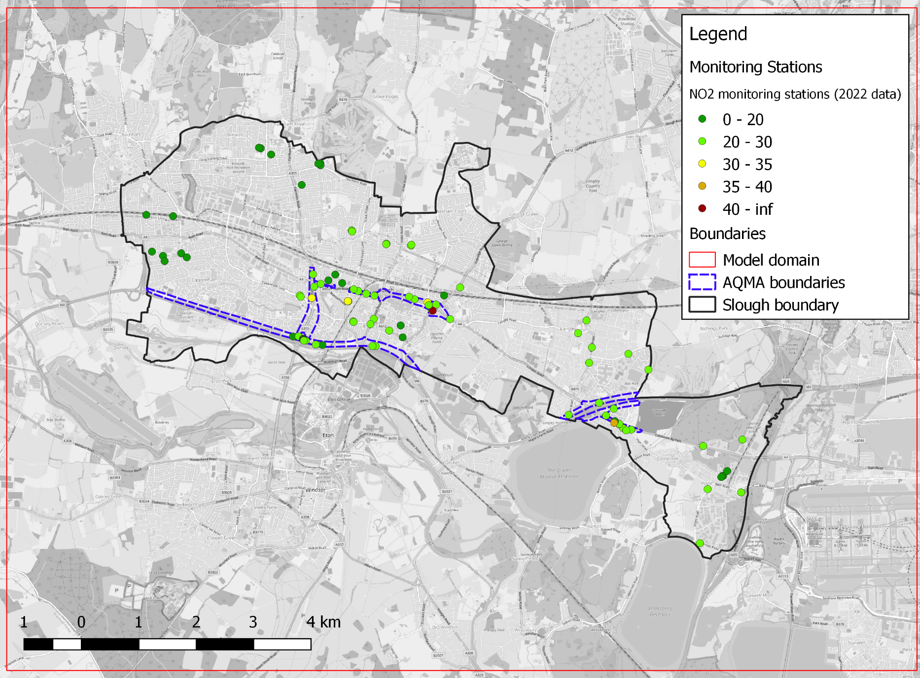

Base year and meteorological dataset
The 2022 surface meteorological data was obtained from three stations (Heathrow, Northolt and High Wycombe) and upper air meteorological data was obtained from two stations (Herstomonceux and Larkhill). RapidAir was used to carry out data filling where necessary. Data gaps from the primary meteorological stations (Heathrow and Herstomonceux) were first filled using data from the other nearby stations (Northolt and High Wycombe for surface stations, and Larkhill for the upper air station). Remaining data gaps were filled based on the persistence method, where a missing value is replaced by the use of data from the previous hour(s), for data gaps up to and including three hours.
Figure 2-B and Table 2-1 show the wind rose and statistics of meteorological parameters for the primary surface meteorological station at Heathrow.
Figure 2-B - 2022 wind rose for Heathrow meteorological station
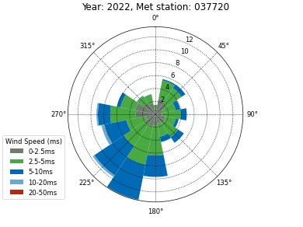
Table 2-1 - Statistics of meteorological parameters for Heathrow meteorological station
 | Wind Speed | Wind Direction | Temperature (°C) | Cloud Cover (oktas)
Mean | 3.87 | 196.27 | 12.61 | 7.6
Min | 0.5 | 10.0 | -5.35 | 0.0
Maximum | 18.9 | 360.0 | 39.35 | 99.0
Data Capture | 100.00 | 100.00 | 100.00 | 100.00

Road locations
A realistic representation of road locations has been modelled by assigning emissions to the road links represented in the Ordnance Survey Highways Network GIS dataset provided by SBC (Figure 2-C). It contains spatially accurate road centreline locations for various road categories (e.g. motorway, A road, B road, minor road, local street, etc.).
Figure 2-C - Modelled road links
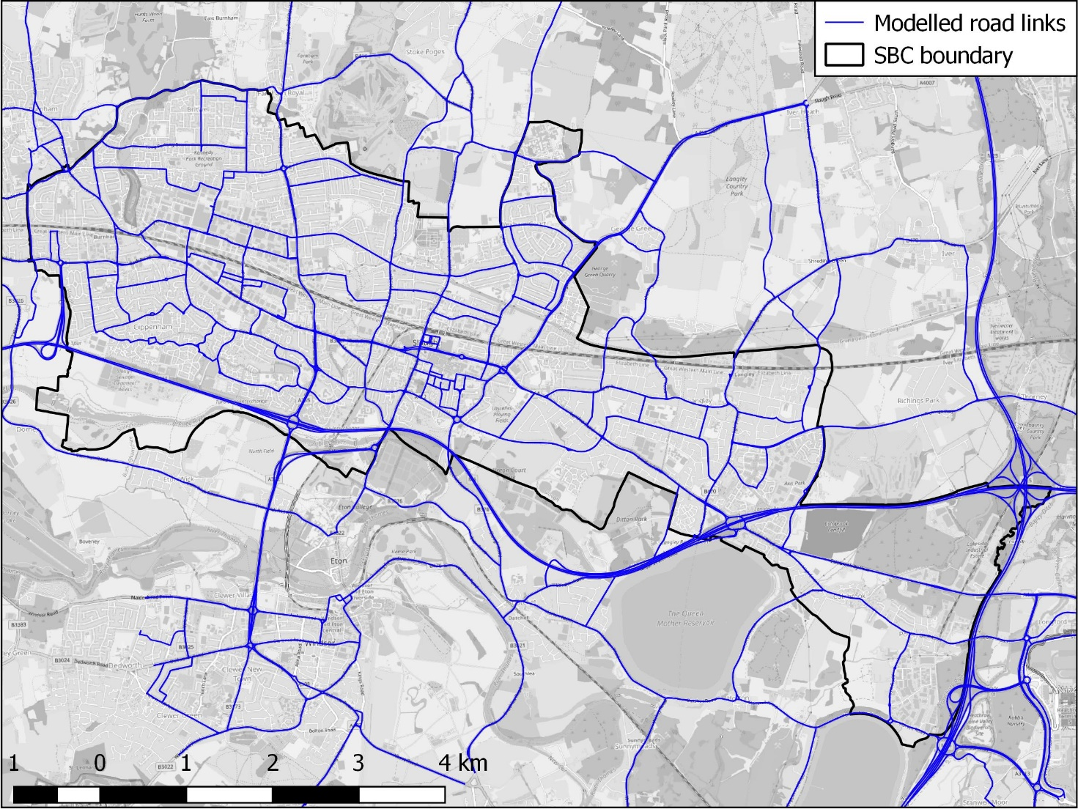

Gradient effects
Gradient effects were included in the modelling, based on elevation data from the Environment Agency’s open data Light Detection and Ranging (LIDAR) Digital Terrain Model (DTM) and Digital Surface Model (DSM) and where this was unavailable, Google Earth.
Gradients were included in the model for all modelled road links. All road links were modelled at ground level in order to provide a conservative estimate of ground level concentrations; roads above ground will have a reduced impact on ground level concentrations due to elevation of the plume centreline.

Street canyons
The presence of buildings either side of a road can introduce ‘street canyon’ effects which result in pollutants becoming trapped, leading to increased pollutant concentrations. There are canyon effects present in Slough, highlighted in Figure 2-D, which may be contributing to air quality issues in the study area.
Street canyon impacts were modelled using the RapidAir canyon module. Building heights were obtained from the Ordnance Survey MasterMap Topography Layer data.
Figure 2-D - Modelled street canyons
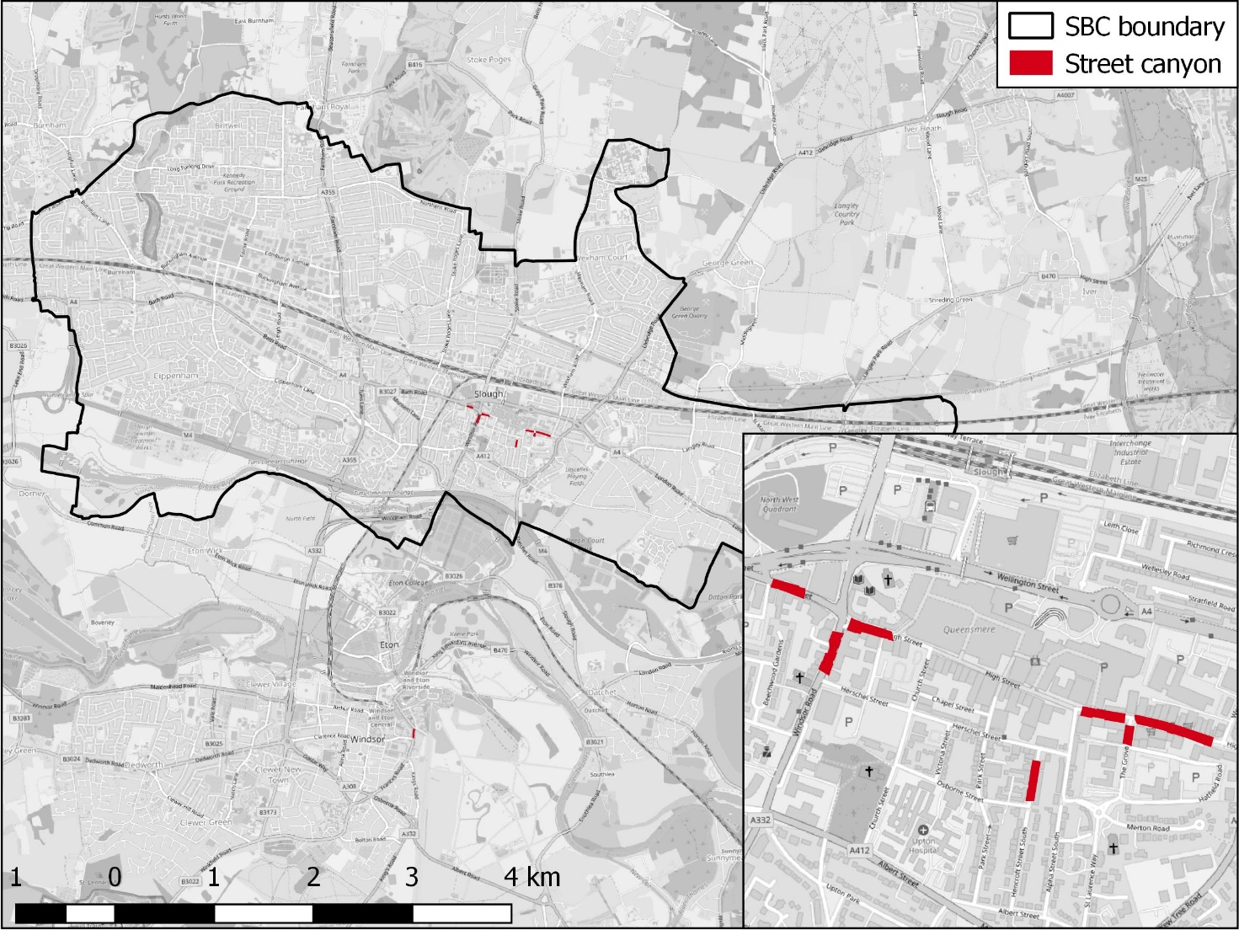

Road transport modelling

Average daily vehicle flow and speeds
Annual average daily traffic (AADT) link flows and daily average speed for each modelled road link were taken from the local SATURN traffic model, provided by Atkins.
A typical UK weekday diurnal profile (sourced from the DfT) was assumed and applied as time varying emissions in AERMOD when creating the RapidAir dispersion kernel.

Vehicle fleet composition
Vehicle fleet composition data for 2022 were applied from the best available local (Slough and other UK local authorities) and national data, based on best scientific knowledge.
Vehicle emissions rates for buses, taxis, coaches, rigid HGVs, articulated HGVs, LGVs, cars and motorcycles have been calculated using the COPERT v5.3 emissions functions contained in the latest version of the Defra Emissions Factors Toolkit (EFT) (v11.0).
The traffic model provided vehicle flows for four highway user classes which were: car, HGV, LGV, and bus. A further breakdown of the HGV class into rigid and articulated categories was conducted using the National Atmospheric Emissions Inventory (NAEI). Similarly, the car class has been further split using the NAEI into diesel, petrol, and hybrid (plug-in petrol hybrid, full petrol hybrid, plug-in diesel hybrid) vehicles.
Vehicle flows for cars and taxis were provided combined in the transport model data. In order to separate car and taxi traffic flows in the transport model, and hence model taxis as part of the source apportionment study, the assumed percentage of cars that were taxis was calculated for Slough for the town centre, outside of the town centre, and for the motorway (M4). These values were calculated using data recorded for other local authorities in England. The motorway percentage calculation also included values for the M4 from the London Atmospheric Emissions Inventory (LAEI).
Taxis within Slough were modelled as either passenger cars (for PHVs) or as LGVs (for Hackney carriages). The proportion of cars which could be attributed to taxis was based on calculations which have assigned a proportion based on the location of the road (city centre, outside city centre and motorways). Taxis considered as passenger cars were further split into a petrol and diesel component using Slough-specific data provided by SBC.

NOx/NO₂ conversion
Link-specific NOx and PM emissions factors were calculated using the COPERT v5.3 emission functions for all vehicles up to and including Euro 6/VI. Emissions rates were calculated using the Emissions Factor Toolkit (EFT) (v11.0).
The most recent version (v8.1) of the Local Air Quality Management (LAQM) NOx to NO₂ conversion toolkit was used to convert road NOx and background NOx into NO₂ concentrations where results at discrete receptor locations were required. This includes all roadside and kerbside 2022 NO₂ monitoring site locations in proximity to modelled road links.
The borough-wide domain was modelled at a 1 m resolution. When calculating NO₂ for large model domains and high-resolution models, using the LAQM NOx to NO₂ conversion spreadsheet tool for the conversion is not practical. In this case, a statistical relationship was derived using an ordinary least squares (OLS) regression model. The OLS model was derived by defining background NO_{x}, road NOx and road fNO₂ as the independent variables, and total NO₂ as the dependent variable.

Background concentrations
Background NOx and PM values were obtained from background mapping data for local authorities available on the LAQM website. The 2022 background maps (2018 base year) were applied to the study. The contribution from local road transport sources sectors that were included in the air quality model were subtracted from the background maps to avoid double counting. Due to the geographic location of the modelling domain, background concentration data were sourced from both the Southern England and Greater London regional data sets.

Measured concentrations
Slough Borough Council’s 2022 NO₂ measurements were applied to the air quality modelling assessment in order to verify the model outputs and to inform the source apportionment analysis. Measurements were applied from 66 monitoring sites which were confirmed as having sufficient data capture for the 2022 base year and in locations where concentrations would be accurately represented in the air quality model. A map showing the sites at which NO₂ concentrations were measured during 2022 is presented in Figure 2-A, with a majority of these being located in and around the town centre, and on the main road links in the borough.

Model verification
To evaluate model performance and uncertainty, the Root Mean Square Error (RMSE) for observed vs predicted NO₂ annual mean concentrations was calculated, as detailed in Technical Guidance LAQM.TG(22).
A single road NOx (global) adjustment factor was derived from the model verification, and was applied to the calculation of:
- Modelled concentrations at specified air quality monitoring locations; and
- Borough-wide 1 m resolution NO₂ and PM annual mean concentration rasters, to provide a continuous representation of the spatial variation in modelled concentrations.
In the absence of sufficient PM data for verification, the road NOx adjustment (Table 2-2) was applied to the modelled road PM₁₀ and PM_{2.5} outputs. This is the recommended methodology from Technical Guidance LAQM.TG(22) which states that in the absence of any PM data for verification, it may be appropriate to apply the road Nox adjustment to the modelled road PM.
Technical Guidance LAQM.TG(22) indicates that a RMSE of up to 10% of the target limit value (4 µg/m³, considering a 40 µg/m³ limit value for NO₂) is ideal, and an RMSE of up to 25% of the target limit value (10 µg/m³) is acceptable.
In the global case the RMSE was calculated at 5.28 µg/m³, which is acceptable and shows good agreement between the modelled and measured concentrations.

Baseline Model results – NO₂
Table 2-2 shows the modelled annual mean NO₂ concentrations for 2022 SBC air quality monitoring stations that are within close proximity to a modelled road. A map showing the modelled annual mean concentrations for 2022 is shown in Figure 2-C.
Figure 2-E – Modelled NO₂ annual mean concentrations (2022 baseline)
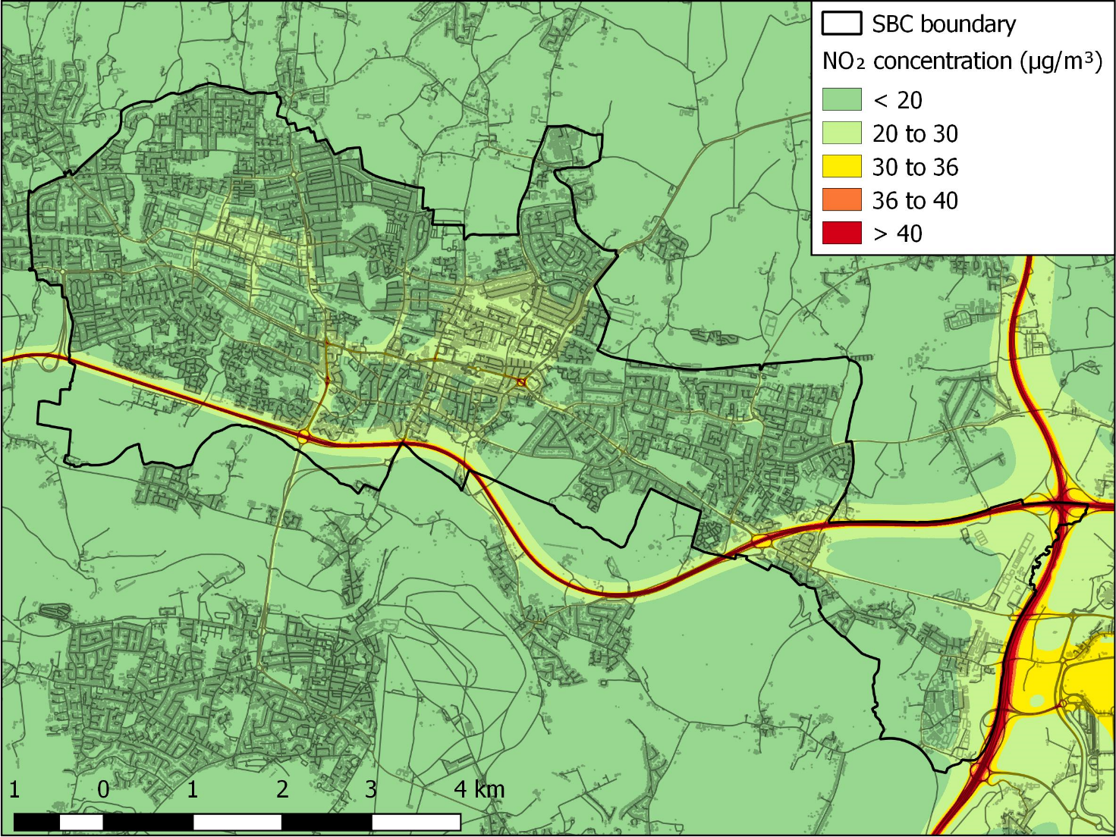

Table 2-2– Measured & modelled annual mean NO2 concentrations for the 2022 base year scenario. Exceeding the AQO (≥40 µg/m³) = red; within 10% of AQO ( ≥36 µg/m³ and <40 µg/m³) = amber; within 25% of AQO ( ≥30 µg/m³ and <36 µg/m³) = yellow; within 50% of AQO ( ≥20 µg/m³ and <30 µg/m³) = light green; more than 50% below the AQO (<20 µg/m³) = green.
Site ID | Site name | 2022 Monitored NO₂ | 2022 Modelled NO₂ | Site ID | Site name | 2022 Monitored NO₂ | 2022 Modelled NO₂
SLO 29 | Yew Tree Rd (Uxbridge Rd) | 44.20 | 29.30 | SLO 47 | Ledgers Road (b) | 24.50 | 26.93
SLO 63,SLO 64,SLO 65 | Brands Hill | 36.80 | 23.27 | SLO 12 | Lakeside road | 24.40 | 27.61
SLO 121 | Ledgers Road (b) | 35.70 | 21.29 | SLO 33 | Wexham Road | 24.20 | 26.18
SLO 50 | Tuns Lane (B) | 32.90 | 26.16 | SLO 56 | Brands Hill London Road | 24.10 | 21.46
SLH 11 | Brands Hill London Road | 32.60 | 23.27 | SLO 78,SLO 79,SLO 80 | Brands Hill (A) | 24.00 | 27.56
SLO 40 | Wexham Road | 32.60 | 31.60 | SLO 81,SLO 82,SLO 83 | London Road (A) | 24.00 | 27.69
SLO 10 | London Road (A) | 32.50 | 26.95 | SLO 72,SLO 73,SLO 74 | High Street Langley (A) | 23.90 | 27.26
SLO 18 | Brands Hill (A) | 31.60 | 22.97 | SLO 116 | Wellington Street | 23.80 | 22.00
SLO 53 | High Street Langley (A) | 30.30 | 20.20 | SLO 6 | Yew Tree Rd (Ux Rd) (B) | 23.80 | 24.45
SLO 46 | Cornwall House, Bath Rd | 29.80 | 24.76 | SLO 90,SLO 91,SLO 92 | Cornwall House, Bath Rd | 23.80 | 28.43
SLO 26 | Yew Tree Rd (Ux Rd) (B) | 29.70 | 27.07 | SLO 44 | Rogans (Colnbrook By-pass) | 23.60 | 23.84
SLO 60,SLO 61,SLO 62 | Wellington Street | 29.50 | 27.67 | SLO 69,SLO 70,SLO 71 | Albert Street/Upton Court Park Road | 23.60 | 27.18
SLO 97 | Albert Street/Upton Court Park Road | 29.20 | 24.46 | SLO 19 | Windsor Road (B) | 23.50 | 24.73
SLO 28 | Rogans (Colnbrook By-pass) | 28.80 | 24.47 | SLO 34, SLO 35, SLO 36 | Slough Town Centre Wellington Street | 23.50 | 27.65
SLO 57,SLO 58,SLO 59 | Windmill | 28.80 | 26.67 | SLO 66,SLO 67,SLO 68 | Princess Street | 23.50 | 27.84
SLH 12 | Slough Windmill Bath Road | 28.70 | 26.67 | SLO 87,SLO 88,SLO 89 | Slough Windmill Bath Road | 23.50 | 28.08
SLH 10 | Slough Town Centre Wellington Street | 28.30 | 27.67 | SLO 30 | Cippenham Lane (a) | 23.40 | 23.59
SLO 5 | Princess Street | 28.30 | 29.97 | SLO 96 | Elliman Avenue (b) | 23.10 | 19.72
SLO 17 | Horton Road (Caravan Park) | 28.30 | 26.60 | SLO 39 | Grampian Way | 22.90 | 24.89
SLO 49 | Windsor Road (B) | 28.20 | 26.02 | SLH 13 | Elliman Avenue (a) | 22.70 | 27.65
SLO 115 | Elliman Avenue (b) | 28.00 | 22.14 | SLO 75,SLO 76,SLO 77 | Blair Road – Victoria Court | 22.60 | 27.52
SLO 122 | Cippenham Lane (a) | 28.00 | 22.36 | SLO 38 | Oatlands Drive (a) | 22.40 | 24.54
SLO 8 | Grampian Way | 27.80 | 28.62 | SLO 23 | Langley Road | 22.20 | 28.54
SLO 114 | Elliman Avenue (a) | 27.30 | 23.16 | SLO 32 | Chalvey Road East (a) | 22.20 | 21.56
SLO 37 | Blair Road – Victoria Court | 27.10 | 25.21 | SLO 13 | Elbow Meadows | 21.90 | 24.40
SLO 112 | Oatlands Drive (a) | 26.80 | 20.71 | SLO 11 | Torridge Road | 21.70 | 27.01
SLO 51 | Langley Road | 26.70 | 23.98 | SLO 24 | Chalvey Road East (b) | 21.40 | 25.98
SLO 118 | Chalvey Road East (a) | 26.40 | 22.04 | SLO 4 | Windmill (Bath Rd) | 21.30 | 26.19
SLO 119 | Chalvey Road East (b) | 25.80 | 21.22 | SLO 93,SLO 94,SLO 95 | High Street Langley (B) | 21.20 | 33.37
SLO 43 | Windmill (Bath Rd) | 25.60 | 25.26 | SLH 3 | Slough-Colnbrook-(Pippins) | 21.10 | 14.95
SLO 54 | High Street Langley (B) | 25.30 | 21.42 | SLO 22 | Windsor Road | 21.00 | 31.17
SLO 7 | Colnbrook By-pass | 25.30 | 26.88 | SLO 55 | Oatlands Drive (b) | 21.00 | 18.94
SLO 113 | Oatlands Drive (b) | 25.20 | 20.82 | SLO 123 | Ledgers Road (a) | 20.80 | 20.56
SLO 21 | Windsor Road | 25.20 | 23.91 | SLH 8 | Slough-Lakeside-2 | 19.90 | 15.82
SLO 120 | Ledgers Road (a) | 25.10 | 20.49 | SLO 25 | Station Road | 19.60 | 24.72
SLO 52 | Station Road | 24.80 | 23.05 | SLO 1 | Salt Hill Park tennis courts | 19.40 | 29.23
SLO 84,SLO 85,SLO 86 | Spackmans Way HE Receptor 7 | 24.60 | 27.87 | SLO 14,SLO 15,SLO 16 | Pippins | 18.50 | 24.41
SLO 9 | Brands Hill | 24.60 | 24.02 | SLO 3 | Salt Hill Park Footbridge | 16.50 | 21.26
SLO 117 | Tuns Lane (B) | 24.50 | 22.60 | SLO 2 | Salt Hill Park Footpath | 15.50 | 23.22

Baseline Model results – PM₁₀ and PM_{2.5}
Table 2-3 and Table 2-4 show the modelled annual mean PM₁₀ and PM_{2.5} concentrations for 2022 at the 2022 same SBC air quality monitoring stations as detailed in Section 2.12. Maps showing the modelled annual mean concentrations in 2022 are presented in Figure 2-F and Figure 2-G.
Figure 2-F – Modelled PM₁₀ annual mean concentrations (2022 baseline)
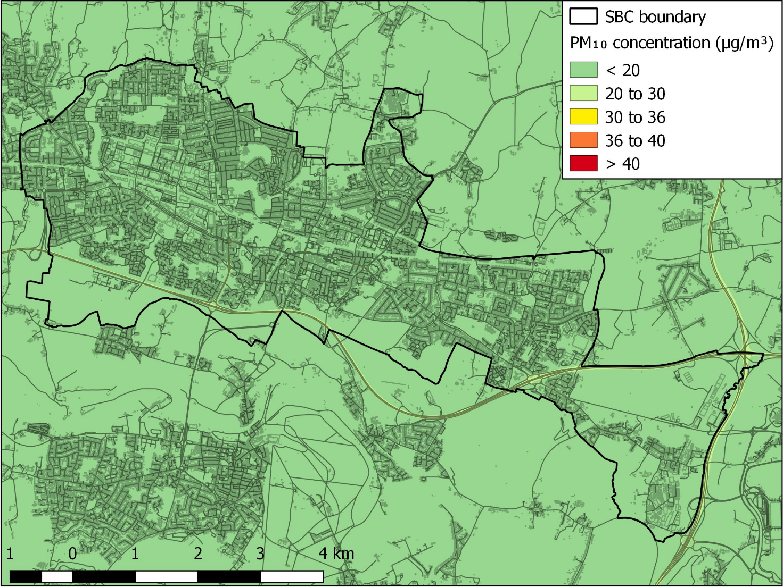

Figure 2-G – Modelled PM_{2.5} annual mean concentrations (2022 baseline)
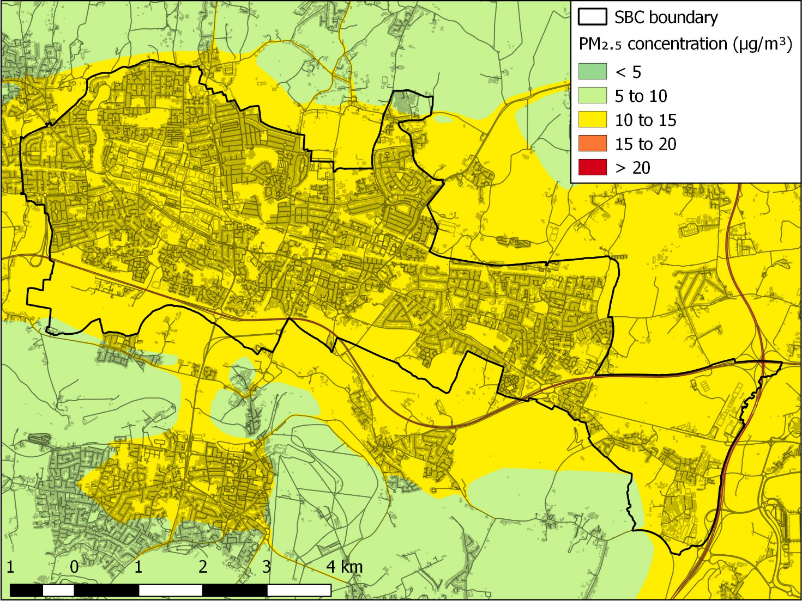

Table 2-3– Modelled annual mean PM10 concentrations for the 2022 base year scenario. All concentrations are below 50% of the AQO (<20 µg/m³) = dark green.
Site ID | Site name | 2022 Modelled PM₁₀ | Site ID | Site name | 2022 Modelled PM₁₀
SLO 93,SLO 94,SLO 95 | High Street Langley (B) | 19.58 | SLO 18 | Brands Hill (A) | 18.09
SLO 40 | Wexham Road | 19.39 | SLH 10 | Slough Town Centre Wellington Street | 18.05
SLO 10 | London Road (A) | 19.27 | SLO 26 | Yew Tree Rd (Ux Rd) (B) | 18.03
SLO 66,SLO 67,SLO 68 | Princess Street | 19.25 | SLO 52 | Station Road | 18.00
SLO 22 | Windsor Road | 19.16 | SLO 44 | Rogans (Colnbrook By-pass) | 17.96
SLO 47 | Ledgers Road (b) | 19.13 | SLO 56 | Brands Hill London Road | 17.92
SLO 49 | Windsor Road (B) | 19.08 | SLO 6 | Yew Tree Rd (Ux Rd) (B) | 17.87
SLO 8 | Grampian Way | 18.90 | SLO 38 | Oatlands Drive (a) | 17.86
SLO 90,SLO 91,SLO 92 | Cornwall House, Bath Rd | 18.83 | SLO 51 | Langley Road | 17.85
SLO 69,SLO 70,SLO 71 | Albert Street/Upton Court Park Road | 18.82 | SLO 19 | Windsor Road (B) | 17.82
SLO 75,SLO 76,SLO 77 | Blair Road – Victoria Court | 18.80 | SLO 122 | Cippenham Lane (a) | 17.75
SLO 87,SLO 88,SLO 89 | Slough Windmill Bath Road | 18.80 | SLO 121 | Ledgers Road (b) | 17.72
SLO 72,SLO 73,SLO 74 | High Street Langley (A) | 18.80 | SLO 32 | Chalvey Road East (a) | 17.67
SLO 78,SLO 79,SLO 80 | Brands Hill (A) | 18.79 | SLO 54 | High Street Langley (B) | 17.65
SLO 84,SLO 85,SLO 86 | Spackmans Way HE Receptor 7 | 18.78 | SLO 30 | Cippenham Lane (a) | 17.54
SLO 81,SLO 82,SLO 83 | London Road (A) | 18.77 | SLO 120 | Ledgers Road (a) | 17.52
SLO 50 | Tuns Lane (B) | 18.77 | SLO 117 | Tuns Lane (B) | 17.41
SLO 39 | Grampian Way | 18.68 | SLO 53 | High Street Langley (A) | 17.34
SLO 97 | Albert Street/Upton Court Park Road | 18.59 | SLO 123 | Ledgers Road (a) | 17.34
SLO 4 | Windmill (Bath Rd) | 18.55 | SLO 114 | Elliman Avenue (a) | 17.33
SLO 21 | Windsor Road | 18.54 | SLO 13 | Elbow Meadows | 17.26
SLO 5 | Princess Street | 18.52 | SLO 55 | Oatlands Drive (b) | 17.25
SLO 9 | Brands Hill | 18.48 | SLO 116 | Wellington Street | 17.24
SLO 29 | Yew Tree Rd (Uxbridge Rd) | 18.44 | SLO 7 | Colnbrook By-pass | 17.17
SLO 60,SLO 61,SLO 62 | Wellington Street | 18.37 | SLO 115 | Elliman Avenue (b) | 17.10
SLH 13 | Elliman Avenue (a) | 18.37 | SLO 113 | Oatlands Drive (b) | 16.99
SLO 63,SLO 64,SLO 65 | Brands Hill | 18.36 | SLO 112 | Oatlands Drive (a) | 16.97
SLO 43 | Windmill (Bath Rd) | 18.34 | SLO 1 | Salt Hill Park tennis courts | 16.91
SLO 23 | Langley Road | 18.32 | SLO 3 | Salt Hill Park Footbridge | 16.79
SLO 33 | Wexham Road | 18.31 | SLO 2 | Salt Hill Park Footpath | 16.45
SLO 118 | Chalvey Road East (a) | 18.29 | SLH 3 | Slough-Colnbrook-(Pippins) | 16.23
SLO 34, SLO 35, SLO 36 | Slough Town Centre Wellington Street | 18.29 | SLH 8 | Slough-Lakeside-2 | 16.23
SLO 24 | Chalvey Road East (b) | 18.29 | SLO 14,SLO 15,SLO 16 | Pippins | 16.23
SLO 37 | Blair Road – Victoria Court | 18.22 | SLO 96 | Elliman Avenue (b) | 16.19
SLO 46 | Cornwall House, Bath Rd | 18.19 | SLO 57,SLO 58,SLO 59 | Windmill | 16.02
SLO 28 | Rogans (Colnbrook By-pass) | 18.18 | SLH 11 | Brands Hill London Road | 16.02
SLO 25 | Station Road | 18.18 | SLO 18 | Brands Hill (A) | 18.09
SLO 11 | Torridge Road | 18.15 | SLH 10 | Slough Town Centre Wellington Street | 18.05
SLO 119 | Chalvey Road East (b) | 18.11 | SLO 26 | Yew Tree Rd (Ux Rd) (B) | 18.03

Table 2-4 – Modelled annual mean PM_{2.5} concentrations for the 2022 base year scenario. Above the 2040 PM_{2.5} objective ( ≥10 µg/m³ and <15 µg/m³) but below the current PM_{2.5} objective = yellow.
Site ID | Site name | 2022 Modelled PM_{2.5} | Site ID | Site name | 2022 Modelled PM_{2.5}
SLO 52 | Station Road | 12.21 | SLO 43 | Windmill (Bath Rd) | 11.71
SLO 93,SLO 94,SLO 95 | High Street Langley (B) | 12.17 | SLO 38 | Oatlands Drive (a) | 11.69
SLO 40 | Wexham Road | 12.15 | SLO 26 | Yew Tree Rd (Ux Rd) (B) | 11.66
SLO 49 | Windsor Road (B) | 12.14 | SLO 25 | Station Road | 11.65
SLO 47 | Ledgers Road (b) | 12.11 | SLO 24 | Chalvey Road East (b) | 11.65
SLO 8 | Grampian Way | 12.11 | SLO 56 | Brands Hill London Road | 11.65
SLO 22 | Windsor Road | 12.02 | SLO 44 | Rogans (Colnbrook By-pass) | 11.63
SLO 54 | High Street Langley (B) | 12.01 | SLO 34, SLO 35, SLO 36 | Slough Town Centre Wellington Street | 11.63
SLO 51 | Langley Road | 12.01 | SLO 121 | Ledgers Road (b) | 11.62
SLO 10 | London Road (A) | 12.00 | SLO 18 | Brands Hill (A) | 11.57
SLO 66,SLO 67,SLO 68 | Princess Street | 11.99 | SLO 19 | Windsor Road (B) | 11.56
SLO 21 | Windsor Road | 11.97 | SLO 122 | Cippenham Lane (a) | 11.56
SLO 50 | Tuns Lane (B) | 11.90 | SLO 120 | Ledgers Road (a) | 11.55
SLO 4 | Windmill (Bath Rd) | 11.90 | SLO 28 | Rogans (Colnbrook By-pass) | 11.55
SLO 97 | Albert Street/Upton Court Park Road | 11.89 | SLH 10 | Slough Town Centre Wellington Street | 11.54
SLO 118 | Chalvey Road East (a) | 11.87 | SLO 6 | Yew Tree Rd (Ux Rd) (B) | 11.53
SLO 9 | Brands Hill | 11.85 | SLO 117 | Tuns Lane (B) | 11.50
SLO 5 | Princess Street | 11.84 | SLO 114 | Elliman Avenue (a) | 11.48
SLO 90,SLO 91,SLO 92 | Cornwall House, Bath Rd | 11.84 | SLO 116 | Wellington Street | 11.45
SLO 69,SLO 70,SLO 71 | Albert Street/Upton Court Park Road | 11.83 | SLO 123 | Ledgers Road (a) | 11.42
SLO 75,SLO 76,SLO 77 | Blair Road – Victoria Court | 11.83 | SLO 30 | Cippenham Lane (a) | 11.42
SLO 72,SLO 73,SLO 74 | High Street Langley (A) | 11.82 | SLO 115 | Elliman Avenue (b) | 11.41
SLO 46 | Cornwall House, Bath Rd | 11.82 | SLO 32 | Chalvey Road East (a) | 11.40
SLO 87,SLO 88,SLO 89 | Slough Windmill Bath Road | 11.82 | SLO 113 | Oatlands Drive (b) | 11.38
SLO 33 | Wexham Road | 11.82 | SLO 112 | Oatlands Drive (a) | 11.38
SLO 78,SLO 79,SLO 80 | Brands Hill (A) | 11.82 | SLO 1 | Salt Hill Park tennis courts | 11.29
SLO 84,SLO 85,SLO 86 | Spackmans Way HE Receptor 7 | 11.82 | SLO 13 | Elbow Meadows | 11.28
SLO 81,SLO 82,SLO 83 | London Road (A) | 11.82 | SLO 3 | Salt Hill Park Footbridge | 11.20
SLO 39 | Grampian Way | 11.81 | SLO 2 | Salt Hill Park Footpath | 11.09
SLO 119 | Chalvey Road East (b) | 11.81 | SLO 7 | Colnbrook By-pass | 10.93
SLO 11 | Torridge Road | 11.80 | SLH 3 | Slough-Colnbrook-(Pippins) | 10.84
SLO 60,SLO 61,SLO 62 | Wellington Street | 11.80 | SLH 8 | Slough-Lakeside-2 | 10.84
SLH 13 | Elliman Avenue (a) | 11.80 | SLO 14,SLO 15,SLO 16 | Pippins | 10.84
SLO 29 | Yew Tree Rd (Uxbridge Rd) | 11.80 | SLO 96 | Elliman Avenue (b) | 10.78
SLO 37 | Blair Road – Victoria Court | 11.78 | SLH 11 | Brands Hill London Road | 10.53
SLO 53 | High Street Langley (A) | 11.75 | SLH 12 | Slough Windmill Bath Road | 10.53
SLO 63,SLO 64,SLO 65 | Brands Hill | 11.74 | SLO 57,SLO 58,SLO 59 | Windmill | 10.53
SLO 55 | Oatlands Drive (b) | 11.73 | SLO 12 | Lakeside road | 10.52
SLO 23 | Langley Road | 11.72 | SLO 17 | Horton Road (Caravan Park) | 10.40

Source apportionment

Data sources and methodology
This section provides the data sources and methodology for the source apportionment study performed as part of the Slough AQAP 2022 baseline modelling assessment.
Figure 3-A provides a schematic of the workflow and data used to inform the source apportionment study. A source apportionment of modelled road emissions was conducted using data from the closest modelled road link(s) to the specified 2022 air quality monitoring locations in Slough. The modelled road link emissions were then separated by vehicle type, based on the 2022 baseline scenario.
Background emissions were included in the source apportionment by assigning each monitoring site to its equivalent Defra background map 1 km x 1 km grid square (based on location of the site across Southern England and Greater London).
To avoid double counting, the explicitly modelled roads were removed from the Defra background maps; these included motorway, primary and trunk roads, brake and tyre wear, and road abrasion. The remaining background emissions were then included in the source apportionment.
A ratio of road to background emissions was calculated for each monitoring location using the modelled concentration outputs. The calculated ratio was then applied to combine the road and background source apportionment datasets, providing a full source apportionment at each monitoring location.
Finally, an attempt at calculating indicatory concentration values for each source category was performed by multiplying the total measured (where possible) and/or modelled concentrations by the percentage contribution from each source. This helps to provide a clearer picture with regards to the significance of the source at each location. These values are presented in Appendix 3 Annex I.
Figure 3-A - workflow and data used to calculate source apportionment
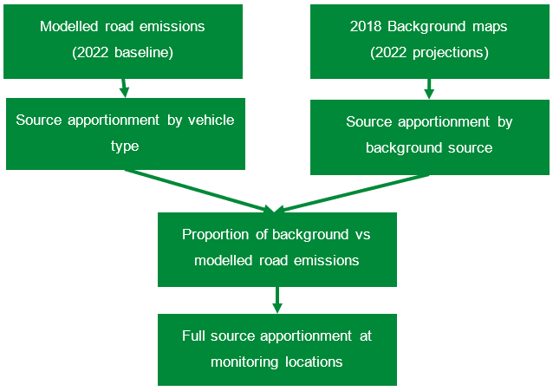

3.2 Source apportionment results
The results from the source apportionment calculations are presented in the form of stacked column bar charts in the following figures. This is to illustrate the contributions of each source at each monitoring locations for each of the pollutants of concern. The underlying data for each of the charts can be found in Appendix C Annex I, which shows the contributions to air pollutant concentrations for NO₂ (as NO_{X}), PM₁₀ and PM_{2.5} at each monitoring site included in the study.
Figure 3-B presents the NO_{X} source apportionment at each of the air quality monitoring locations specified for the study using the results from the 2022 baseline model. Considering the average of all monitoring sites, the results indicate that diesel cars represent the greatest proportion of NO_{X} emissions from road transport, on average, 24.2% of total NOx emissions. This is followed by rural background, domestic background, and LGVs, contributing 18.0%, 8.1%, and 7.7%, respectively. Contributions from road emissions represent an average of 46.0% of total emissions, compared to the background contribution of 54.0%.
Figure 3-C shows the equivalent 2022 Baseline PM₁₀ source apportionment for each of the monitoring locations. The results indicate that secondary PM represents the greatest proportion of PM₁₀ emissions, an average of 37.1% of total PM₁₀. This is followed by residual salt, and domestic, contributing 33.5%, and 9.6%, respectively. Unlike NOx, contributions from background emissions of PM₁₀ are greater than from road sources and represent 89.0% of total emissions, compared to the road contribution of 11.0%.
Equivalent results are shown for PM_{2.5} in Figure 3-D. The results show that secondary PM represents, on average, 47.6% of the total PM_{2.5} emissions. This is followed by residual salt, and the domestic sector, contributing 22.6%, and 13.9%, respectively. Contributions from background emissions are again significantly greater than road sources of PM_{2.5}, representing 90.4% of total emissions compared to 9.6% for road transport. It should be noted that brake and tyre wear from road vehicles are included in the modelled road emissions for each vehicle type.
Appendix C Annex I shows the absolute values for NO_{X}, PM₁₀ and PM_{2.5} emissions at each diffusion tube location.

Figure 3-B - NOx source apportionment for the 2022 Baseline scenario at monitoring locations, broken down by road and background sources
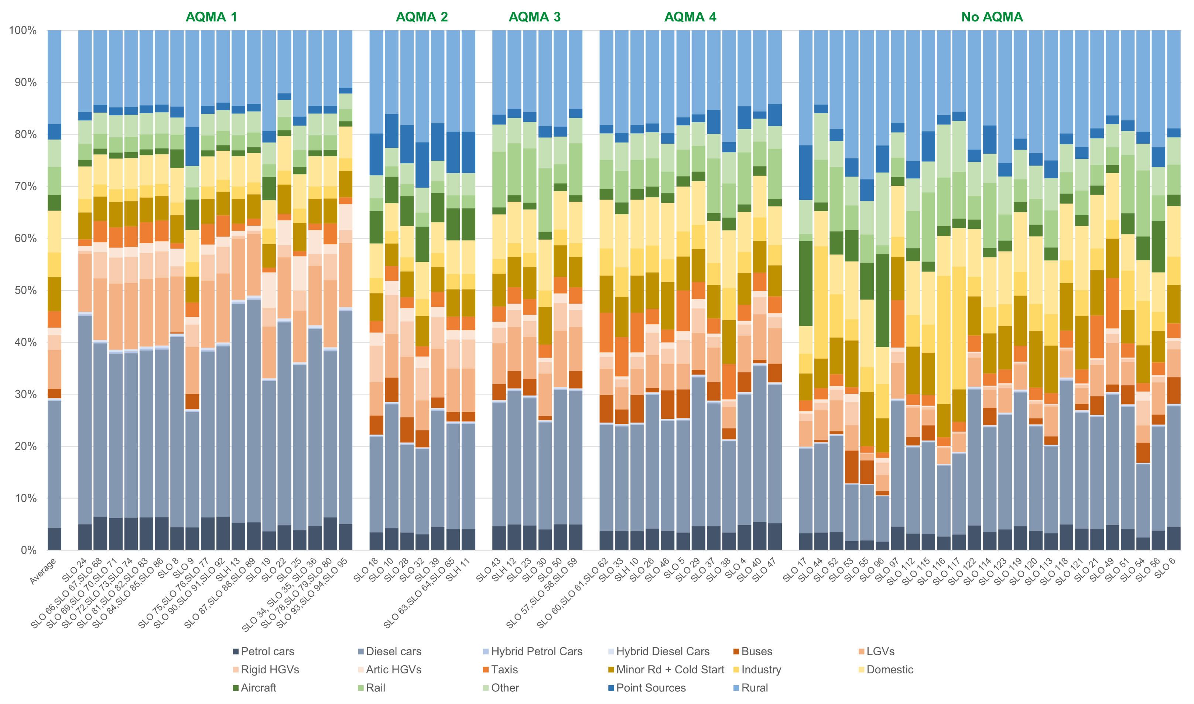

Figure 3-C – PM₁₀ source apportionment for the 2022 Baseline scenario at monitoring locations, broken down by road and background sources
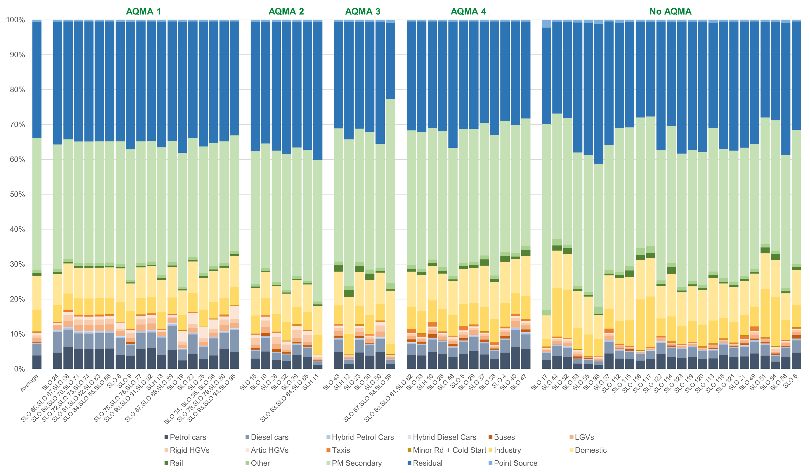

Figure 3-D – PM_{2.5} source apportionment for the 2022 Baseline scenario at monitoring locations, broken down by road and background sources

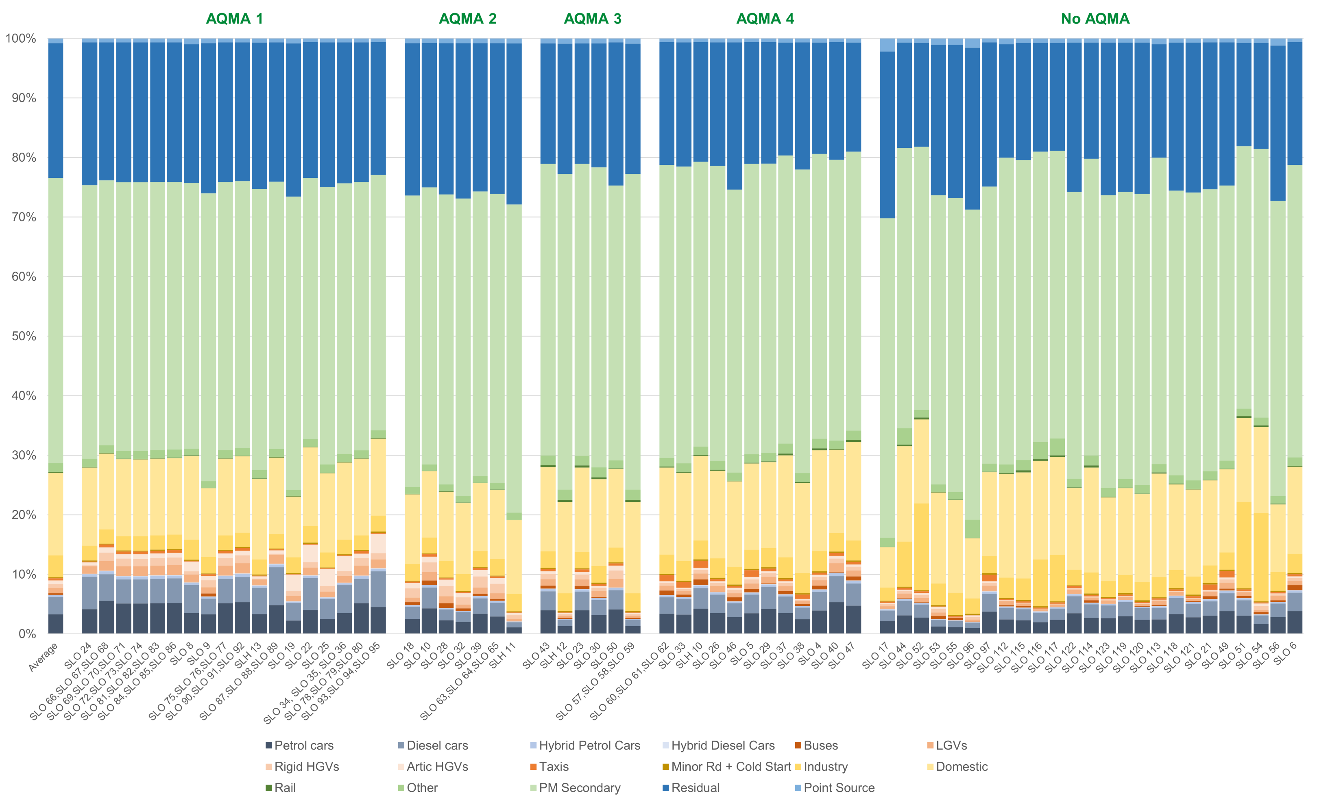

Scenario modelling of AQAP measures

Measures modelled
The measures set in out in Slough’s AQAP were selected due to their anticipated positive impact in improving air quality. The impact of measures were captured in thematically relevant bundles, as shown in Table 4-1.
Table 4-1 – measures included in scenario modelling
Scenario #1: Modal Shift to Active Travel and EV Transition
Measure ID | Measure description
HEA1 | Collective delivery of school active travel initiatives including smarter travel for school measures (school streets, Bikeability, sustainable travel campaigns), development of clean air plans, emission exposure and reduction campaign
TM1 | Implement Slough Electric Cycle and Scooter Infrastructure and Hire programme
TM2 | Provide secure undercover cycle storage with welfare/repair facilities
TM3 | Introduce cargo bikes into the network for businesses and residents
TM4 | Cycle scheme from Burnham Station to A4 via Station Road
TM5 | Foxborough Cycle Lane between Langley High Street and Junction 5 Footbridge
TM6 | Introduce segregated A4 cycle highway (including provision of cycle docking)
TM7 | Deliver Destination Farnham Road scheme
EM7 | Creation of a strategic Slough public charge point network (residential)
EM8 | Implement EV (rapid and fast) off-street and car park Programme
EM9 | Implement EV (rapid and fast) on-street Programme
EM10 | Develop and implement an electric car club across the borough
Scenario #2: Yew Tree Road (AQMA 4)
Measure ID | Measure description
TM16 | Undertake junction improvement review at Yew Tree Road
Scenario #3: Minimum Euro VI HGVs and LGVs
Measure ID | Measure description
EM3 | Set minimum emission standards for all major contracts including maintenance, where vehicle use is inherent in the contract
EM4 | Improve emissions from the council's operational fleet, including waste and recycling, light commercial and community service fleet
EM5 | Support the implementation of the HDV gas station Programme
EM6 | Update the Slough Low Emission Strategy with tightened emission controls, electric vehicle charging standards and construction emissions

Scenario #4: 100% ZEV buses
Measure ID | Measure description
TM13 | Seek funding opportunities to migrate to zero bus emission fleet in coordination with neighbouring authorities
Scenario #5: Combination of quantified AQAP borough-wide measures and 100% ZEV taxis
Measure ID | Measure description
As above | All measures above (except TM16)
EM11 | Deliver Defra funded taxi demo project
EM12 | Install a network of rapid charging facilities to support plug-in taxis
EM19 | Re-introduce minimum emission standards for hackney carriages and private hire vehicles that comply with national clean air requirements and promote ULEVs

Scenario modelling methodology
To allow for comparability with the baseline model, the model setup is consistent with that established in Appendix C.2. The impact of measures were captured by modifying the average daily vehicle flow (#1, #5) and speeds (#2), and the vehicle fleet composition (#1, #3, #4, #5). The scenarios modelled are shown in Table 4-2, and Table 4-3 presents the average speeds used in modelling in Scenario #2.

Table 4-2– measures included in scenario modelling
Scenario #1: Modal Shift to Active Travel and EV Transition
Scenario | Model description
#1a | 9.5% modal shift from passenger cars to active travel
#1b | 9.5% modal shift from passenger cars to active travel; and a 5% uptake of BEV passenger cars
#1c | 9.5% modal shift from passenger cars to active travel; and a 10% uptake of BEV passenger cars
Scenario #2: Yew Tree Road (AQMA 4)
Scenario | Model description
#2a | 10% speed increase along Yew Tree Road junction road to show easing congestion
#2b | 20% speed increase along Yew Tree Road junction road to show easing congestion
#2c | 50% speed increase along Yew Tree Road junction road to show easing congestion
Scenario #3: Minimum Euro VI HGVs and LGVs
Scenario | Model description
#3 | Minimum Euro VI standards for LGV and HGV fleet
Scenario #4: 100% ZEV buses
Scenario | Model description
#4 | Transition of bus fleet to 100% ZEV
Scenario #5: Combination of quantified AQAP borough-wide measures and 100% ZEV taxis
Scenario | Model description
#5 | Transition of taxi fleet to 100% ZEV; bus fleet to 100% ZEV (#4) ; 9.5% modal shift from passenger cars to active travel (#1c); 10% uptake of BEV passenger cars (#1c); minimum Euro VI standards for LGV and HGV fleet (#3)

Table 4-3 - Scenario #2 average speed at Yew Tree Road junction
Scenario | Speed increase (%) | Northbound speed (km/h) | Southbound speed (km/h)
Baseline | 0 | 18 | 13
#2a | 10 | 20 | 14
#2b | 20 | 22 | 16
#2c | 50 | 27 | 20

The increases in speed modelled under the different sensitivity tests in Scenario #2 are expected to result in decreased emissions, as increased vehicle speed results in more efficient driving. The maximum speed modelled under Scenario #2c (27 km/h) is still below 20 mph, such that the ambition of this measure does not compromise safe driving practices, such as speeding.
Scenario #5 captures all measure scenarios applicable to the wider region (except for Scenario #2). This measure targets all road emissions sources, and acts as an analogue for modelling the total cumulative impact of all transport measures in the AQAP.
The results of the scenario modelling are calculated using multiple adjustment factors:
- the global NO_{X} adjustment factor (see Appendix D.2.11);
- individual adjustment factors, and
- adjustment factors for eastern AQMA 4.

Global adjustment factor
This adjustment factor is used as it is most representative of the entire model domain. It is the most appropriate adjustment factor when considering the average impact of each measure scenario across Slough.

Individual adjustment factor
This adjustment factor is used to show the impact of measures for each specific monitoring site. It is most suitable when comparing against the 2022 measured NO₂ concentrations, as the baseline NO₂ has been adjusted to be exactly equitable.

AQMA 4 adjustment factor
The specific adjustment factor for AQMA 4 is used to assess the effectiveness of Scenario #2, in which congestion is eased at the Yew Tree Road junction in the east of AQMA 4. It is modelled from five sites (SLO29, SLO40, SLO26, SLO5 and SLH10) around the roundabout intersected by Wellington Street and Uxbridge Road within AQMA 4. The AQMA adjustment factor (2.2909) has an associated RMSE of 5.83 µg/m³, which is comparable with the global adjustment factor (1.7052) of 5.28 µg/m³.

Scenario model results – Nitrogen Dioxide
The average results of the scenario modelling are presented in Tables 4-4, 4-5 and 4-6 for each adjustment factor described in Appendix D.4.2.
The average measured NO₂ concentration is shown as the average of all relevant monitoring sites in Slough considered in the 2022 baseline study (Appendix D.2). The modelled NO₂ concentrations under each scenario is the resultant average after the implementation of each set of air quality measures. The measured and modelled NO₂ are shown in yellow if within 20% of the NO₂ air quality objective (i.e. 32 µg/m³), and green if below this.
The change from the baseline is highlighted green, with vibrancy proportional to the magnitude of the change in baseline. Scenario #2 is shown only in Table 4-6, as the impact on the measure is specific to AQMA 4. It is evident from Tables 4-4 and 4-5 that all measure scenarios are expected to result in a reduction in NO₂ concentrations across the entire borough.
Table 4-4 shows that Scenario #5 (all measures) is expected to lead to the greatest reduction of NO₂ at 9.4% (an improvement of 2.29 µg/m³). This is attributed mainly to the contributions from modal shift (from passenger cars to active travel), and EV transition (Scenario #1) at 6.0%, as well as smaller contributions from enforcing minimum Euro VI standards for LGVs and HGVs (Scenario #3) at 1.9%, and transition to ZEV buses (Scenario #4) at 1.5%.
The sensitivity tests from Scenario #1 shows that increasing uptake of ZEV cars is proportional to an increased reduction of NO₂. Similarly, Table 4-6 (AQMA 4) shows that the average emissions reduction achieved by Scenario #2 is proportional to the increase in speed, and thus reduction of congestion.
From Figure 4-A, it is evident that, when using the individual adjustment factors, bringing site SLO 29 (44.2 µg/m³) into compliance with NO₂ air quality objective can only be achieved under Scenario #5 (36.1 µg/m³). This shows the greatest improvement in NO₂ concentrations, with a reduction of 8.1µg/m³, or 18.4%. Figure 4-A also shows that measures under Scenario #2 result in observable decreases at SLO 29 only. This shows the necessity of implementing all measures in the AQAP in order to achieve and maintain compliance.
The absolute and relative change in NO₂ concentrations for each scenario and each adjustment factor are shown in Appendix 3 Annex II.

Table 4-4 – scenario modelling NO₂ concentrations across Slough (using global adjustment factor).
Average Measured NO₂ (µg/m³) | Average Modelled NO₂ (µg/m³) by scenario
 | Baseline (Global) | #1a | #1b | #1c | #3 | #4 | #5
25.45 | 24.46 | 23.95 | 23.24 | 23.00 | 24.00 | 24.15 | 22.17
Change from Baseline (µg/m³)  Change from Baseline (%) |  | -0.51 | -1.22 | -1.47 | -0.47 | -0.32 | -2.29
 |  | -2.1% | -5.0% | -6.0% | -1.9% | -1.3% | -9.4%

Table 4-5 - scenario modelling NO₂ concentrations across Slough (using individual adjustment factors)
Average Measured NO₂ (µg/m³) | Average Modelled NO₂ (µg/m³) by scenario
 | Baseline (Global) | #1a | #1b | #1c | #3 | #4 | #5
25.45 | 25.45 | 24.89 | 24.11 | 23.84 | 24.94 | 25.04 | 22.83
Change from Baseline (µg/m³) |  | -0.56 | -1.34 | -1.61 | -0.51 | -0.41 | -2.62
Change from Baseline (%) |  | -2.2% | -5.3% | -6.3% | -2.0% | -1.6% | -10.3%

Table 4-6 - scenario modelling NO₂ concentrations for sites SLO29, SLO40, SLO26, SLO5 and SLH10 (east AQMA 4) (using AQMA 4 adjustment factor).
Average Measured NO₂ (µg/m³) | Average Modelled NO₂ (µg/m³) by scenario
 | Baseline (Local) | #1a | #1b | #1c | #2a | #2b | #2c | #3 | #4 | #5
32.62 | 32.81 | 31.99 | 30.94 | 30.53 | 32.68 | 32.67 | 32.24 | 32.16 | 31.52 | 27.64
Change from Baseline (µg/m³) |  | -0.82 | -1.87 | -2.27 | -0.12 | -0.13 | -0.56 | -0.64 | -1.29 | -5.16
Change from Baseline (%) |  | -2.5% | -5.7% | -6.9% | -0.4% | -0.4% | -1.7% | -2.0% | -3.9% | -15.7%

Figure 4-A – scenario modelling NO₂ concentrations across AQMA 4 monitoring sites using individual adjustment factors.
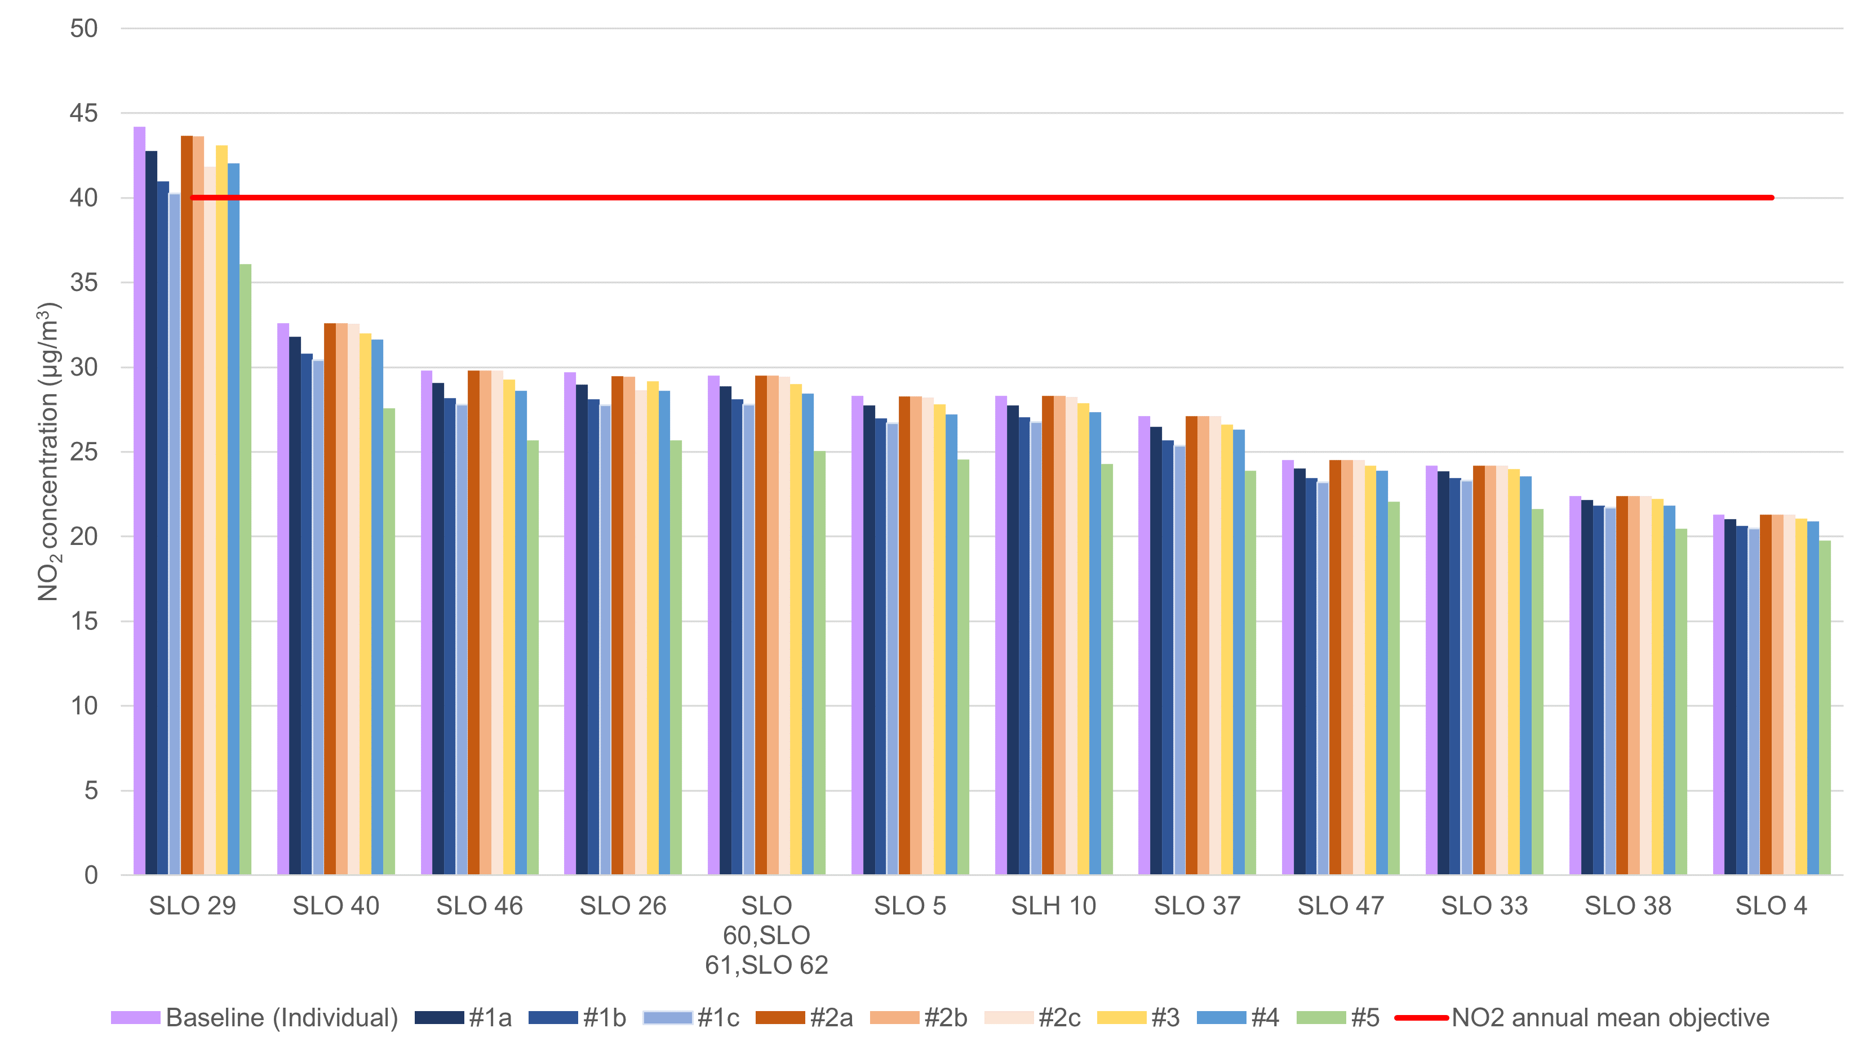

Scenario model results – PM₁₀ and PM_{2.5}
From the outcomes of the scenario modelling for NO₂, it can be seen that the most effective measures target the modal shift from passenger vehicles and transition towards using EVs (#1) and the combination of all measures in the AQAP (#5). The outcomes of the source apportionment study show that road emissions contribute relatively less to PM₁₀ and PM_{2.5} concentrations than to NO₂ concentrations (see Section 3.3 and Appendix C.3).
As such, the measures which are expected to result in the largest impact on PM emissions (#1 and #5) have been modelled.
The results of implementing these scenarios are shown in Tables 4-7, 4-8 and 4-9 for PM₁₀, and Tables 4-10, 4-11 and 4-12 for each adjustment factor. It can be seen that for PM₁₀, the modal shift from private vehicle use to active travel, and EV transition (#1c) contributes to the majority of PM₁₀ emission reductions (compared to #5).
Table 4-7 and Table 4-10 show that for PM₁₀ and PM_{2.5}, emissions reductions as a result of implementing all measures (Scenario #5) result in 0.9%, and 1.2% reductions in average concentrations, respectively. Considering that only 10.6% and 9.3% of PM₁₀ and PM_{2.5} emissions, respectively, were found to be sourced from road emissions sources (Appendix C.3.2), there is a 10-13% reduction in total PM road emissions as a result of implementing all measures.
It is worth noting that although tailpipe PM emissions are reduced as a result of transitioning passenger car, taxi, and bus fleets to ZEVs, there are still contributions to PM emissions from brake and tyre wear.
The absolute and relative change in PM₁₀ and PM_{2.5} concentrations for Scenario #1c and #5 and each adjustment factor are shown in Annex III.

Table 4-7 – scenario modelling PM₁₀ concentrations across Slough (using global adjustment factor)
Modelled PM₁₀ (µg/m³) by scenario
Baseline (Global) | #1c | #5
18.00 | 17.85 | 17.83
Change from Baseline (µg/m³) | -0.15 | -0.17
Change from Baseline (%) | -0.9% | -0.9%

Table 4-8 - scenario modelling PM₁₀ concentrations across Slough (using individual adjustment factors)
Modelled PM₁₀ (µg/m³) by scenario
Baseline (Individual) | #1c | #5
18.40 | 18.22 | 18.19
Change from Baseline (µg/m³) | -0.19 | -0.21
Change from Baseline (%) | -1.0% | -1.1%
Table 4-9 - scenario modelling PM₁₀ concentrations for sites SLO29, SLO40, SLO26, SLO5 and SLH10 (east AQMA 4) (using AQMA 4 adjustment factor)
Modelled PM₁₀ (µg/m³) by scenario
Baseline (Local) | #1c | #5
18.64 | 18.43 | 18.41
Change from Baseline (µg/m³) | -0.20 | -0.23
Change from Baseline (%) | -1.1% | -1.2%
Table 4-10 – scenario modelling PM_{2.5} concentrations across Slough (using global adjustment factor)
Modelled PM_{2.5} (µg/m³) by scenario
Baseline (Local) | #1c | #5
12.10 | 11.99 | 11.95
Change from Baseline (µg/m³) | -0.10 | -0.14
Change from Baseline (%) | -0.8% | -1.2%
Table 4-11 - scenario modelling PM_{2.5} concentrations across Slough (using individual adjustment factors)
Modelled PM_{2.5} (µg/m³) by scenario
Baseline (Local) | #1c | #5
12.33 | 12.20 | 12.15
Change from Baseline (µg/m³) | -0.12 | -0.18
Change from Baseline (%) | -1.0% | -1.5%
Table 4-12 - scenario modelling PM_{2.5} concentrations for sites SLO29, SLO40, SLO26, SLO5 and SLH10 (east AQMA 4) (using AQMA 4 adjustment factor)
Modelled PM_{2.5} (µg/m³) by scenario
Baseline (Local) | #1c | #5
12.47 | 12.33 | 12.28
Change from Baseline (µg/m³) | -0.14 | -0.19
Change from Baseline (%) | -1.1% | -1.5%

Scenario model results – CO₂
The scenario modelling also includes a comparison in total carbon dioxide (CO₂) emissions across Slough in the baseline 2022 scenario, Scenario #1 and Scenario #5.
Table 4-13 presents the total modelled CO₂ emissions from road vehicles in 2022 within the Slough model domain (Appendix C.2.2). Total modelled CO₂ emissions were calculated using the EFT (v11.0), and considers emissions from road vehicles only. Table 4-13 shows a decrease of 18.7% total CO₂ emissions as a result of implementing all measures, 12.6% of which comes from modal shift to active travel and transition to ZEV passenger cars. Tables 4-14 and 4-15 show the split of contributions from light vehicles and heavy vehicles.
Table 4-13 - scenario modelling CO₂ emissions for all vehicles
 | All Vehicles (Annual Emissions (kilotonnes/yr))
Scenario | Baseline | #1c | #5
Total (kt/year) | 906.6 | 805.06 | 764
Change from baseline (kt) |  | -102 | -143
Change from baseline (%) |  | -12.6% | -18.7%
Table 4-14 - scenario modelling CO₂ emissions for light vehicles (cars, taxis and HGVs)
 | Light Vehicles (Annual Emissions (kilotonnes/yr))
Scenario | Baseline | #1c | #5
Total (kt/year) | 665.6 | 564.2 | 543.4
Change from baseline (kt) |  | -101 | -122
Change from baseline (%) |  | -18.0% | -22.5%
Table 4-15 - scenario modelling CO₂ emissions for heavy vehicles (HGVs and buses)
 | Heavy vehicles (Annual Emissions (kilotonnes/yr))
Scenario | Baseline | #1c | #5
Total (kt/year) | 240.9 | 240.9 | 220.2
Change from baseline (kt) |  | 0 | -21
Change from baseline (%) |  | 0.0% | -9.4%

Appendix E: Evidence Base

E.1 Local Policy Review
This review considers all of Slough’s current and emerging plans, policies and strategies, and how the AQAP will support the aims and objectives within them. This also ensures that the AQAP accurately reflects the work that the Council is undertaking or is planning to undertake which has an influence on air quality.
Many strategies are being redrafted since implementation of the Section 114 notice, however it is likely that key themes are likely to persist. Any fundamental changes to Slough’s recovery and corporate direction will be highlighted in future ASRs.

1 Council Aspirations and Vision

1.1 The Corporate Plan (2023-2027)
The Corporate Plan sets out Slough Borough Council’s vision for the Council and what will be delivered in the borough, setting out the Council’s strategic priorities from 2023 to 2027. As illustrated in Section 3.2, Slough has a poor healthy life expectancy compared to neighbouring boroughs, therefore the Corporate Plan seeks to address this by improving the health outcomes of those who live in Slough, focusing on children.

The approach of the Corporate Plan is to be resident focused, providing financial sustainability, enabling residents and communities to live well independently, strengthening partnerships and building trust.

The three strategic priorities of the Corporate Plan are as follows:
- A borough for children and young people to thrive.
- A town where residents can live healthier, safer and more independent lives.
- A cleaner, healthier and more prosperous Slough.

The latter priority refers specifically to environmental improvement, focusing on improving air quality, promoting active travel and sustainable forms of transport, and taking action to prevent or minimise the impact of climate change. Inclusion of this priority therefore directly supports the AQAP.

1.2 Inclusive Growth Strategy (2020-2025)
The Inclusive Growth Strategy sets the strategic direction for the borough, focusing on well-paid and sustainable employment, a first-class education and skills system, and a great living and working environment. The strategy also has a focus on sustainable growth as a factor to delivering success.
To deliver Slough’s vision, six strategic priorities have been defined, each with specific actions:
- Creating secure and productive jobs
- A skills system working for all
- Regeneration & infrastructure unlocking growth
- Enterprise & scale-up ecosystem
- Inclusive & sustainable neighbourhoods
- Connecting & celebrating Slough
Priority 3 has a series of actions which relate to the regeneration and transformation of the town, with a specific action focusing on new transport solutions to alleviate traffic hotspots (Action 3.6), which in turn would result in improved air quality.
Priority 5 aims to provide neighbourhoods where safety, integration and environmental sustainability is paramount. Although there are no actions regarding air quality specifically, action 5.1 (effective place making) can result in air quality improvements, which supports action 5.2 (prioritising wellbeing) by improving health outcomes. The AQAP will align with the Inclusive Growth Strategy by addressing these actions.
It should be noted however that a new Economic Development Strategy is currently being developed and is due for initial consultation in March 2024. Any new concepts that arise from this Strategy will be incorporated into the action plan prior to submission to Defra mid 2024.

1.3 2040 Vision
The Slough 2040 Vision outlines the ambition for the town as a whole, shared by the Council and its partner organisations. The vision is that “Slough will be a vibrant, thriving and innovative town, where people are supported to live happy and fulfilled lives. People will feel safe and valued in their local communities, and proud to call Slough home”.
The shared ambitions of organisations working in partnership include:
- having a vibrant town centre, brimming with diverse and exciting culture
- having attractive, green neighbourhoods, which bring people together
- being a globally connected town, with a transport system which prioritises public and active transport
- being a carbon-neutral and sustainable town
- having a strong, globally renowned economy, which supports its people to prosper and live well
- being a place of lifelong learning and aspiration for all
- being a healthy town, where people are supported to live empowered lives
- having a strong, diverse community where differences are celebrated, and everyone feels safe.
Community engagement on the 2040 Vision was undertaken from July to October 2020 and received over 350 survey responses. A full review of the feedback has been presented in Appendix E.2 and forms part of the evidence base for the AQAP, to enable the plan to support these objectives.

2. Departmental Plans and Strategies

2.1 Air quality plans and strategies
AQMA 1 & 2
Slough’s first AQAP was produced in 2005 in response to the declaration of two AQMAs, one for the M4 corridor across Slough’s southern boundary (AQMA 1), and the second for the A4 at Brands Hill (AQMA 2). These were declared as such due to exceedance of the NO₂ air quality objective, originating primarily from road traffic emissions (contributing 37-74%), with contributions from HGVs reaching 33% on local roads.
The measures described within AQAP 1 & 2 can be divided into three areas:
- Actions to improve air quality across Slough, such as measures to reduce emissions, reduce traffic volumes and improvement traffic management and speeds
- Specific measures to tackle air quality in AQMA 2 (A4), such as partnership work
- Partnership work to tackle air quality in AQMA 1 (M4), with a separate action plan developed in collaboration with the Highways Agency (HA).
The key themes of AQAP 1 & 2 include:
- Acceleration and uptake of new low emission technology
- Campaigning and raising awareness of air quality
- Partnership and collaboration with neighbouring authorities, partners and organisations
- Incorporating air quality considerations into planning policy, supporting mitigation contributions
- Strategies to reduce traffic volumes and congestion (freight, public transport, parking, traffic management)
- Strategies to increase use of sustainable travel modes (walking and cycling)
- Travel planning for new developments, schools and businesses
- Clean council fleet and staff travel planning
Progress of the measures’ impact on air quality was to be monitored using air quality indicators including target NO₂ levels, vehicle speeds and AADT data. The measures within AQAP 1 & 2 have been taken into consideration in the development of the new AQAP.

AQMA 3 & 4
In early 2011, the Council declared two additional AQMAs due to exceedances of the annual mean AQO for NO₂. This covered Tuns Lane (AQMA 3) and the A4 Town Centre (AQMA 4). The principal cause of this exceedance was due to emissions from road traffic, with HGV emissions accounting for over half of the emissions. As such, a new AQAP was produced to address NOx emissions in both AQMA 3 and 4 in 2012.

The AQAP 3 & 4 strongly aligns with LTP3 concepts, with measures focusing on sustainable land use planning to manage parking and ensure air quality is considered in the development process, better management of congestion and speed, promoting cleaner buses, taxis and commercial vehicles, and promoting less polluting travel. The measures presented within AQAP 3 & 4 have been reviewed and considered in the new AQAP.

Low Emission Strategy (2018-2025)
The Low Emission Strategy 2018-2025 (LES) was taken to Cabinet on 17th September 2018 and subsequently adopted as a Council strategy on 27th September 2018. The wellbeing of those living in Slough are the highest priority and this is reflected in the measures detailed in the LES programme.
The principal outcomes of the strategy include:
- Improving air quality within the whole borough.
- Improving communication and raising awareness of vehicle emissions and their impact on air quality and health.
- Implementing electric public transport infrastructure (pubic ‘fast’ and ‘rapid’ electric charging points) to cater and allow for the acceleration of EVs in the borough.
- Implementing and enabling the operation of electric/ULEV taxis through changes to the licensing emission standards and provision of dedicated EV taxi infrastructure.
- Working with bus operators to upgrade the emission standards of their buses operating in the borough (including through retro-fitting) with a view to promoting and facilitating electric/hybrid/gas buses, through the provision of low emission infrastructure)
- To implement and operate in partnership a dedicated town centre wide electric/ULEV car club for all residents to use, and to expand the car club to transport hubs (Burnham and Langley).
- Adopting planning policies for new developments to support sustainable transport (including restrictions on parking) and implementation of low emission technologies and vehicles standards (including on site EV charging, low emission NOx boilers and requiring the latest EURO standards for HDVs servicing new major commercial developments).
- Developing planning air quality and planning guidance to promote air quality mitigation at the design stage of new development and support wider air quality improvements through off-setting mitigation.
- Requiring developers to produce sustainable travel plans that are focused on modal shift away from car use, and where this is not possible on increased uptake of ULEVs.
- The Council leading by example, by implementing Fleet Challenge and Low Emission Standards within all the Council fleet operations.

The key projects that were implemented or are planned to achieve the LES aims and objectives are represented in the LES Programme. This includes:
- Air Quality Monitoring 10 year programme
- Slough Electric Car Club Programme
- EV Infrastructure Programme
- Taxi EV Rapid Charger Infrastructure Programme
- EV (rapid and fast) Off-street and Car Park Programme
- EV (rapid and fast) On-street Programme
- Clean Air Zone Feasibility Programme
- Cycle Infrastructure and Hire Programme
- Bus Retrofit Programme
- Electric Bus A4 Smart Service
- HDV Gas Station Programme
As such, the LES represents the core actions of the AQAP concerning emission reduction. In 2024, the LES will be updated to reflect measures brought forward in the new AQAP, and to refresh previous measures relating to planning guidance, electric vehicle infrastructure requirements and partnership working.

Electric Vehicle Charging Infrastructure (EVCI) Strategy 2024 – 2029
The Electric Vehicle Charging Infrastructure (EVCI) Strategy outlines how the Local Electric Vehicle Infrastructure fund (£2.233m of capital grant) will be used to deliver suitable vehicle charging infrastructure to serve Slough’s residents. The overarching aim of the Strategy is to develop a comprehensive plan for EV charging infrastructure in Slough that ensures both residents and visitors have sufficient access to affordable, reliable, and accessible charging, thus enabling the switch to EV and delivering against the Council’s environmental goals. The Strategy has a primary focus towards low powered on-street charging to serve residents who do not have access to residential charging facilities, due to the type of dwelling, parking arrangements or type of tenure for example. This applies to around 50% of properties in the borough.
The Strategy aims to address the shortfall in EV charging infrastructure in anticipation of the upcoming ban on the sale of all new petrol and diesel vehicles by 2035. Slough has been consistently reported by DfT vehicle statistics over recent years to be in the top three local authorities in England for total numbers of plug-in vehicles registered to the borough, however statistics have now been disaggregated for company and private vehicles confirming that the overwhelming majority of these ultra-low emission vehicles are company vehicles. This is mostly likely to be associated with major vehicle leasing companies head quartered in the borough. While 18.5% of the company fleet registered to Slough is comprised of ultra-low emission vehicles, only 1.9% of the private fleet registered to Slough were battery or plug-in hybrid electric vehicles as at the end of June 2023.
Mapping has been undertaken to identify where properties without EV charging options are located and determine their proximity to private sector charging facilities (both existing and potential future provision) including petrol stations, drive throughs, retail parks, and restaurants. In areas of the borough where on-site charging is not viable, due to street layouts, parking arrangements, or a lack of potential private sector sites, the Strategy proposes to supplement on-street charging with charging provision at Council assets where these are being retained.
This is a significant project which will give residents and visitors of Slough the opportunity to upgrade to cleaner vehicles by having access to the appropriate infrastructure, which will encourage uptake of EVs and subsequently result in a reduction in emissions from traffic sources.

2.2 Slough Wellbeing Strategy 2020-2025
The Slough Wellbeing Board is a collaborative partnership of public, private and voluntary sectors in the borough, with a shared duty to improve the health and wellbeing for those who live in Slough. The Slough Wellbeing Strategy, developed by the Slough Wellbeing Board, is based on the needs identified by the Joint Strategic Needs Assessment (JSNA), and outlines the plans to improve the health and wellbeing of its residents over the next five years.
The strategy highlights how the densely populated urban nature of Slough, with high levels of personal car use, result in high levels of congestion and poor air quality. Poor air quality can exacerbate the severity of health issues such as respiratory and cardiovascular conditions, therefore measures within the AQAP can help to reduce this impact.
The strategy is underpinned by four key priorities:
Priority 1 – Starting Well: focusing on the health and wellbeing of children and young people
Priority 2 – Integration: alignment of health and social care professionals to provide better care
Priority 3 – Strong, Healthy & Attractive Neighbourhoods: building community asset resilience
Priority 4 – Workplace Health: supporting employment to protect health outcomes

Priority 3 relates directly to air quality. It is noted in the strategy that areas of the borough with poor air quality contribute to the health inequalities in Slough, particularly in areas such as Britwell & Northborough, Chalvey and Foxborough, which have high mortality rates of people under the age of 75.
In the next five years, the strategy aims to increase levels of resident satisfaction, improve life chances of residents, reduce health inequalities between wards and improve community resilience. This will be achieved by working with local communities to understand their specific issues, and design and implement SMART neighbourhood plans.
In 2019, an initiative called Strong, Healthy and Attractive Neighbourhoods (SHAN) was launched. The first SHAN focused on Chalvey, as the area scored lowest against the Council’s key deprivation indicators and is the second poorest ward across the Frimley area. The aim of the SHAN was to create a strong, healthy and attractive neighbourhood in collaboration with its residents and partners, to create resilience, pride and ownership within the community.
A Needs Analysis was conducted as part of the initiative, which highlighted the key issues that residents experienced in Chalvey. One of the themes chosen as a key area for development was environmental considerations, with an aim to create cleaner streets, improved air quality and safe green space.
The AQAP will contribute to improvements to air quality in Chalvey, particularly focusing on the high concentrations experienced at Tuns Lane. The M4 also contributes to poor air quality in Chalvey, therefore work will be ongoing with National Highways (formerly Highways England) to reduce impacts to nearby residential receptors.
The Slough Borough Council Public Health team is currently being expanded and refreshed, which will bring the renewal of the Slough Wellbeing Strategy, a new Obesity Strategy to reduce the number of Reception and Year 6 aged children classified as obese, and a new ‘Health in all Policies' approach, to ensure health is the top priority in plans and policies across the Council, which will in turn help to support the air quality objectives. The Community Development team is due to be incorporated into the Public Health directorate, which will refocus on delivering the SHAN agenda.

2.3 Taxi Licensing
Taxi licensing allows the Council to control the number and type of taxis (private hire and hackney carriage) that are registered in Slough. Slough Borough Council have recently renewed the taxi licensing policy to incorporate the government’s plans to phase out diesel and petrol vehicles. The renewed policy was consulted upon in August to September 2023, with the new licencing requirements agreed at Cabinet in October 2023.
The licensing requirements are as follows:
Vehicle age:
- All private hire and hackney carriage vehicles being licensed for the first time, must be less than 5 years old on the date the vehicle licence application is submitted.
- Currently licensed petrol, diesels and mild hybrid vehicles can remain licensed until the vehicle reaches 9 years of age. Hybrid (with zero emissions capability) and electric vehicles can remain licensed until the vehicle reaches 12 years of age.
- Requests to renew a vehicle licence for a petrol, diesel, or mild hybrid beyond 9 years of age will be automatically refused.
- Wheelchair Accessible Vehicles (WAVs) and specialist vehicles must be less than 5 years old at the first time of licensing and be Euro 6 compliant.
- WAV’s and specialist vehicles can remain licensed until 17 years of age. This applies to both private hire and hackney carriage licensed vehicles.
Diesel vehicles – 2025 onwards:
- From 1st January 2025, Slough Borough Council will cease to licence diesel vehicles (applicable to vehicle grant applications only).
- Currently licensed diesel vehicles will remain so until they reach 9 years of age, subject to valid renewal applications being made before the expiry date of the licence.
- WAVs and specialist vehicles will be exempt, and the licensing of diesels permitted.
Hybrid and electric vehicles – 2026 onwards:
- From 1st January 2026, Slough Borough Council will cease to grant new vehicle licences to petrol and mild hybrid vehicles. Vehicles must be less than 5 years old at the first time of licensing, either a hybrid or electric vehicle, and a minimum range of 30 miles with zero emissions.
- Valid renewal applications for petrol, diesel and mild hybrid vehicles will be accepted until the vehicle reaches 9 years of age.
- Hybrid vehicles with zero emission capability and electric vehicles can remain licensed until the vehicle reaches 12 years of age.
- WAVs and specialist vehicles will be exempt, and the licensing of petrol & diesels permitted.

2.4 Sustainable Transport
Access Fund / Capability Fund
The Slough Borough Council Access Fund Programme was implemented 2017-2020. The programme aimed to support the local economy by addressing traffic congestion, increasing cycling and walking and improving access to jobs, skills, training and education. Within the programme are numerous sustainable transport projects, aiming to make journeys by bike, foot or public transport easier, more reliable and more environmentally friendly, therefore naturally, all measures implemented under the Access Fund Programme lead to improvements in air quality.
The Access Fund Programme includes four different elements:
- Smarter Travel for Slough Businesses
- Supporting Sustainable Access to Jobs and Training
- Smarter Travel for Schools
- Targeted Marketing of Sustainable and Healthy Travel
The Access Fund programme is now funded by the Capability Fund, awarded by Active Travel England. Slough Borough Council were awarded £413,000 in May 2023 towards the Access Fund Programme, to help to reduce congestion in Slough, whilst supporting health incentives for the borough. Funding is expected to be received on an ongoing annual basis.
These measures will be re-launched through the AQAP.
Local Cycling & Walking Infrastructure Plan (LCWIP)
Slough have produced a Local Walking and Cycling Infrastructure Plan (LCWIP) in response to the Government’s Cycling and Walking Investment Strategies (CWIS1 2017, and CWIS2 2023). Slough Borough Council’s LCWIP aligns with the aims of these strategies and the Cycling and Walking Investment Strategy LTN 1/20, by providing a variety of infrastructure proposals intended to promote active travel, improve safety, enhance health and wellbeing, and improve connectivity, across the borough.
The LCWIP includes three deliverables:
- Network maps for cycling and walking, before and after proposed interventions.
- A prioritised list of proposed schemes with approximate costings.
- A narrative report setting out the way the plan fits in with existing and complimentary Council strategies and commitments and helps realise the overall vision.
Cycling
The overall ambition of the LCWIP is to provide segregated cycle lanes where feasible and appropriate for the context. Where this is not anticipated to be feasible, alternate facilities such as light segregation, shared footway, mandatory/advisory cycle lanes, or a quietway / healthier streets approach (in line with TfL) were considered. In the Slough context, the healthier streets package includes measures which lead to improvements in attractiveness, safety, and comfort of a route for cyclists and pedestrians.
There are 10 priority cycle routes identified within the LCWIP, illustrated as a cycle network map. This map was generated from a combination of outputs from the Propensity to Cycle Tool (PCT) and stakeholder input to define a Preliminary Network. This network was then subject to a Route Selection Tool assessment, to review routes based on directness, gradient, safety, connectivity and comfort. Low scores in regards to safety and comfort were further scoped to identify the 10 priority routes.
Improved cycle routes have an indirect positive impact on air quality, as it encourages road users to choose an alternative mode of travel to private car, which results in a reduction of congestion and emissions. As such, improved cycle routes will feature within the AQAP.
Walking
A walking network has also been developed to provide access to key destinations and attractions, focusing on core walking zones in both the town centre and Slough Trading Estate. In total, 33 walking routes were identified and were each reviewed using the walking route audit tool (WRAT). The outputs of the WRAT informed the development of design measures to improve conditions for walking on low scoring segments, including but not limited to, installation of tactiles, new footways and crossings, bus shelter relocations and parking restraints. The proposed design measures for walking were then prioritised based on feasibility, deliverability, coherence, and anticipated impact.
Improving the walking environment for Slough’s residents will assist further in encouraging modal shift away from private vehicles.
Going forward, the LCWIP proposes additional aspects which require further attention. This includes:
- Completing a full independent audit of existing and planned walking and cycling routes
- Continued engagement with Planning regarding integration of the LCWIP into major development plans and to refine route design
- Seek opportunities through new development applications and planning process to improve uptake of walking and cycling, and obtain funding for projects
- Undertake service-wide prioritisation for all major infrastructure projects
- Maximise consultation to further establish links with wider strategies
- Undertake PCT ongoing analysis and monitoring to measure the effectiveness of the network
- Liaise with Maintenance teams to sustain a high-quality network
- Work collaboratively with project managers to ensure scheme designs align and support active travel
- Production of a formal policy on mandatory and advisory cycle lanes should be developed and ratified

2.5 Carbon Management and Climate Change
Climate Change Motion 2019
The climate change motion stated:
This Council notes the UK Government and Local Government Association’s declaration of a national ‘climate emergency’, recognises that there is a growing urgency for national and international action to combat climate change, and commits to developing a Climate Change Strategy and Action Plan that will address the causes and consequences of climate change in Slough by tackling 5 key objectives:

- Reducing emissions from our estate and operations
- Reducing energy consumption and emissions by promoting energy efficiency measures, sustainable construction, renewable energy sources, and behaviour change
- Reducing emissions from transport by promoting sustainable transport, reducing car travel and traffic congestion, and encouraging behaviour change
- Reducing consumption of resources, increasing recycling and reducing waste
- Supporting Council services, residents and businesses to adapt to the impacts of climate change.

There are clear links between the Climate Change Motion and air quality, as both share a common theme in reducing transport emissions through a reduction of car travel and congestion, primarily achieved through behaviour change measures.

Carbon Management Plan 2020-2030

The Carbon Management Plan sets out the ambitions of the Council in reducing and mitigating the carbon emissions from Council activities and assets, with an overall aim of achieving the following outcomes over the next 10 years:

- Outcome 1: A 10% reduction of CO₂e net emissions per annum of all Council operations by 2029/30 relative to 2018/19.
- Outcome 2: A 100% reduction of CO₂e net emissions by 2029/30 against the 2018/19 baseline.
- Outcome 3: A reduction of 10.5 tonnes CO₂e to 0 tonnes per Full Time Equivalent Employee (FTE) by 2029/30.
- Outcome 4: A revenue saving of 10% over lifetime of the plan against 2018/19 baseline operating costs for the Council

The Carbon Management Plan builds upon existing local and national policy, the previous Carbon Management Plan (2015-2020) and the Climate Change Motion (2019). The plan sets out six key priorities:

- Reduce CO₂ emissions from energy consumption across all Council operations
- Reduce energy consumption revenue costs across all Council operations
- Embed carbon management in the Council’s policies and procedures
- Raise awareness of carbon management among staff through the Environmental Strategic Board, to reduce carbon emissions and energy consumption
- Incorporate high standards of energy efficiency into new buildings, equipment and contracts
- Incorporate carbon intensity into the procurement of goods and services

Many measures described in the Carbon Management Plan interlink with air quality aspirations. Priority 1 includes key actions to reduce emissions such as ‘take all opportunities during refurbishment works to install the most energy efficient plant and use the most energy efficient building operation methods, include energy efficiency into the Asset Management Plan, and develop a sustainable energy model/plan.’ This, alongside measures outlined under priority 5 regarding energy efficiency, are likely to result in cleaner plant being used and reducing the overall background concentration of air pollutants.

Priority 4 recognises that staff travel to, from and during work, which adds a significant amount of carbon to the Council’s overall operations. There are two key actions under priority 4 which are also applicable to air quality improvements:

- Use Environmental Strategic Board and Green Champions Group to engage staff around carbon management, reducing corporate waste and reducing energy consumption.
- Provide additional measures to encourage staff to travel more sustainably including cycle training and the implementation of additional staff electric pool cars.

The Environmental Strategic Board was disbanded in 2021 following the Council wide restructure and Section 114 notice, however the communication of carbon and air quality awareness to Council staff will remain a priority within the AQAP.

Priority 6 covers activities outsourced by the Council, which is a major source of greenhouse gas emissions. The resulting key action is to have tenderers and bidders quantify and mitigate the impact on the Council’s carbon emissions as part of any procurement. This can have a positive indirect effect on air quality.

RE:FIT Programme
RE:FIT is a retrofitting programme to provide a model for public bodies wishing to implement energy efficiency and local energy generation measures to their buildings or estate. The first RE:FIT framework to deliver the programme was created in 2010, building on experiences with pilot BEEP (Building Energy Efficiency Programme) which was in place from 2009 to 2010. It streamlines the procurement process for energy services by providing pre-negotiated, EU-regulation-compliant contracts that can be used with a specific group of qualified Energy Service Companies (ESCos) to identify and implement energy efficiency measures, enabling organisations to cut running costs, energy consumption and carbon emissions. Such measures include but are not limited to insulation and building fabric improvements, replacement or upgrading of mechanical and electrical services equipment, water saving devices and the installation of bespoke energy efficiency and generation measures. It may also include services to support projects such as ongoing maintenance and operation services and potentially financing, or part financing, of projects.

The Council has been enacting the programme to improve the energy efficiency of its corporate building estate, using the ESCo Ameresco, to refurbish and retrofit Council owned assets to make them more energy efficient to reduce carbon and operating costs. Since implementation of the S114 notice however, this project has been on hold. It is anticipated that when resource and funding become available, the RE:FIT project will recommence.

Improving energy efficiency results in reduced fossil fuel power generation and subsequently cleaner air.

Fleet Challenge
Introduced in 2017, Fleet Challenge is a programme which aims to of decarbonise SBC’s fleet by promoting low emission vehicles, while reducing revenue expenditure from mileage claims.
The purpose of Fleet Challenge Programme is to adopt an approach that is focused on:
- sustained decarbonisation of our fleet across the estate (significant reduction in CO₂ emissions)
- implementing a pool electric car and e-bike scheme,
- formal adoption of a travel hierarchy aimed at sustainable travel options which links in with smart working
- reduce our dependency on the use of grey fleet whilst reducing revenue spend (on mileage claims) as well as meeting CO₂ targets within our Carbon Management Plan
- increase the number and use of pool electric vehicles over the programme period,
- implementing a hire car scheme for longer out of Borough journeys,
- set out emission specifications with our fleet contracts to reduce carbon,
- air pollution emissions and to ensure fuel efficiency savings (i.e. Amey, Interserve)
- being an exemplar organisation within the Borough and in the region to decarbonise its fleet.

SBC’s grey fleet (staff owned vehicles driven on Council business and reimbursed using a mileage rate) has the largest environmental impact which produced 401 tonnes of carbon dioxide in 2014/15 from staff driving 0.9 million miles.
The vehicle pool fleet was due to expand in 2020, however as a result of the Covid-19 pandemic, the number of staff using Council officers for work significantly reduced. As such, there was a reduced need for additional vehicles. This was further exacerbated by the S114 notice, which resulted in reduce spend across directorates.
The scheme has clear benefits to air quality, by reducing the number of vehicles on the road and improving emission standards of vehicles. As such, opportunities to expand the scheme will be explored during the lifetime of the action plan.

Climate Change Strategy
Following from the motion on climate change declaration, the Council developed a Climate Change Strategy in 2021, which set a target of borough-wide carbon neutrality by 2040, with an ambitious stretch target of 2030. This target complies with the UK’s national target of net zero emissions by 2050 and a reduction of 78% of emissions by 2035 relative to 1990.

Measures within the Climate Change Strategy focus on carbon reductions across multiple areas, including buildings, transport, waste, industry, energy supply and natural environment. The baseline emission review indicated that 30.8% of emissions in the borough arise from transport sources, with the biggest source being on-road transport. A greater proportion of total baseline emissions are associated with buildings in Slough at 57.7%. Reducing emissions from both of these sources will result in improvements in air quality, however it should be noted that the most effective measure to reduce road transport emissions is to reduce car use overall, to assist in reducing PM_{2.5} emissions.
The key actions related to both building and transport emission reductions shall be represented within the new AQAP.

2.6 Transport Plans and Strategies
Local Transport Plan 3 (2011-2026)
Slough’s third Local Transport Plan (LTP3 2011-2026) outlines the framework to maintain and improve the borough’s transport network and services. It complements the priorities set out in the Sustainable Community Strategy:
- Environment - to reduce carbon emissions, protect heritage and habitats, and adapt to a changing climate.
- Economy and Skills – to make sure Slough remains a competitive place to do business as well as to facilitate development for new jobs and housing.
- Community cohesion – to improve access to opportunities such as jobs and education, and reduce social exclusion.
- Health and wellbeing – to encourage people to be fitter and healthier through walking and cycling, and to improve air quality and local neighbourhoods.
- Safer Communities – to reduce the number of road accidents and to tackle anti-social behaviour and crime.

LTP3 consists of three main components: a 15 year core strategy, supplementary planning documents for detailed information on particular aspects of transport, and an implementation plan which outlines the transport measures that will be delivered. There are 12 objectives outlined within LTP3 spanning the following themes: community cohesion, health and wellbeing, community safety, economy and skills, and environment.

LTP3 recognises that due to key transport corridors and proximity to Heathrow Airport, in conjunction with high car ownership in Slough, the borough suffers from poor air quality and traffic congestion, which adversely affects communities. At the time of writing the LTP3, only two AQMAs had been declared in Slough: the M4 corridor and Brands Hill.

LTP3 aims to address a number of transport challenges experienced in Slough:

- Community Cohesion
When LTP3 was developed, 14% of residents had a limiting long term disability which limits their access to transport services. Not all bus stops are designed to support disabled access. Accessible taxi fares are high compared to community transport therefore demand is likely to increase. Blue Badge holders also experience issues with parking provision. In addition, providing suitable travel information is difficult due to the language barrier. This suggests there were two areas for development: better communication regarding sustainable transport, provision of community transport services and improved physical access to public transport.
Due to an imbalance of skills and job opportunities in Slough, many workers commute out of Slough for work or commute in from elsewhere. These journeys are primarily made my car, impacting the environment. LTP3 also illustrates how public accessibility is poor (see Figure 4.4 within LTP3), with an estimation that travelling from east Slough to the Slough Trading Estate can take up to one hour. Shift workers are another challenge as working hours are not in favour of public transport access, and the cost of bus services is high which discourages its use. Areas for development therefore include improving bus services and reducing bus fares.

- Health and Wellbeing
Proximity to major roads is one of the factors which impacts the health of residents in Slough. This is exacerbated by the high proportion of residents which rely on excessive car use, which in some cases will be due to ill health. This suggests therefore that actions which support these individuals to change travel mode, if they can, is needed. For those who have no option but to use a private car, for example due to health reasons, measures which support those individuals to transition to cleaner vehicles is needed. Both of these aspects will feature in the AQAP.

- Community Safety
Within this chapter of LTP3, it is recognised that footway parking and conflicts between pedestrians and cyclists on shared footpaths contributes to traffic accidents and injuries. It also acknowledges that parking on cycle lanes makes it difficult for cyclists to travel a continuous route. This will be considered when parking related measures are incorporated into the action plan.
It is also noted within this chapter that crime and safety after dark are factors which deter use of public transport, walking and cycling, and risk of theft contributes to reduced bicycle ownership in Slough. As such, provision of adequate cycle storage is likely to increase use, which will assist in reducing vehicles on the road and contribute towards air quality improvements.

- Environment
Travel in Slough is dominated by car. As Slough is compact, there are opportunities to work with businesses, schools to promote sustainable travel modes. This chapter focuses on carbon reduction, with little information presented on air quality impacts, although there are co-benefits between carbon emission reduction and air quality improvements.

- Economy and Skills
Traffic congestion causes delays in peak periods and unreliable journey times, particularly on the A4. Local businesses cite congestion as their major transport issue, therefore connectivity to Heathrow Airport, London and other centres of economic activity is vital. A primary cause of congestion is car based commuting, including school traffic peaks. Proximity to the motorway means congestion on the M4 results in diversion through Slough. In addition, issues associated with freight includes difficulties unloading and shortage of parking for HGVs. Targeted actions associated with partners including schools and businesses will therefore feature in the action plan. It is noted that travel planning primarily focuses on large businesses suggesting more work is needed to support smaller businesses.

LTP4 is due to be developed in 2024 and will replace and update the existing LTP3.

Supplementary Strategy Documents (SSDs)

Cycling
The Cycling SSD gives an overview of issues related to cycling, including the results of a cycling consultation, which provides insight into the reasons cycling is not always the first mode of choice. The top three issues identified include lack of ownership (31.9%), distance barriers (26.5%) and general dislike (8.5%). It is later discussed that a national correlation exists between income and cycle ownership. Interestingly, mobility and safety issues only account for 4.2% and 2.4% of responses, respectively.

To combat these issues, interventions are provided such as improving integration, permeability and interconnectivity, whilst overcoming ownership issues through implementation of cycle hire schemes. The LCWIP develops these concepts further and acts as the main plan for the delivery of cycle and walking infrastructure improvements.

Parking
Within the Parking Strategy, public consultation indicates that 27.8% of respondents were dissatisfied with car parking in Slough. Regarding views on improvements to car parking in Slough, the top three responses included improved safety and security (28%), cheaper parking (23.2%) and more parking spaces (19.7%). This feedback informed the parking interventions, including adherence to the town centre parking cap of 5,000 spaces within the town centre.

The Parking Strategy references the parking standards within the Developers Guide (Part 3). Regarding parking associated with new development, the Developers Guide sets out parking requirements for different buildings and uses, for example 1-bed units with allocated parking, a minimum of two spaces are required, however zero parking spaces are required in the town centre commercial core area. It is noted in the Parking Strategy that since the town centre commercial core concept was discontinued following adoption of the LDF, the commercial core standards now apply to flats over shops rather than large scale residential developments. In regards to residential cycle parking, the required parking is 1 space per unit as a minimum, which also applies to 4 bed houses. Cycle spaces for visitors are needed for blocks of flats of 10 or more units, however the exact amount is not specified.

It should be noted that a new Parking Strategy is due to be developed, which will revisit parking interventions in Slough, and parking requirements for new developments. This will bring further opportunities to manage parking more effectively, and reduce the number of vehicles in Slough, which would have an indirect benefit to air quality.

The Transport Vision
The Transport Vision was approved by Cabinet in February 2020, and sets out the principles for transport in Slough over the next 20 years. The key principles are to:

- Make public transport the dominant mode of travel to and from the centre of Slough, the rest of the borough and beyond.
- Provide the capacity for movement to and from the centre of Slough, in the form of a high quality, reliable, high capacity public transport network, which enables a higher scale of development.
- Maximise the benefits of enhanced strategic public transport connectivity to London, Heathrow Airport and the wider Thames Valley.
- Make walking and cycling to and from the centre of Slough an attractive option, and greatly improve the permeability of the centre of Slough for pedestrians.
- Create an attractive environment in which people are put first in terms of movement and use of space for interaction, creating safe, healthy and vibrant urban spaces which encourage people to live, work and relax locally.
- Use the high quality design of transport infrastructure to enhance the quality of the public realm.
- Significantly reduce the dominance of the car as a mode of travel to, from and through the centre of Slough.
- Minimise the impacts of roads, parking and motorised vehicles on the urban realm and on people, including improved air quality and road safety.
To achieve the above principles, the following are proposed:
- Introduce a segregated Mass Rapid Transit scheme with additional priority bus services along A4 corridor. Phase 1 (between Slough Trading Estate and the centre of Slough) has been delivered. Phase 2 would extend to the east of Slough.
- Park and Ride sites with routes utilising the MRT network, offering free or low cost parking. The four proposed sites include west Slough linking Slough Trading Estate and the town centre, north-east of Slough linking to the town centre, east of Slough linking the Slough Trading Estate, town centre and Heathrow, and a site to the south to serve Slough and Windsor town centres.
- Mobility as a Service (MaaS) platform for integration of transport services, providing live public transport data, navigation, taxi access, parking and sustainable travel incentives.
- Provide a cycling and walking network including the northern gateway scheme, cycle super-highway on key corridors, creation of walking routes integrating with heritage sites and new developments and overcoming severance issues.
- Create a low-car zone in the town centre, where some areas have public transport access only, and others have reduced access.
- Northern gateway bus corridor with improved conditions for pedestrians, cyclists and buses.
- Reduce parking impact by restricting parking in the town centre, reduce visibility of parking and amount of land allocated to car parking by consolidating public parking into fewer, larger parking areas outside of the urban core e.g. park and ride sites and three multi-storey car parks on the edge of the urban centre. The sites include north of the Thames Valley University (TVU) site, east side of the urban core as the town centre is redeveloped, expansion of the existing Herschel car park to serve west side of urban core, and reprovision of an eastern station car park. Private parking will also be phased out gradually as non-car alternatives are introduced.
- Electric vehicles and car club parking in line with the Low Emission Strategy (2018-2025).

Strategic Transport Infrastructure Plan
The Strategic Transport Infrastructure Plan (STIP), which follows on from the Transport Vision, sets out the plan to reduce car use in favour of sustainable travel and public transport, with an aim to improve connectivity, health outcomes and protect Slough’s economy. The STIP facilitates delivery of new homes and jobs proposed in the new local plan, by providing capacity in the transport networks for additional journeys created by this growth. The STIP proposals intend to achieve a significant shift away from use of the private car, which could also result in air quality improvements, dependent on scheme design.

At the time of writing, the STIP has not yet been approved by the Slough Borough Council Cabinet and there is ambiguity on the feasibility of its delivery following the Covid-19 pandemic and S114 implementation. It is therefore expected that the content within the STIP will require revisiting once adequate resource is available. As such, major infrastructural schemes which featured within the STIP have not been included in the action plan at this time. Should any of the schemes be considered for adoption, they shall be incorporated into the action plan via the ASR process at that stage.

Bus Service Improvement Plan
Slough developed its Bus Service Improvement Plan (BSIP) in October 2021. This is a requirement of the National Bus Strategy ‘Bus Back Better’, to improve bus services in England (outside of London) through greater local leadership, with an overall aim to encourage greater use of public transport. The Strategy also requires all Local Transport Authorities to form Enhanced Partnerships as required by the Bus Services Act 2017, by April 2022. The BSIP is consistent with the Bus Strategy and wider Local Transport Plan 3 (2011-2026).

The plan outlines and reviews the current bus offer to passengers and how this aligns with the National Bus Strategy. Issues such as low frequency services, high bus fares with no multi-operator ticketing scheme, and inconsistent information dissemination, are highlighted as barriers to higher bus patronage. There are however positive elements of the existing provision including the real-time passenger information system, bus priority measures in the form of bus gates and bus priority lanes on the A4 Bath Road, A4 London Road and A355 Farnham Road, and bus emission standards meeting Euro VI for the majority of operators.

The BSIP sets out 4 headline targets to be achieved by 2024/25:

- 11% improvement of bus journey times (2.5 minutes)
- 10% improvement of bus journey time reliability relative to 2017/18 levels
- 20% increase in passenger numbers relative to April 2022
- 10% increase in average passenger satisfaction in relation to accessibility, affordability, information availability and reliability.

The BSIP is due a review in March 2024 and it is expected that it will link and make reference to the measures outlined with the new AQAP.

2.7 Planning Policy

Local Development Plan (2006-2026)
The Local Development Plan (LDP) sets out the vision for how Slough should develop and the strategy to enable this vision. The LDP consists of a core strategy development plan, site allocations, policies and proposals.

The core strategy development plan summarises the spatial vision as Slough having a ‘positive image which will help create prosperous, confident and cohesive communities’ by 2026, ‘achieved by the comprehensive redevelopment of parts of the town centre…’. This is followed by a set of strategic objectives, many of which influence air quality or can be supported by the AQAP, including:
- To focus development in the most accessible locations such as the town centre, district and neighbourhood centres and public transport hubs, and make the best use of existing buildings, previously developed land and existing and proposed infrastructure
- To reduce the need to travel and create a transport system that encourages sustainable modes of travel such as walking, cycling and public transport.
- To reduce areas subject to risk of flooding and pollution, and control the location of development, in order to protect people and their property from the effects of pollution and flooding.
- To promote a safe and healthy community that is inclusive of the needs of the borough’s diverse population.

The core strategy development plan also outlines core policies, two of which are relate to air quality: Core Policy 7 (Transport), and Core Policy 8 (Sustainability and The Environment).
Under Core Policy 7 (Transport), all new development is required to reinforce the principles of the transport strategy as set out in the Council’s Local Transport Plan and Spatial Strategy, which seek to ensure that new development is sustainable and is located in the most accessible locations, thereby reducing the need to travel. Development proposals will, either individually or collectively, have to make appropriate provisions for:
- Reducing the need to travel;
- Widening travel choices and making travel by sustainable means of transport more attractive than the private car;
- Improving road safety; and
- Improving air quality and reducing the impact of travel upon the environment, in particular, climate change.

Development proposals will also have to make contributions towards, or provision for:
- The development of Slough town centre as a Regional Transport Hub;
- The improvement of key transport corridors such as the links to Heathrow Airport;
- Improvements to Slough, Burnham and Langley railway stations, and the creation of a transport hub within Slough Trading Estate.
- No overall increase in the number of parking spaces permitted within commercial redevelopment schemes unless this is required for local road safety or operational reasons. Maximum restraint will be applied to parking for residential schemes in the town centre. In the rest of the Borough, the level of parking within residential development will be appropriate to both its location and the scale of the development and taking account of local parking conditions, the impact upon the street scene and the need to overcome road safety problems and protect the amenities of adjoining residents.

A specific target within Core Policy 7 is for the number of vehicles entering Slough town centre during the morning peak (07:00-10:00) to be a maximum of 30,000, and the annual mean NO₂ air quality levels to be 35µg/m³ by 2021. This target has unfortunately not been achieved however it will be re-established within the new AQAP, with a target date of 2028.

Under Core Policy 8 (Sustainability and The Environment), all development in the borough shall be sustainable, of a high quality design, improve the quality of the environment and address the impact of climate change.
Development shall not:
- Give rise to unacceptable levels of pollution including air pollution, dust, odour, artificial lighting or noise;
- Cause contamination or a deterioration in land, soil or water quality; and
- Be located on polluted land, areas affected by air pollution or in noisy environments unless the development incorporates appropriate mitigation measures to limit the adverse effects on occupiers and other appropriate receptors.

Paragraph 7.160 specifies that “Developers will also have to carry out air quality modelling to show that the site is not affected by poor air quality and that the proposed activity will not make the air quality any worse”.

Local Plan (2016-2036)
A new Local Plan is currently being developed as an update to the existing Core Strategy, Site Allocations and Local Plan Saved Policies. The emerging Local Plan brings a refreshed vision for Slough to be a place where people want to “work, rest, play and stay”, achieved by key aspirations such as creating a vibrant centre with high quality buildings, becoming an ‘economic powerhouse’ with a skilled workforce and developing excellent accessibility via Crossrail and the western rail link to Heathrow. This vision is supported by 14 objectives, two of which can be supported by the new AQAP:
G. Make public transport the most dominant mode of travel, ensure walking, cycling are attractive options, by reducing the need to travel by making non-car modes the best choice for short journeys. H. To improve the health and wellbeing of all residents and reduce deprivation through providing opportunities for our residents to live positive, healthy, active and independent lives.
M. Protecting and enhancing the natural environment, adapting and mitigating the effects of climate change, reducing energy use, addressing flood risk, carbon emissions, energy use and pollution.

Spatial Strategy
In preparation of the new Local Plan, a new Spatial Strategy has been developed.
It is noted within the Strategy that Slough’s poor air quality and high levels of traffic congestion contribute to the poor image of the town whilst impacting health and wellbeing of residents, therefore one of the guiding principles of the strategy is that development should be located in the most accessible locations, which have greatest capacity to absorb growth and deliver social and environmental benefits. This will also reduce the need to travel and encourage use of sustainable modes, resulting in cleaner air.

One of the challenges the emerging Local Plan aims to address is how to tackle congestion on Slough’s roads, which in turn could lead to air quality improvements.

Developers Guide
The Developers Guide sets out the Councils planning requirements and processes, to aid developers submitting planning applications, based on Local Plan and Core Strategy Policies. Part 4 General Development Guidance contains a chapter specific on air quality, setting out local air quality context and when to consider completing an air quality assessment. This information is very outdated (2008) and does not accurately represent existing air quality conditions in Slough. This document is in the process of being refreshed in line with existing, up to date guidance. Once the AQAP has been developed, any changes regarding the planning process and required mitigation will be incorporated into the Guide.

E.2 Behaviours and Attitudes Towards Healthy Choices: Prior Consultation Review
A number of consultations and public engagement exercises undertaken across various service areas has provided people who work, live and visit Slough the opportunity to voice their views on matters regarding air quality, public health and transport, which provides invaluable insight into the behaviours and attitudes of people in Slough towards the environment, physical activity and travelling in an active, sustainable way.
The following consultation feedback results have been reviewed to draw out the behaviours and attitudes in relation to these themes and has been used as part of the evidence base to inform the AQAP.
- Slough 2040 Vision (July – October 2020)
- Healthy Behaviours survey (June – July 2022)
- A4 cycle lane scheme (August – September 2023)
- Thinks public engagement survey (June – October 2023
- School engagement survey (January 2024)
- School Hands Up surveys (2018 – 2022)

Slough 2040 Vision
The Slough 2040 Vision was a project undertaken in 2020 which aimed to gain a view of what the people of Slough wanted the town to be like in the future. This engagement considered the views of five different stakeholder groups including residents, council officers, council members, partners (including the NHS, police and voluntary sector) and businesses, who were engaged with between July and October 2020.

Methodology
Due to the COVID-19 outbreak, engagement was undertaken entirely remotely, using video and telephone calls, and Mural software, and consisted of interviews, surveys, online tasks, participatory mapping and focus groups at the Partnership Conference in July 2020. This data was then analysed using thematic analysis on Computer Aided Qualitative Data Analysis Software (CAQDAS), which identified 64 themes. These themes covered a wide range of topics, including environment, transport, education, community and public perception. Over 350 responses were received from the surveys.
Several themes identified in the analysis related to the topic of air quality, including:
- Reduced Air Pollution
- Car Free/Less Cars
- Keep the Bus Lane/More Bus Lanes
- Low Emission Vehicles
- Public Transport System
- Walking Encouraged
- Cycling Encouraged
- Park and Ride
However, some of the data collected also showed some of the tensions around this topic, as some topics which appear to contradict these earlier themes were also discussed. These themes are:
- Parking/Car Friendly Town
- Remove the Bus Lane

Results
Below is a summary of the responses and the themes ranked in order of most frequently mentioned by participants. The rankings are split between ‘partners’ (to include council officers, members, partner organisations and businesses) and ‘residents’, to show points of agreement and tension between the main categories of different stakeholders in the area.
Reduced air pollution
‘Reduced air pollution’ was the 28th most commonly mentioned theme by residents, and 35th most commonly mentioned by partners.
Overall, the feedback indicated that Slough’s residents and partners would like air pollution to be lower in Slough by 2040. They would also like more warnings and data about air pollution to be made public to Slough residents.
As Slough Borough Council continually monitor air quality and have publicly accessible webpages which display air quality data, this response suggests that the accessibility of air quality information requires improvement. This will be considered in the action plan.
Private car use
‘Car Free / Less Cars’ was the 12th most common theme mentioned by partners. However, it was discussed less frequently by residents, ranked as the 40th most commonly mentioned theme.
In contrast, ‘parking/car friendly town’ was a topic discussed relatively frequently by residents, for whom it was the 7th most frequently discussed topic, whereas this topic was mentioned relatively infrequently by partners, ranking 43rd most commonly discussed theme.
This highlights the difference of views on private cars in Slough between partners and residents, and indicates that residents do not have a strong interest in reducing the amount of private cars in Slough. Due to the high quantum of vehicle ownership per household in Slough (see Appendix E.3), this is an expected result.
However, specific feedback received from residents and partners indicates that in the future, residents should be encouraged to not use their cars as frequently, and would like the use of cars for short journeys to be reduced. To promote less car use, they think that electric vehicles should be made available to rent easily, so that people are encouraged to not own cars, and only rent one when it is absolutely necessary.
This suggests that there is some appetite in Slough for reducing vehicle use. It is clear that further education and awareness on the benefits of reducing car use, such as improved health outcomes and reduced air pollution, is needed to help support modal shift ambitions. In addition, providing viable alternatives to private car use will be key aim within the action plan to help support residents to make more sustainable choices in how they travel within Slough.
Public Transport and Bus Lanes
‘Public Transport System’ was seen as incredibly important to both partners and residents. It was the most commonly discussed theme by partners, ranking 1st in most commonly discussed topics. It also ranked highly for residents, being the 6th most commonly discussed theme by residents.
However, ‘Keep the Bus Lane/More Bus Lanes’ was mentioned very infrequently by both groups. In particular, residents did not often voice support for the bus lane, and it was ranked 62nd most commonly mentioned theme by residents. In contrast, ‘Remove the Bus Lane’ was very commonly mentioned. It was the 14th most frequently mentioned topic by residents and was ranked 51st most commonly discussed by partners.
Based on the responses received, partners and residents in Slough think that in the future, Slough should have a bus or tram system that is reliable, cheap, safe, and not crowded. They would like this system to have good links to the train stations and a park and ride system. They would like it to be easy to use, with a jump on/off system, or a tap/oyster card system. They would also like improved links to Heathrow, and the existing train stations to be upgraded. Finally, they would like public transport to be accessible, and for there to be free transport for the elderly, carers and young people.
This indicates that both groups put value on having an effective public transport system, which suggests that with the correct provision, increased uptake may be successful. It is evident that strong engagement work is needed to understand the existing barriers to public transport use and the type of system residents want in Slough.
Low Emission Vehicles
‘Low-Emission Vehicles’ was seen as relatively important by both groups, with partners making this their 22nd most commonly discussed theme, while residents made this their 30th most commonly discussed theme.
Overall, respondents have raised that they would like to see more electric and hybrid vehicles, including private cars and buses. To support this, they would like improved infrastructure such as charging points, and incentives to car owners. In addition, they would like more low-emission and zero-emission vehicles in the town centre, which could be hired for short journeys in Slough.
The Council are making good progress towards increasing the quantity of charging options in the borough and the continued implementation of the Slough Electric Vehicle Programme will be a key action within the plan to support residents to upgrade to low emission vehicles. In addition, implementation of the Slough Electric Vehicle Car Club will provide residents and partners the opportunity to travel within Slough using a more sustainable mode without having to rely on their own vehicles for these journeys.
Walking and Cycling
‘Walking Encouraged’ and ‘Cycling Encouraged’ was discussed frequently by both partners and residents. For partners, the two themes were the 8th most commonly discussed topics, while for residents ‘Cycling Encouraged’ was the 18th most commonly discussed theme, whilst ‘Walking Encouraged’ was discussed less often, being the 40th most commonly discussed theme.
Feedback from respondents indicates that more cycling should be encouraged, supported by improved cycle lanes. These lanes should be safe, away from cars (ideally in a Copenhagen/Netherlands style) and well linked. They would also like more bike storage throughout the town, and for this storage to be safer. Finally, they would like the existing cycle hire scheme to be continued, and if possible, extended.
In regards to walking, partners and residents have raised that more residents should make journeys by foot, supported by provision of good walking paths that are green and safe.
The Council are delivering a number of active travel schemes such high priority cycle lane developments identified within the LCWIP, which meet the quality requirements that the partners and residents have identified in their responses. It is therefore expected that these schemes will result in more residents choosing active travel options for shorter journeys and support modal shift ambitions.

Summary
In summary, partners and residents in Slough would like to see improvements in air quality, but require support through increases in reliable public transport, improved provision of cycle lanes, low emission travel alternatives, and access to electric vehicles and charging infrastructure.
However, the nature of the responses suggest that schemes which negatively impact private car users are unlikely to receive full public support. As such, a focus of the action plan will be on increasing opportunities for partners and residents to make more regular healthy / active travel choices, for example, choosing to cycle rather than travel via private car when undertaking short journeys. Where the option to travel actively is not available or suitable for an individual, these individuals should be supported to travel using alternative modes such as via a car club, or supported to upgrade to a cleaner vehicle so the effect of their journey is less impactful on air quality. This will be supported by increasing education and awareness of poor air quality and the actions that partners and residents can take to reduce exposure and emissions of air pollution.

Healthy Behaviours Survey
Between 7th June and 19th July 2022, Slough Borough Council conducted a survey to gain information on the type of support residents need with improving their health, to inform a Healthy Behaviours Health Needs Analysis.
The survey focused on asking about support needed in relation to four key behaviours that are recognised to have the greatest impact on health:
- Smoking
- Drinking alcohol
- Diet
- Physical activity
The survey sought views from Slough residents and from professionals working in health and other frontline services.

Methodology
The survey questions were developed by a Healthy Behaviours steering group comprising of colleagues from Public Health, Communications, Community Engagement, and Primary Care, across East Berkshire, in addition to advice from a Senior Researcher in the Nuffield Department of Primary Health Care Sciences at the University of Oxford.
The survey was produced as two versions; a survey for the public and a survey for professionals. Both surveys were launched digitally on Survey Monkey (survey website).
The surveys were widely promoted to stakeholders through different communication channels, including:
- SBC Social Media channels (Twitter, Facebook, etc.)
- The SBC Members’ newsletter
- The GP newsletter
- Adult Social Care
- Children’s First
- Directly to commissioned services
- With our Voluntary Sector organisation
In total 133 survey responses were received from:
- Residents: 114 responses (86%).
- Professionals: 19 responses (14%).
Of the 19 responses from Professionals, these were received from:
- Social workers – 4 (21%)
- Allied Health Professional – 3 (16%)
- Care co-ordinator – 1 (5%)
- Public health professional – 2 (11%)

Results
Respondent characteristics
Responses were received from residents living across a variety of wards in Slough, whilst a small quantity of responses were received from residents outside of Slough. The age of respondents ranged from under 17 to over 65, with the majority of respondents aged 55 to 64 (29.2%). 55.1% of respondents were White - British, whilst 28.1% were Asian - Asian British. The majority of respondents (70.3%) had no impairment or disability.
Health results
In regards to health and physical activity, 67.3% (74) of respondents reported concerns about their weight (112 responses, 2 skipped), and 65.8% (73) of respondents reported concerns about their activity levels (112 responses, 2 skipped) (Figure E.1). When asked if they were looking to make healthy changes (Q5, Figure E.2), 84 (77.8%) respondents wanted to get active. This scored highly compared to other healthy behaviours, for example, a lesser proportion of respondents wanted to give up smoking or drink less alcohol, with just 16% and 15% of respondents agreeing respectively.
Figure E.1: Distribution of unhealthy behaviour concerns

Figure E.2: Distribution of healthy changes

It’s clear from these responses that Slough residents are keen on making changes to their lifestyle to improve their health. Despite the number of respondents to the survey that reported wanting to make healthy lifestyle changes, 77% of respondents stated that they had never used any of SBCs support services – the answers to ‘Is there anything else you would like to say?’ would appear to indicate that a lack of information regarding what is available is amongst the causes of this. These findings indicate that there is an opportunity to improve knowledge, and uptake, of effective health improvement services offered by SBC.
The survey conducted for healthcare professionals indicated that 78% respondents thought that the right support services were not in place to help people make healthy behaviour changes, and were asked to provide their views on what else was needed to support residents. This included residents not knowing what is available and how to access services, and a lack of education and understanding the impact of positive changes.
These themes align with similar conclusions drawn from the Slough 2040 Vision engagement study and highlights that these are common issues across service areas. This also means therefore that collaborative work across service areas that focuses on improving areas such as education, awareness and access to information to help inform healthy choices is likely to have co-benefits across multiple service areas.

Barriers to health improvement

The public survey highlighted a number of barriers that residents felt were inhibiting their ability to access services to support them make healthy choices. These included:

- Lack of classes
- Poor promotion of available services resulting in lack of knowledge of offering
- Other duties such as caring for family members
- Cost
- Lack of council support
- Inability to attend mainstream classes due to medical conditions

The professional survey indicated that the majority of respondents do not think the right support services are in place at present. In addition to this, a majority of respondents thought that lack of time; location of services being inaccessible and existing services not being the right fit all contribute to the barriers residents face. However 76% and 65% of respondents thought that residents were ‘Not ready to change’ or ‘Struggling to maintain change’ respectively. This suggests that education and communication campaigns need to be strengthened alongside core services such as exercise classes.

Summary
In summary, the results of the surveys indicate that Slough residents have an ambition to improve their health by becoming more physically active, however the responses suggest that there is a lack of support to assist residents in making this change. This is reinforced by the healthcare professionals survey, which indicated that there is a lack of awareness of available resources alongside a lack of education on the benefits of physical activity.
This indicates that improving education and awareness of physical activity and its benefits, plus improving availability of resources and information, will assist Slough’s residents in becoming more physically active, and is likely to assist in modal shift targets regarding active travel.

A4 Cycle Route and Road Safety Improvements Consultation
In 2021, Slough Borough Council undertook an assessment of the existing cycling and walking facilities along the A4 between Huntercombe Lane and Uxbridge Road, to assess how the route could be upgraded to accommodate all levels of cycling ability and improve the walking environment. This engagement was used to inform a proposal for a new off-road, mostly segregated, two way cycle route alongside the A4, in conjunction with road safety improvements.
The scheme was consulted upon from August to September 2023. In total, responses to the online survey were received from 193 individual respondents, 9 of which responded via email or post. These nine respondents did not answer the specific consultation questions, therefore the total number of respondent responses to be analysed standards at 184. In addition to this, there were 9 ‘other’ respondents which consisted of 3 elected members and 6 businesses / organisations.
A summary of the responses to each of the specific questions of the consultation survey (i.e. excluding introductory questions) is provided below.

Results
Transport mode
Question 4 of the survey asked respondents to state what mode of transport they currently use on the A4 in Slough, between Huntercombe Land and Uxbridge Road (travelling along or crossing over). The options available included car, taxi, motorbike / moped / motor scooter, public bus, private bus, wheelchair / mobility scooter, manual cycle, electric cycle, push scooter, walk, and ‘other’. Under ‘other’, responses included van, skateboard, bike and passenger only. Respondents were able to select all modes that were applicable to them. The results are shown in Figure E.3.
The largest mode choice was private car (160 respondents, 87.0%), followed by walking (58 respondents, 31.5%) and manual cycle (49 respondents, 26.6%) as the next most popular mode choices. In regards to public transport, 27 (14.7%) respondents travelled via public bus, whilst 14 (7.6%) travelled via taxi.
The next question asked what the purpose of these journeys were, giving options including to / from work, shops, social / leisure activities, personal business / health related visits, exercise, to accompany a child to / from school, to / from university, to visit friends / family, and ‘other’. The results are shown in Figure E.4.
The option that received the highest votes was to travel to and from shops (79.3%), followed by to and from social / leisure activities (58.7%), to and from work (54.3%), and to and from visiting friends and family (40.2%).

Figure E.3: Distribution of transport modes via the A4

Figure E.4: Distribution of journey destinations via the A4

Impact of proposals
The survey also allowed respondents to indicate whether the proposed cycle and A4 safety improvement scheme would enable and encourage the respondent to use an alternative mode choice, with options including using a motor vehicle less often, start using e-scooters for short journeys or use them more often, start push-scooting for short journeys or use them more often, start cycling for short journeys or cycle more often, and start walking for short journeys or walk more often. The results are shown in Figure E.5 below.
Figure E.5: Mode change as a result of the A4 scheme

The responses indicated that overall the proposals are not likely to result in the respondents to change their travel mode to push scooters or e-scooters, with 80% of respondents on average saying no to the proposal making them choose these travel options.
In regards to walking and cycling impact due to implementation of the scheme, on average 63% of respondents said the scheme would not make them start walking for short journeys, walk more often than now, start cycling for short journeys or cycle more often than now. On average, 32% of respondents said that these modes would increase.

Distribution of positive and negative comments
Figure E.6 shows the distribution of positive and negative comments. The top three positive themes from comments included ‘praise for the scheme in general’, ‘agree scheme would increase walking and make walking / wheelchair use better and safer’, and ‘agree scheme would make cycling better / safer’.
However, the majority of comments received were negative, with the top three themes including ‘scheme is not wanted / needed’, ‘scheme would have negative consequences’ and ‘general criticism of finances’, although the latter is not a direct criticism of the scheme.
Figure E.6: Distribution and theme of positive and negative comments

Car only mode users
Out of the 184 respondents, 76 (41.8%) selected car use as their only mode of transport. To understand this mode choice further, these respondents have been reviewed separately.
Figure E.7: Distribution of journey destinations for car users only

Figure E.8: Mode change as a result of the A4 scheme for car users only

For people who travel by car only, their main reasons for travel are for visiting shops (76.3%), going to work (60.5%), leisure activities (59.2%) and visiting friends and family (31.6%) (shown in Figure E.7)
On average, 88.0% of these respondents said that the scheme would not make them switch to a different transport mode (84% specific to walking and cycling – excluding scooting which is not a popular mode choice across the sample), and 82.9% would not use their motor vehicle less often (see Figure E.8). It is evident therefore that more targeted work is needed with this group to understand the reasons behind their transport mode choice and explore options to suit this group to transfer to a different transport mode.
When excluding those who only use car as their mode of transport, there is a more even split between those who would and would not switch modes as a result of the scheme (see Figure E.9). The results suggest that approximately 50% of mixed-mode users would cycle and walk more often as a result of the scheme.
Figure E.9: Mode change as a result of the scheme (excluding car only users)

Summary
In summary, respondents to the consultation mostly travelled by private car (87.0%), followed by walking and cycling (58.1% in total) and public transport (22.3% in total). The reason for travel was predominantly to travel to and from shops (79.3%), followed by social / leisure activities (58.7%), work (54.3%) and visiting friends and family (40.2%). When asking whether the scheme would result in a change of their mode choice to a more sustainable option, the majority of respondents (71%) on average voted that the scheme would have no impact on either their mode choice or reducing car travel. However, this appears to be skewed by a number of respondents (41.2%) who use private cars as their only mode of travel, as those who use mixed modes are more likely to start walking and cycling for short journeys (average 46%), and cycle and walk more often than now (44%). As such, targeted engagement is needed on individuals who rely on private car use as their only mode of travel in Slough, to understand the barriers they face in transitioning to more sustainable travel modes.

School Engagement Survey
In January 2024, a short qualitative survey was distributed at a school engagement event, to ascertain the baseline level of understanding and interest at local schools in active travel, health and air quality. In total, 9 school representatives provided feedback on the aims and ambitions of their schools in relation to these topics and gave insight into the barriers they face in relation to implementation and uptake of active travel initiatives.

Methodology
A five-point Likert scale was used to ask school representatives to specify their levels of agreement with the following statements:
- My school puts value on improving children’s health.
- My school values and promotes sustainable behaviours.
- My school actively promotes active travel initiatives (e.g. Walk to School Week).
- Improving or reducing exposure to poor air quality is part of my school's agenda.
This was followed by open questions regarding the active travel initiatives the particular school is involved in, or if none, what the barriers are to implementing these initiatives.
To gauge interest levels in active travel and air quality related projects, participants were asked whether they would be interested in getting involved with Council led projects in future, and whether they would like to be kept informed of air quality trends, data and actions in Slough.
This survey was also distributed digitally however at the time of writing, no responses to the online survey have been received. As such, this review focuses on the participant feedback and discussions had at the engagement event. It should be noted also that there are over 50 schools in Slough, therefore this sample should be considered as an insight into the values of some schools rather than a definitive representative sample. For reliable results, it is recommended that this survey is repeated in future with a larger sample size.

Results
Figure E.10 below shows the distribution of responses to the Likert scale questions regarding attitudes towards children’s health, active travel and air quality.
All of the schools which participated in the survey indicated that they ‘strongly agreed’ or ‘agreed’ that their school puts value on improving children’s health. This is a positive indication that the participating schools have a strong interest and motivation to improve the health of children that attend their school.
There were fewer ‘strongly agree’ responses to the following question, which asked about the promotion of sustainable behaviours, with one voting ‘not sure’. This suggests that although there is a strong ambition to improve children’s health, there is a weaker link between this and achieving beneficial health outcomes via sustainable behaviour measures.
In regards to active travel initiatives, there were some schools which were not actively promoting active travel initiatives, however the majority of schools voted that they were, which again suggests that there is a weak link between health and active travel at schools.
Finally, in regards to improving or reducing exposure to poor air quality, no school participants strongly agreed with this statement. One participant agreed, whilst the remaining eight school participants were either not sure or disagreed with this statement. As all school participants had indicated that their school puts value on improving children’s health, it is evident from these results that there is a large knowledge gap in understanding the health implications of poor air quality on school children and highlights the opportunity available to address this in the AQAP actions.
Figure E:10: School attitudes towards health, active travel and air quality

The next set of questions included open responses. When asked if their school was involved in sustainable or active travel initiatives, there was an even split. For representatives whose schools were involved in active travel initiatives, there were only four that were mentioned, including walk to school week, cycle to school week, school streets and Bikeability. Although involvement in these initiatives is a positive sign, the walk to school and cycle to school weeks only occur for one week of the year, therefore this feedback suggests that there are few active travel activities ongoing throughout the year.
The next question asked about the barriers to active travel initiatives. Feedback indicated that parents driving and a lack of alternative parking options are key issues, alongside resourcing issues including staff capacity, poor communication and limited finances. Additional issues raised included a lack of access and incentive for SEND pupils, and negative perceptions associated with active travel.
The school representatives were also asked to specify what could help their schools to implement active travel initiatives. School representatives raised that the Council could organise workshops for schools, improve awareness of initiatives with schools, and communicate with parents on active travel initiatives and advise on their benefits. These aspects will be considered in the delivery of the action plan.
When asked about future school engagement, 7 out of 9 participants confirmed that they would be interested in getting involved in Council led air quality and active travel projects in future, and 6 out of 9 participants wanted to be kept informed of air quality trends and actions in Slough, therefore this may act as a starting point for future projects. Although this is a positive outcome, there were 2-3 school representatives who believed their school would not be interested in these aspects. As such, it is clear that improved engagement is needed.

Summary
In summary, the school engagement survey has indicated that out of the schools which participated, all put value on improving children’s health, however fewer schools were actively promoting sustainable behaviours and active travel initiatives, and only one school has improving or reducing exposure to poor air quality as part of their agenda.
The survey outcomes identified a number of key themes to be incorporated into the action plan. These are as follows:
- Education – improving understanding and knowledge between children’s health outcomes and poor air quality exposure, and how active travel can improve this, both for schools and parents.
- School engagement – improving awareness of initiatives via a regular communication stream (such as a monthly newsletter) and providing active travel workshops to schools.
- Parent engagement – improving awareness of initiatives and the health benefits for their children, either directly or via the school
- Travel planning – some of the issues raised suggest that schools may benefit from travel planning and advice, which could be delivered via Modeshift STARS.
- Monitoring – as this survey represents a small sample of schools, this exercise should be repeated via a planned monitoring regime, to increase understanding of barriers to implementation of active travel initiatives and address issues more effectively.

Hands Up Surveys
A ‘Hands Up’ survey is a poll of how students usually travel to school, compared with how they would prefer to travel. This is typically carried out in classrooms, where teachers read out a list of modes of transport, and children put up their hands when they hear the mode of transport they used to travel to school that day versus how they would have preferred to travel.
These surveys are undertaken periodically at schools in Slough and is a requirement for schools that are signed up to the Modeshift STARS, which is an active travel accreditation scheme. Slough Borough Council are currently working with over 30 schools who have signed up to Modeshift STARS and are working towards an accreditation.

Methodology
5 year mode change trends
Surveys from 15 schools have been reviewed from 2018/19 to 2022/23, to gain insight into the different modes children within Slough schools use and how this has changed over time.
For each year school year, data from the following number of schools was obtained:
2018/19 – 8
2019/20 – 8
2020/21 – 4
2021/22 – 4
2022/23 – 6
The distribution of mode choices has been averaged across all participating schools, to provide an overall summary of mode choices across schools in Slough. Possible mode choices include walking, cycling, scooting or skating, car sharing, car (single passenger), park and stride (parking elsewhere and walking the remainder of the journey), public bus, and school bus. Taxi and train journey data was removed from this review as only a very small number of schools reported taxi use in 2018/19 and 2019/2020, and very few pupils travelled by train.
It should be noted however that only one school has collected data every year from 2018/19 to 2022/23, whereas the other schools have only provided data for the first few years or the last few years, therefore trends across the sample period may not be reflective of the true change in mode choice over time for each school. This is primarily due to schools signing up to Modeshift STARS at different times and the pandemic resulting in school disruption reducing the number of surveys being undertaken, therefore resulting in significant data gaps. It should be noted also that there may be factors which affect schools differently, for example, accessibility via active travel modes, or alternative parking provision for park and stride mode. It is recommended that these results are validated by resurveying all of the schools to determine if the trends are accurate.
Usual and preferred mode choices
A sample of three primary schools has been selected to compare the usual and preferred modes of travel, described as ‘School A’, ‘School B’ and ‘School C’ for anonymity reasons.
School A is a school nearby the town centre, in a predominantly urban area. School B is a school located towards the east of Slough, within a residential area with close access to green space. School C is in a similar environment, surrounded by residential dwellings but closer to a main road. All schools are therefore accessible by sustainable travel modes, however some have better access than others.
These schools have been chosen as they had the largest datasets collected during Hands Up surveys (approximately 500 participating pupils on average). The samples are taken from different periods of the year, in March 2022, May 2021 and February 2022, to observe whether warmer months had an influence on mode choice when compared to a cooler month.
This review aims to provide insight also into how pupils would like to travel and the potential reasons for why their preferred mode of choice is not their usual mode of choice, and potential options to facilitate these modes.
Age group influence on mode choice
Two of the above described anonymised schools have been subject to a more in-depth review, to determine whether the age of the student has an influence on the mode choice (School A and School B). School A includes children from Reception through to Year 6, plus a sample of staff travel modes, whilst School B includes Year 4 to Year 6. These schools were chosen due to having the broadest and most complete and detailed datasets, with 532 participants for School A and 152 participants for School B. It should be noted that a dataset from May 2022 was used for School B as the May 2021 dataset used for the ‘usual and preferred mode choices’ review did not separate participations by age group, therefore a smaller, more detailed dataset was chosen to review the influence of age on mode choice.

Results
5 year trend
Figure E.11 shows the results of the 15 analysed schools. The most popular mode choice is walking, which has been the most voted mode choice across the entire sample period. This is followed by car share and car (single child).
Across all schools in Slough on average, in 2018/19, 39% of pupils walked to school, whilst 23% travelled to school via a car sharing arrangement, and 18% travelled in a car individually. 10% of pupils travelled to school via public bus and <1% travelled via a dedicated school bus. A small quantity of pupils cycle or scooter to school, at 4% for both.
By 2018/19, walking, cycling and scooting increased by 5%, 3% and 4%, respectively, whilst single child car travel reduced by 8%. Car sharing also increased marginally by 1%.
In 2020/21, the proportion of children walking to school peaked at 51%. This trend was also matched by increased scooting at 10%. The proportion of children cycling to school however dropped from 7% to 4%, and public bus use from 7% to 1%.
2020/21 to 2022/23 saw a rapid increase in single child car use, rising from 11% to 38%, whilst the proportion of children walking to school decreased to 42%. There was however an increase in ‘park and stride’, peaking at 10%. Cycling, scooting and car sharing all fell to 3% by 2022/23, whilst use of public and school buses increased by 1% and 4% respectively.
Figure E.11: Annual school travel mode proportions from 2018/19 to 2022/23

The prevalence of walking modes, despite increases in single child car use, is very positive from an active travel and air quality perspective. It is likely that those who choose to walk to school live in close proximity to the school. It is possible that the surveys undertaken in 2021/22 are reflective of the impacts of the Covid-19 pandemic, which may explain the sudden drop in public bus use and an increase in walking, as a result of social distancing measures. An increase in single child car use by 2022/23 will have negative impacts on congestion and subsequently air quality and public health, therefore an element of the school partnership work within the AQAP will focus on reducing single occupancy school vehicle trips.
Usual and preferred mode choices
Figure E.12 shows the usual mode choices for School A, School B and School C. Similarly to the 5 year trend analysis, walking is the most common mode choice at School A and School B at 57% and 42%, respectively. In contrast however, only 28% of pupils walk to school at School C, although this school has the highest proportion of pupils who travel to school via park and stride at 13%. In regards to cycling, School A has the lowest proportion of children who travel to school via this mode at 2%, followed by School C at 5% and School B at 13%. Scooting appears to be a more popular mode choice at both School A and School C when compared to cycling, at 3% and 6% respectively. Use of both private and school buses is low across all three schools at under 1% on average.
At School B, car sharing is the second most common mode choice at 23%, whereas at School A and School C, car sharing is very low at 1% and 2%, respectively. Both School A and School C have a high proportion of pupils who travel as a single child by car, at 31% and 44%, respectively.
Figure E.13 in comparison presents the preferred mode of choice for School A, School B and School C. For all schools, the proportion of children who prefer to walk to school is less than those who currently walk to school, by 15% on average. A similar occurrence is observed for park and stride, which has reduced by 4% on average. This is balanced however by a significant increase in the proportion of children who would prefer to cycle to school, from 2% to 19% at School A, 13% to 46% at School B, and 5% to 25% at School C. The proportion of children who would prefer to scooter to school has also increased across all schools in comparison to usual, by 7% on average. Other modes have also increased by a smaller degree, including train (1%), public bus (1%), school bus (2%), and scooter (2%) on average across all three schools.
In contrast, the proportion of children who would prefer to travel to school by car has dropped at all schools, from 31% to 14% at School A, 11% to 2% at School B, and 44% to 22% at School C. A mixed result is observed for car shares, which has increased at School A by 2% and School C by 3%, whereas School A car shares have reduced by 12%.

Figure E.12: Comparison of usual travel modes between School A - C

Figure E.13: Comparison of preferred travel modes between School A - C

There are a number of different factors which may influence the mode choices described above. When considering the time of year, the likelihood of colder weather appears to correlate with a higher prevalence of single child car modes as the School C sample was taken in February, whereas the lowest proportion of single child car modes occurred at School B which was surveyed in May, suggesting that time of year and/or weather may have an influence on mode choice as travelling in poor weather may be seen as unpleasant or inconvenient.
Access and safety may also be contributing factors. For example, crossing major roads may be a significant barrier for cycle and scooting modes at School A and C, which both have residential areas divided by a major road, whereas School B is predominantly residential and subsequently has a greater proportion of cycling and scooting.
It is evident from the results that a number of children in the three schools have a strong interest in cycling to school, and although driving to school is a usual common mode choice, evidence suggests that it may not be the child who is choosing to travel in this mode.
Age group influence on mode choice
Figure E.14 and Figure E.15 below show the results of the usual and preferred mode choices for School A and School B from the example above, split into different age groups.
Figure E.14 (School A) shows that across all age groups, walking is the most popular usual mode of choice. The highest proportion of children who usually walk to school are in Year 3 at 68%, and the lowest is Year 4 children at 51%. By comparison, school staff walk the least at 35%. This further supports the suggestion that adults have a preference for car modes compared to children.
Second to walking, single child car use is highest across all age groups, with Year 4 pupils travelling by car the most at 41%, and Year 3 pupils travelling by car the least at 23%. Use of car shares by comparison is very low at 0.9% on average (highest for Year 1 pupils at 4%).
Cycling is not a common usual mode choice, at 2% on average across all children age groups, however scooting is more common, at 3% on average (highest for Reception age children at 9%). Use of public or school buses is not common for School A (<0.2% on average across children age groups) and train modes are not used by any pupils. Park and stride is only used by Year 3 and Year 6 pupils at 4% and 6% respectively, but is used more commonly by school staff at 29%.
When comparing to preferred mode choices, similarly to other results in this section, walking reduced for all age groups. The biggest drop is observed for Year 4 pupils by 33%, followed by Year 3 by 25%, and Year 5 and Year 6 by 20% each. By comparison, school staff would prefer to walk to school by an increase of 6%. This is balanced by an increase in cycling observed across all age groups as a preferred mode choice, highest for Reception age pupils at 30%, and lowest for Year 3 pupils at 4%. Year 3 and Year 4 pupils however would prefer to scooter to school, at a 10% and 18% increase relative to usual travel modes. There is interest in travelling to school via school bus for Year 2 and Year 5 aged children at 8% and 11% , respectively, and an interest in car sharing predominantly for Year 1 aged pupils (14% increase).
Similarly to previously discussed results, the proportion of children who would prefer to travel to school by car (single child occupant) has reduced overall by 17% on average, but the biggest reduction is observed for Year 5 pupils (26%) and a smaller reduction is observed for Year 4 pupils (2%).
In summary, children at School A predominantly travel to school by walking and single child car modes. There does not appear to be a correlation between the age of the children and the mode that they usually use to travel to school, as the proportion of pupils who travel by various modes is very similar across age groups, for example 55% of Reception age children usually walk to school, which is similar to Year 6 children where 56% usually walk to school. This is also the case with car modes, as a greater proportion of Year 4 pupils are driven to school (41%) when compared to Year 1 and Year 2 pupils (29% and 38%, respectively).
Although cycling as a usual travel mode is low, there are a significant proportion of children across all age groups who would prefer to travel to school by bike.
It is possible that proximity to school may have an influence on mode choice, however data is not available by postcode therefore to determine this, a more detailed study would be required.
School B results shown in Figure E.15 are provided for Year 4, 5 and 6. As with School A, walking to school is the most common mode choice for all age groups, however the highest prevalence of walking to school is for Year 6 pupils at 52%, whilst the lowest prevalence is for Year 4 pupils at 44%. Park and stride is also a popular mode choice, with 28% of Year 5 pupils usually using this option to travel to school, followed by Year 6 at 27%, and Year 4 at 11%.
The next most popular mode choice on average across all age groups is the single child car mode at 13%, however this is more common for Year 4 (23%) when compared to Year 5 (10%) and Year 6 (5%). Neither Year 4 nor Year 6 pupils travelled to school via car share, whereas 7% of Year 5 pupils used this mode. In regards to cycling, 13% of both Year 4 and Year 6 pupils used this mode, followed by 7% of Year 5 pupils, and the proportion of pupils scooting to school is lower at 5% for Year 4, 3% for Year 5 and 2% for Year 6. Remaining modes including public and school bus, train and motorbike are low across year groups, with 2% of Year 6 pupils using the public bus, and 3% of Year 4 using the school bus, whilst all other modes are 0%.
When comparing usual to preferred mode choices, the proportion of children who would prefer to walk to school reduces across all age groups, with the greatest reduction at 26% for Year 6, followed by 14% for Year 5 and 7% for Year 4. Park and stride has also reduced across all age groups, with a 26% reduction for Year 6, 10% reduction for Year 5 and an 8% reduction for Year 4. This is balanced however by an increase in cycling preference, highest for Year 6 pupils at 42%, followed by 33% for Year 4 pupils, and 24% for Year 5 pupils. Scooting preference has also increased but to a lesser extent, at 2%, 7% and 10% for Year 4, 5 and 6, respectively. Single child car travel as a preferred mode choice has reduced by 20% for Year 4, followed by 3% for Year 5 and 2% for Year 6, although it should be noted that car modes as a usual travel choice for Year 5 and 6 are already low. Modes including public bus, school bus, motorbike and car share have either remained at zero or have slightly reduced, whilst train mode has slightly increased.
In contrast with School A, the data suggests that there may be a correlation between active travel modes in younger children (Year 4) when compared to older children (Year 6). Overall, 18% of Year 4 pupils travel via active travel modes (walking, cycling and scooting), compared to a 23% for Year 6. A negative correlation can be seen for single child car travel, which is highest for Year 4 at 23%, and lowest for Year 6 at 5%. It should be noted however that the difference between Year 4 and Year 6 using active travel modes is only 3 pupils, so if a correlation exists, the significance is small.

Summary
In summary, when considering trends across five years, the most popular usual mode choice for travel to school on average across all 15 participating schools over the time period is walking, peaking at 51% in 2020/21. This is also the case when observing data for three specific schools (School A – C). Single child car use has increased in recent years and is currently the second most popular mode choice, peaking at 38% in 2022/23.
When considering preferred mode choices, children have a strong preference to cycle to school when compared to their usual travel option, ranging from 19% - 46%. A small proportion of children would prefer to travel to school by car, ranging from 2% - 22%. When examining data by year group from School A and School B, there does not appear to be a strong correlation between age and mode of transport to school, suggesting that age is not a strong factor that influences whether a child can travel to school in an active way (i.e. cycling, walking or scooting).
It is possible that there are individual factors which influence how a child may travel to school, including distance, safety, and convenience, however the data from the 5 year analysis suggests that COVID-19 may have had a more significant impact on how children travel.
Going forward, it is evident that targeted engagement with schools, children and parents is required to reduce single child occupancy car trips to school, in favour of more active, sustainable modes. In addition, improving education and increasing awareness of the links between active travel, air quality and public health is likely to contribute to this aim.

Figure E.14: Distribution of school travel modes by age group for School A
Figure E.15: Distribution of school travel modes by age group for School B

Thinks Report
The Council for the Independent Scrutiny of Heathrow Airport (CISHA) ensures independent oversight of the way Heathrow engages with stakeholders. CISHA fulfils the role of Airport Consultative Committee as set out in the Section 35 of the Civil Aviation Act, to provide “adequate facilities for consultation with respect to any matter concerning the management or administration”, in this case, for Heathrow Airport.
In meeting these requirements, CISHA oversees and coordinates the network of stakeholder engagement forums, who work with stakeholders to make progress on key issues regarding Heathrow Airport. Every quarter there is a formal meeting with the forum chairs and other stakeholder representatives, including Councils, the Civil Aviation Authority, the Department for Transport, the business community and airport user groups to consider issues raised by forums.
One of CISHA’s responsibilities is to ensure constructive and effective engagement between Heathrow Airport and those who are impacted by the airport, by ensuring voices are heard, effective discussions are held, and that open and honest engagement and feedback is delivered to Heathrow, the CAA and the Government.
In June 2023, CISHA commissioned Thinks Insight and Strategy to conduct a public review of the local community’s views on air quality, including perceptions of Heathrow’s actions and commitments to improve air quality.

Methodology
The community engagement phase of the engagement project ran from 7th September to 2nd October 2023. Engagement included six in-person deliberative focus groups with 37 local residents, a focused survey of 754 local community residents, an open link survey of 516 respondents, 16 local community engagement events, and a webinar. This review considers the engagement and feedback from Slough only, of which there were 115 respondents to the focused survey. The age brackets of respondents included 18-29, 30-44, 45-59 and 60+, with 20.9%, 25.2%, 22.6%, and 29.6% of respondents respectively (two respondents did not provide their age).
The focused survey asked participants 30 questions relating to the individual’s perceptions of Heathrow Airport and attitudes towards air quality. Some themes included attitudes towards active or sustainable travel also, which provides beneficial insight into the behaviours and attitudes of Slough residents towards this topic.
As such, the questions that focus on behaviours and attitudes have been reviewed only. Any questions specific to perceptions of Heathrow Airport and their sustainability measures has not been included as it is not relevant to SBC’s AQAP.

Results
The first set of questions asked respondents whether they or anyone in their household currently works at Heathrow Airport. 12 respondents answered yes to this question. In terms of the geographic distribution of respondents, 7% of respondents live within 3 miles of the airport, 19% live 3-5 miles from the airport, 49% live 5-10 miles from the airport and 19% live over 10 miles from the airport (illustrated in Figure E.16). The majority of respondents have lived in the area for over 10 years (63%).
Figure E.16: Geographic distribution of respondents by zone
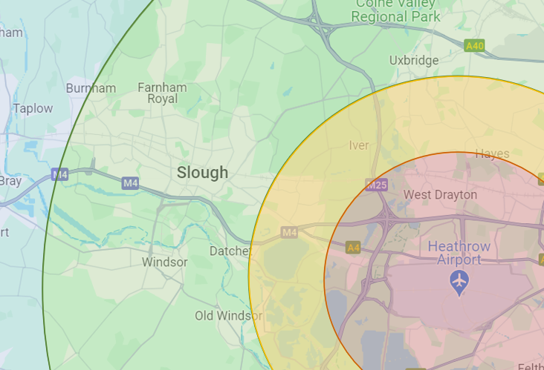Key: orange = 0-3 miles; yellow = 3-5 miles; green = 5-10 miles; blue = >10 miles.
Question 6 of the survey asked respondents "which, if any, of the following would encourage you to travel more sustainably by using public transport such as buses, trains, the underground, or active transport such as walking or cycling?". The options provided included:

- Incentivised sustainable travel (e.g. reward systems and loyalty points for using public transport or active travel)
- Cheaper sustainable travel (e.g. discounted travel on public transport)
- Better active travel infrastructure (e.g. more cycle lanes and parking, better lit pedestrian walkways)
- Wider public transport links and services (e.g. more frequent bus or train services, more routes and fewer changes)
- Better public transport infrastructure and environment (e.g. more accessible train stations or tram stops, more wheelchair space on trains and buses)
- Other
- None of the above
Figure E.17: Distribution of responses regarding sustainable transport modes

The results shown in Figure E.17 indicate that cheaper sustainable travel was most likely to result in Slough residents travelling more sustainably at 28%, closely followed by wider public transport links and services at 23% and better public transport infrastructure at 19%. Incentivised sustainable travel and better active travel infrastructure was considered the least effective at 12% and 11%, respectively.
Question 7 asked respondents how concerned they were about air quality, with options including ‘very concerned’, ‘fairly concerned’, ‘not very concerned’, ‘not at all concerned’ and ‘don’t know’. Overall, there was a fairly even split between those who were and were not concerned about air quality. 12% of respondents were very concerned, followed by 43% who were fairly concerned about air quality (55% in total). 37% of respondents voted that they were ‘not very concerned’ about air quality, and 8% voted that they were ‘not at all concerned’ (44% in total).
When asked how they felt air quality had changed in the last five years (question 8) 45% believed that air quality had worsened, whereas 42% believed that there had been no change. 11% of respondents did not know, and 2% believed air quality had improved.
Question 9 asked respondents what sources they believed were responsible for air pollution in the area. Options included car traffic, congestion, trucks/vans/lorries, aircraft, airport activities, construction, industry, train/underground, fireplaces, or none of the above. Respondents were able to select multiple answers. Figure E.18 shows the distribution of responses. In total, 52% of respondents believed that vehicle traffic contributed significantly towards poor air quality in their local area, with car traffic and congestion voted the highest contributors at 18% and 17%, respectively. Many respondents (16%) voted that aircraft was one of the most significant contributors to poor air quality, followed by industry and construction at 12% and 8%, respectively. Interestingly, fireplaces only received 2% of votes, despite scientific evidence being widely available on PM_{2.5} emissions which result from wood burning.
Figure E.18: Distribution of voted pollutant sources

Question 13 asked respondents whether they have used or are familiar with Heathrow’s Airwatch website, which shares live air quality information recorded from 22 air quality monitoring stations around the airport. This question was reviewed to gain insight into the awareness of Slough’s residents on available air quality resources. Question 14 followed which asked of those respondents who were not previously aware of the Airwatch website, how likely were hey to access the website now they are aware of it. Results are shown in Figure E.19 and Figure E.20.
The majority of respondents (71 respondents, 62%) were not aware of the website. Of those respondents, 16% would be very likely to visit the Heathrow Airwatch website, followed by 41% that would be somewhat likely. In total, 44% would be not likely or not likely at all to visit the Heathrow Airwatch website. This could possibly be due to difficulty interpreting the information, or due to not being concerned generally with air quality.
Figure E.19: Respondent awareness of Heathrow Airwatch website

Figure E.20: Likelihood of visiting Heathrow Airwatch website

Question 24 asked respondents whether they agree that there should be more community involvement with Heathrow Airport’s activities in relation to air quality, with 83 respondents (72%) agreeing with this statement. Question 25 followed asking what type of engagement these respondents wanted to see, of which 84% of respondents wanted to see greater community engagement and collaboration. Specific suggestions included:
- A general increase in community engagement, collaboration and awareness of issues and solutions
- Transparent and honest communication of air quality and sustainable transport through advertisements, newsletters, mail and media, with regular community updates
- Collecting public opinion through surveys and polls
- Hosting community meetings and events
- Involving community advisory groups and local councils
- Providing an online portal for residents to provide feedback

Summary
In summary, a greater proportion of respondents would be encouraged to travel sustainably if travel was cheaper, better linked and with improved infrastructure. Fewer respondents however would be encouraged to travel in an active mode.
Approximately half of the respondents (55%) had concerns about air quality compared to those who were not concerned (44%), with 45% who believed that air quality had worsened in the last five years.
When asked about contributors to poor air quality, the majority of respondents (52%) believed that vehicle traffic contributes towards poor air quality, which suggests that some respondents have good awareness of key pollutant sources. However, fireplaces (i.e. solid fuel burning) was seen to contribute only 2% towards poor air quality, which suggests there is not a strong understanding between solid wood burning and health implications. It is therefore evident that action is needed on improving information and awareness of the dangers of wood burning.
In regards to awareness of accessing air quality information, 62% were not aware of Heathrow’s Airwatch website and of that 62%, 44% would not be likely to visit it. It is therefore clear that further engagement work is needed with communities, not only to increase awareness of the availability of air quality data, but also to support the community to develop an interest in air quality information and help them understand air quality implications to their health.
Overall, the community would like to be more involved Heathrow Airport community activities (72% agreeing), and useful suggestions have been made on how the community should be engaged, including community meetings, newsletters and surveys, which will be considered when engaging with the public regarding air quality.

E.3: Behaviours and Attitudes Towards Healthy Choices: Census Data
This section reviews the data available on the Office for National Statistics (ONS) 2021 census data, in the context of healthy choices regarding vehicle ownership and travel to work.
Appendix D indicates that the highest contributor to poor air quality in Slough is from private vehicles, particularly diesel cars. This review intends to understand the behaviours and attitudes of Slough residents in relation to vehicle ownership and travel choices, to highlight potential opportunities for improvement.

Methodology
The data reviewed in this section has been obtained from the 2021 census. This data has been reviewed in terms of vehicle ownership, to understand the number of vehicles Slough households privately own, and the distribution of modes used to travel to work. Information on vehicle use for other activities such as leisure or retail purposes is not available on ONS.
The vehicles included in the ‘number of cars or vans owned or available for use by household members’ data is provided below:
- pick-ups, camper vans and motor homes
- vehicles that are temporarily not working
- vehicles that have failed their MOT
- vehicles owned or used by a lodger
- company cars or vans if they're available for private use

Results
Vehicle Ownership
Graph E.21 displays the percentage of vehicles owned per household in Slough compared with neighbouring local authorities (Windsor & Maidenhead, Spelthorne and Hillingdon, shown in pink shades), local authorities in the South East with a similar population density (Reading, Portsmouth and Southampton, shown in blue shades), and the average for the South East region and England (shown in green shades).

Figure E.21: Vehicle ownership per household in Slough compared to other local authorities and the England and South East average

In Slough, 20.3% of households do not have access to a car or van. This is above the average for the South East region (16.9%) and some neighbouring authorities including Windsor & Maidenhead at 12.7% and Spelthorne at 14.7%. Hillingdon has a greater percentage of households without access to a car or van at 22.3%, however all three of the highest population density areas exceed this at Reading (28.4%), Portsmouth (30.3%) and Southampton (27.4%). There are fewer households in Slough that have no access to a car or van despite Portsmouth and Southampton being more densely populated.
The majority of households have one car or van in their household. Slough exceeds the average for the South East and England at 42.7%, but is comparable to neighbouring authorities with Spelthorne at 42.0% and Hillingdon at 44.0%. Windsor & Maidenhead is slightly lower at 40.0%. Reading, Portsmouth and Southampton all have a higher percentage of households with one car or van, at 44.3%, 43.5% and 44.3%, respectively.
Fewer households have access to two cars or vans. Windsor & Maidenhead and Spelthorne both exceed the percentage at Slough (26.9%), by 7.0% and 4.4%, respectively, however Slough has a higher percentage than Reading (21.1%), Portsmouth (20.8%) and Southampton (21.8%). The percentage at Slough is slightly above the England average (26.1%), but is below the average for the South East (30.5%).
For households who have access to three or more cars or vans, the highest percentage is observed at Windsor & Maidenhead at 13.4%, followed by Spelthorne at 12.0% and Slough at 10.1%. Hillingdon falls below Slough at 8.9%. When comparing to areas with similar population density, Reading, Portsmouth and Southampton all have lower proportions, at 6.2%, 5.4% and 6.5%, respectively.
Figure E.22 compares the population density of these locations with the percentage of households who have access to three or more cars or vans.
Figure E.22: Correlation between percentage of households with three or more cars or vans and population density

Slough has a comparable percentage to Hillingdon and Spelthorne however Slough has a much denser population, which will be a contributing factor to the level of congestion experienced at Slough. For its population density, Slough has a high quantity of households who own or have access to three or more cars or vans.

Travel Behaviours
Figure E.23 below shows the breakdown of economic activity by group in Slough in the context of travel to work. This includes those who are employed and travel to work, those who mostly work from home, those who mainly work offshore or outside of the UK, and those who are not in employment or under 15 years old.
Figure E.23: Breakdown of economic activity by group in Slough

The graph shows that 26% of Slough residents are employed and travel to work, whilst 13% mainly work from home. 8% mainly work offshore, in no fixed place or outside of the UK. In contrast, 53% are not in employment due to age, long term sick or disability, looking after home or family, being a student, retired, general unemployment, or other.
Figure E.24 shows a further breakdown of the portion of Slough residents who are employed and travel to work. The graph shows that of that portion, 71% travel to work via car or van, whereas public transport and active travel account for 13% each. It is therefore evident that the majority of people who travel to work choose to do so using private vehicles.

Figure E.24: Mode choice distribution for Slough residents who are employed and travel to work

Figure E.25 below provides a more detailed breakdown of travel mode options. The graph shows that 64.0% of journeys to work by car or van are single occupant, with the remaining 7% being passengers in a car or van.
Figure E.25: Detailed mode choice distribution for Slough residents who are employed and travel to work

The most popular travel mode of choice for Slough residents after private car or van is travelling on foot at 10.6%. Journeys by bicycle are much lower however at 2.8%, suggesting that walking is a more popular mode choice. Bus, minibus or coach is the most popular public transport travel mode at 5.9%, followed by train at 4.3%.
Of those who travel to work, the distances travelled are shown in the pie chart below (Figure E.26). The majority of residents in Slough who travel to work travel less than 10km to reach their destination (68%). 25% travel between 10-30km, and only 7% travel over 30km to work. Figure E.27 provides a further breakdown of the distances travelled by mode category. This shows that the greatest proportion of journeys by car or van are for travelling less than 10km. As expected, the majority of active travel modes are used to travel less than 10km.
Figure E:26: Distance travelled by Slough residents who are employed and travel to work

Figure E.27: Distances travelled by mode category

Figure E.28 below shows the mode choices for Slough residents who travel less than 10km to work. Of those who travel in a car or van, 57.2% of those journeys are by individuals driving themselves to their destination, whereas only 7.6% are passengers in a car or van. Bus, minibus or coach is the most popular mode for these short journeys out of the public transport options at 7.2%, and travel on foot is more frequently used than bicycle at 17.0% and 4.1%, respectively.

Figure E.28: Mode choices for Slough residents who travel <10km to get to work

Figure E.29 below is a map showing the percentage of Slough residents who travel less than 10km to work by location. A breakdown of the different modes used to travel under 10km is not available, however it can be inferred from the information shown in Figure E.28 that the majority of the journeys undertaken are done so via private vehicles.
Figure E.30 shows the current bus routes in Slough. The maps suggest that there are routes which serve some of the areas that have the highest percentage of people who travel less than 10km to work (primarily by private vehicles), therefore there may be opportunities available to improve uptake on public transport, particularly through the BSIP, however there are some areas that appear to be poorly served by public transport. It should be noted also that areas highlighted in dark blue are primarily within industrial areas including Slough Trading Estate and Poyle Industrial Estate. As there is no split between car and van, it is not clear if these industrial areas have higher proportions of private vehicle use due to work purposes. This aspect would need further data collection to draw a reliable conclusion.
Figure E.29: percentage of Slough residents who travel less than 10km to work by location
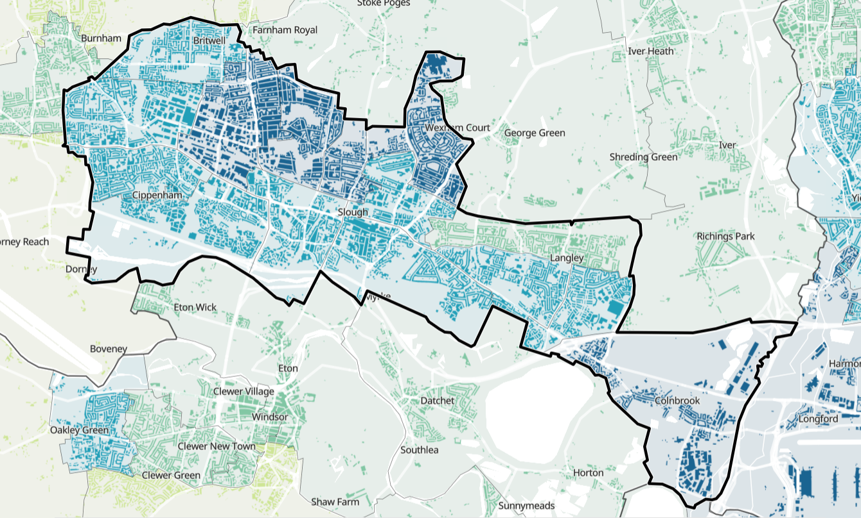
Figure E.30: Bus routes in Slough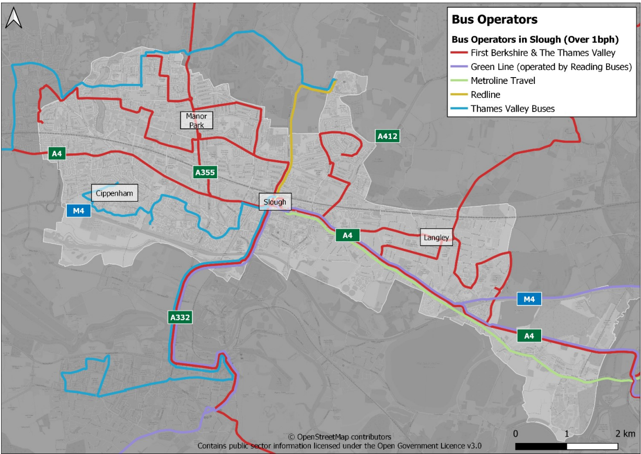

When considering mode choice change over time, the proportion of residents who travelled to work by car has reduced from 2011 to 2021. Figure E.31 below shows that in 2011, 66.6% of Slough residents travelled to work via car or van, which decreased by 19.9% by 2021 to 46.7%. On balance, the proportion of Slough residents who mainly work from home has increased from 2011 to 2021 by 20.4%, from 6.7% to 27.1%. Figure E.32 shows the same data but with the home working and driving portions removed to better visualise the changes in lesser used modes. In regards to active travel modes, there is almost no increase (0.04%) in the number of people who are choosing to cycle to work, and the number of people who walk to work has reduced by 0.1%.
Figure E.31: Mode of travel to work in 2011 and 2021

Figure E.32: Mode of travel to work in 2011 and 2021 (excluding home working and driving a car or van)

When considering census data from 2011, the quantity of residents in Slough who work from home has tripled, which is likely to have been accelerated by improvements in technology since 2011 and the Covid-19 pandemic which saw an increase in home working from March 2020 onwards.

Summary
In summary, areas with high population density including Reading, Portsmouth and Southampton tend to have a high number of households who do not have access to a car, at 28.4%, 30.3% and 27.4%, respectively. Slough in comparison has a lower number of households without access to a car at 20.3%.
Areas with high population density also tend to have a lower number of households with multiple cars, as the proportion of households in Reading, Portsmouth and Southampton with access to three or more cars or vans is 6.2%, 5.4% and 6.5%, respectively. Slough in comparison has 10.1% of households with 3 or more cars or vans.
In regards to travel behaviours, of the 26% of Slough residents who are employed and travel to work, 71% travel via a car or van (64% single occupant, 7% passengers). Of those who are employed and travel to work, 68% travel less than 10km, and over half of those journeys are by private vehicles, despite the journey being relatively short and there being alternative modes of travel such as public transport being available to most areas.
When considering mode choice over time however, the proportion of residents who travel by driving a car or van has reduced from 2011 to 2021 by 19.9%. This is balanced by a large increase in the proportion of residents who mainly work at or from home, which will have benefits to air quality.

Appendix F: Maps
Figure F.1: Air Quality Management Areas in Slough
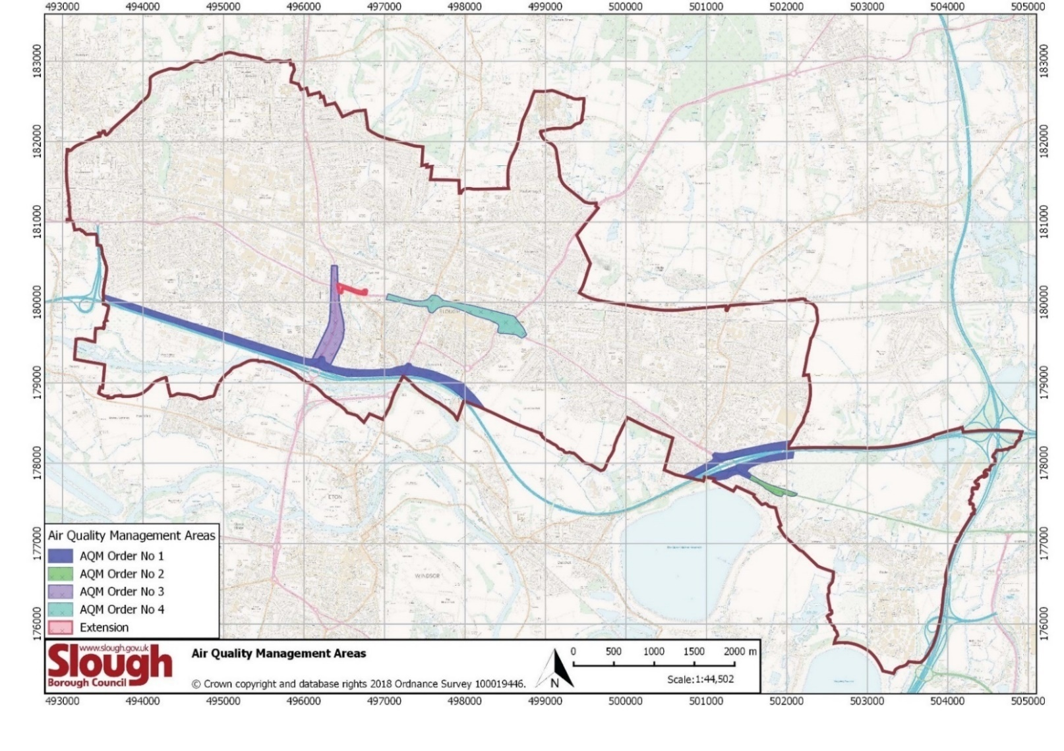
Figure F.2: Passive diffusion tube monitoring sites in Slough
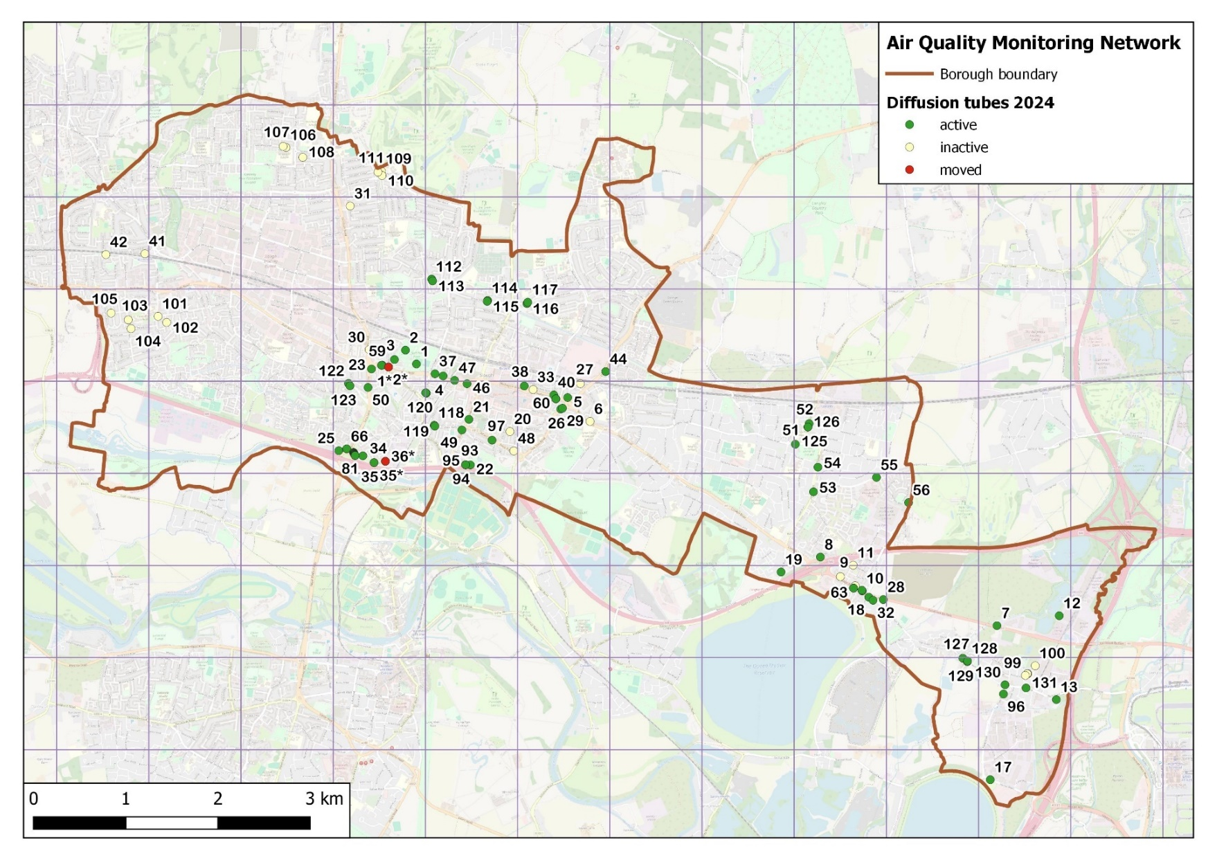
Figure F.3: Automatic (continuous) monitoring sites in Slough
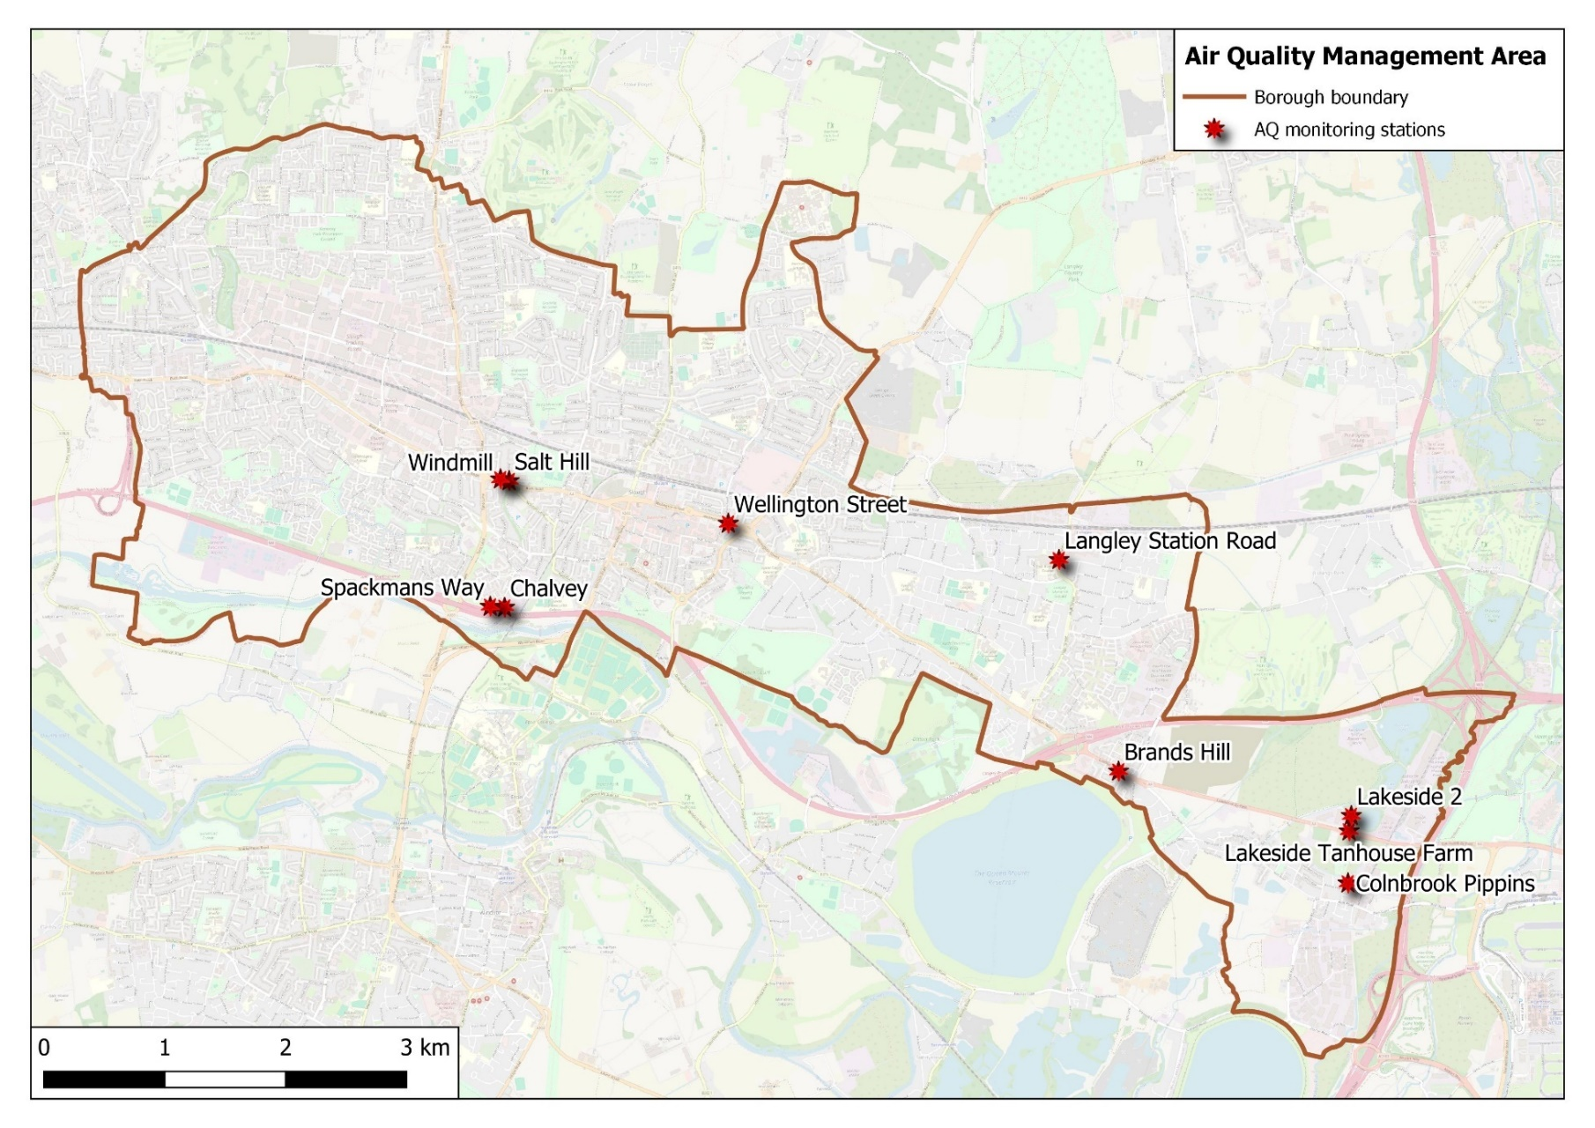

Appendix G: Air Quality Objectives
The Air Quality (England) Regulations 2000 (2002 as amended)

Pollutant | Air Quality Objective | Averaging Period
Nitrogen dioxide | 200μg/m³ not to be exceeded more than 18 times per year | 1-hour mean
Nitrogen dioxide | 40μg/m³ | Annual mean
Particulate matter (PM₁₀) | 50μg/m³ not to be exceeded more than 35 times/ year | 24-hour mean
Particulate matter (PM₁₀) | 40μg/m³ | Annual mean
Sulphur dioxide | 266μg/m³ not to be exceeded more than 35 times per year | 15 minute mean
Sulphur dioxide | 350μg/m³ not to be exceeded more than 24 times per year. | 1 hour mean
Sulphur dioxide | 125μg/m³ not to be exceeded more than 3 times per year | 24 hour mean
Benzene | 16.25μg/m³ | Running annual mean
Benzene | 5μg/m³ | Annual mean
1,3-butadiene | 2.25μg/m³ | Running annual mean
Carbon monoxide | 10mg/m³ | Maximum daily running 8-hour mean
Lead | 0.5μg/m³ (limit value) | Annual mean
Lead | 0.25μg/m³ (objective) | Annual mean
Pollutant and metric | Target | Target year
PM_{2.5} annual mean concentration | Interim target: 12μg/m³ | 2028
PM_{2.5} annual mean concentration | Legally binding target: 10μg/m³ | 2040
PM_{2.5} population exposure | Interim target: 22% reduction in exposure compared to 2018 | 2028
PM_{2.5} population exposure | Legally binding target: 35% reduction in exposure compared to 2018 | 2040
The Environmental Targets (Fine Particulate Matter) (England) Regulations 2023

The Air Quality Standards Regulations 2010
Pollutant | Air Quality Objective | Averaging Period
Particulate matter (PM₁₀) | 50 µg/m³ not to be exceeded more than 35 times a year | 24 hour mean
Particulate matter (PM₁₀) | 40 µg/m³ | annual mean
Particulate matter (PM_{2.5}) | 20 µg/m³ | annual mean
Particulate matter (PM_{2.5}) | Target of 20% reduction in concentrations at urban background | annual mean
Nitrogen dioxide | 200 µg/m³ not to be exceeded more than 18 times a year | hourly mean
Nitrogen dioxide | 40 µg/m³ | annual mean
Ozone | 100 µg/m³ not to be exceeded more than 10 times a year | 8 hour mean

World Health Organisation Air Quality Guidelines (AQGs) 2021
Pollutant | 2005 AQGs | 2021 AQGs | Averaging Time
PM_{2.5} (µg/m³) | 10 | 5 | Annual
PM_{2.5} (µg/m³) | 25 | 15 | 24 hour
PM₁₀ (µg/m³) | 20 | 15 | Annual
PM₁₀ (µg/m³) | 50 | 45 | 24 hour
O₃ (µg/m³) | - | 60 | Peak season
O₃ (µg/m³) | 100 | 100 | 8 hour
NO₂ (µg/m³) | 40 | 10 | Annual
NO₂ (µg/m³) | - | 25 | 24 hour
SO₂ (µg/m³) | 20 | 40 | 24 hour
CO (mg/m³) | - | 4 | 24 hour
*Please note, WHO AQGs are not legally binding but are useful health based targets.

Glossary of Terms
Abbreviation | Description
AQMA | Air Quality Management Area – An area where air pollutant concentrations exceed / are likely to exceed the relevant air quality objectives. AQMAs are declared for specific pollutants and objectives
AQS | Air Quality Strategy
ASR | Air quality Annual Status Report
ASR | Annual Status Report
BSIP | Bus Service Improvement Plan
CCS | Climate Change Strategy
CMP | Carbon Management Plan
CSSD | Cycling Supplementary Strategy Document
Defra | Department for Environment, Food and Rural Affairs
EfW | Energy from Waste
EU | European Union
EV | Electric Vehicle
EVCI | Electric Vehicle Charging Infrastructure
FC | Fleet Challenge
LAQM | Local Air Quality Management
LCWIP | Local Cycling and Walking Infrastructure Plan
LES | Low Emission Strategy
LEVI | Local Electric Vehicle Infrastructure
LTP3 | Local Transport Plan 3
NO₂ | Nitrogen Dioxide
NO_{x} | Nitrogen Oxides
PH | Public Health
PM₁₀ | Airborne particulate matter with an aerodynamic diameter of 10µm (micrometres or microns) or less
PM_{2.5} | Airborne particulate matter with an aerodynamic diameter of 2.5µm or less
PSSD | Parking Supplementary Strategy Document
SBC | Slough Borough Council
STIP | Strategic Transport Infrastructure Plan
TL | Taxi Licensing
TV | Transport Vision
WSSD | Walking Supplementary Strategy Document

References
Chief Medical Officer’s Annual Report, 2022
Courts and Tribunals Judiciary - Ella Kissi-Debrah, April 2021
Defra. Abatement cost guidance for valuing changes in air quality, May 2013
Defra. Air quality strategy: framework for local authority delivery, 2023
Defra. Annual nitrogen dioxide (NO₂) summary, 2022
Defra. Background Maps, 2022
Defra. Daily Air Quality Index, 2024
Defra. Technical Guidance LAQM.TG(22), August 2022
Department for Levelling Up, Housing and Communities and Ministry of Housing, Communities & Local Government. Planning practice guidance, 2024
Department for Levelling Up, Housing and Communities. National Planning Policy Framework, 2023
Department for Transport (DfT). Cycle Infrastructure Design, July 2020
Local Air Quality Management. Emission Factor Toolkit, EFT V11.0, 2021
Local Air Quality Management. NOx to NO₂ calculator, 2020
London Assembly. 20mph Speed Limit and Air Pollution, July 2022
National Highways. Air quality speed limit trials, 2023
Office for National Statistics (ONS). Census, 2011 and 2021
Pye, S., King, K., Sturman, J. Air quality and social deprivation in the UK: an environmental inequalities analysis, 2006
Slough Borough Council. Air quality annual status reports, 2018-2022
Slough Borough Council. Carbon Management Plan, 2020
Slough Borough Council. Citizen Space, Corporate Plan Consultation, 2023
Slough Borough Council. Citizen Space, The Proposed Spatial Strategy, 2021
Slough Borough Council. Climate Change Motion, 2019
Slough Borough Council. Developer guide Part 3 Transport and highways guidance, 2008
Slough Borough Council. Inclusive Growth Strategy, 2020
Slough Borough Council. Local Cycling and Walking Infrastructure Plan, 2021
Slough Borough Council. Local Transport Plan 2, Annex C, 2005
Slough Borough Council. Low Emission Strategy Technical Report, 2018
Slough Borough Council. Bus Service Improvement Plan, 2021
Slough Borough Council. Slough 2040 Vision, 2020
Slough Borough Council. Slough Wellbeing Strategy, 2020
Slough Borough Council. Transport Vision, 2019
Slough Borough Council. The local development plan for Slough, 2006
Slough Borough Council. Taxi Licensing Policy Renewal, 2023
University of Birmingham. Reducing motorway speed may improve air quality, June 2023
Wheeler, B., Ben-Shlomo, Y. Environmental equity, air quality, socioeconomic status and respiratory health, 2010
World Health Organisation (WHO) Air Quality Guidelines, 2021

Rural emissions accounts for NO_{X} occurring naturally and from agricultural sources.
Due to limitations of the 1km x 1km resolution Defra background maps, the contributions from Industry are not accurately reflected at Industrial monitoring sites considered in our source apportionment study
Technical Guidance LAQM.TG(22) – August 2022
Environmental equity, air quality, socioeconomic status and respiratory health, 2010
Air quality and social deprivation in the UK: an environmental inequalities analysis, 2006
Defra. Abatement cost guidance for valuing changes in air quality, May 2013
Air quality reports annual status reports – Slough Borough Council
WHO Air Quality Guidelines (2021)
Daily Air Quality Index - Defra, UK
Nitrogen dioxide (NO2) - GOV.UK (www.gov.uk)
Chief Medical Officer’s Annual Report 2022 (publishing.service.gov.uk)
Ella Kissi-Debrah - Courts and Tribunals Judiciary
Air quality strategy: framework for local authority delivery - GOV.UK (www.gov.uk)
NPPF (2023): National Planning Policy Framework (publishing.service.gov.uk)
Planning practice guidance - GOV.UK (www.gov.uk)
Background Maps | LAQM (defra.gov.uk)
Background concentrations are defined by Defra as “The total concentration of a pollutant comprises those from explicit local emission sources such as, roads, chimney-stacks, etc., and those that are transported into an area by the wind from further away. If all the local sources were removed, all that would remain is that which comes in from further away; it is this component that is called ‘background’. In many situations the background contribution may represent a significant or dominant proportion of the total pollutant concentration, so it is important that authorities give this careful consideration.”
Defra background maps provide emissions split for background sources for NO_{X} only. The percentage contributions from road and background sources for NO_{X} are analogous to NO₂
Rural emissions accounts for NO_{X} occurring naturally and from agricultural sources.
Cycle Infrastructure Design (publishing.service.gov.uk)
20mph Speed Limit and Air Pollution | London City Hall
Reducing motorway speed may improve air quality – but more real-world studies are needed - University of Birmingham
Air quality speed limit trials - National Highways
EFT V11.0 was used, as study commenced prior to the release of EFT V12.0 (Dec 2023). EFT V11.0, LAQM – 2021
NOx to NO₂ calculator, LAQM – 2020
Results from the modelling in Section 2.12 onwards show results for 78 monitoring sites. 12 sites were not included in model verification due to not being within close proximity of a modelled road.
For the purposes of assessing the projected impact of measures on air quality concentrations at the sites with highest concentrations, this study also considers local NO_{X} adjustment factors in Section 4 of this report.
SBC Corporate Plan Consultation - Slough Borough Council - Citizen Space
Slough Inclusive Growth Strategy - 2020-25
Appendix B - Slough 2040 Vision
Slough LTP2_AnnexC.indd (defra.gov.uk)
Appendix 1 - Summary LES final draft (slough.gov.uk)
Slough Wellbeing Strategy 2020-2025 (slough.gov.uk)
Taxi Licensing Policy Renewal 2023 (slough.gov.uk)
Local Cycling and Walking Infrastructure Plan – Slough Borough Council
Climate Change Motion 2019 (slough.gov.uk)
Carbon Management Plan (slough.gov.uk)
Appendix A - Transport Vision Supplementary.pdf (slough.gov.uk)
National Bus Strategy - Bus Back Better – Slough Borough Council
The local development plan for Slough – Slough Borough Council
The Proposed Spatial Strategy - Slough Borough Council - Citizen Space
Developer guide - Part 3 Transport and highways guidance – Slough Borough Council
This map is provided by ONS (2021) and includes the home working portion of residents, which results in different proportions to the graphs outlined in this section.

